**TEMASEK POLYTECHNIC  
SCHOOL OF INFORMATICS & IT**

**Diploma in Cyber and Digital Security**

**AY2015/2016**

Final Report

**Project Particulars**

|  |  |
| --- | --- |
| **Supervisor** | Logesh Madhavan |
| **Project Number** | 01 |
| **Project Title** | Packet Ninja |

**Project Team’s Particulars**

|  |  |  |  |
| --- | --- | --- | --- |
| **Student Number** | **Student Name** | **Email Address** | **Mobile No.** |
| 1705018H | Anurag Prabhakar | 1705018H@student.tp.edu.sg | 9068 7896 |

# **Acknowledgements**

I would like to express my gratitude to my supervisor Logesh Madhavan for his guidance and co-operation throughout the project as well as colleagues of National Cybersecurity R&D Lab for their encouragement and assistance in testing and evaluating the product. I would also like to thank NCL’s testbed and infrastructure that helped me to test the project.

**Table of Contents**

**Acknowledgements** 3

**List of Illustrations** 6

**Abstract** 13

**1. Introduction** 14

**1.1 Background** 14

**1.2 Purpose** 15

1.2.1 Project 15

1.2.2 Report 15

**1.3 Scope** 15

**1.4 Methodology** 17

**2. Problem Recognition** 18

**3. Feasibility Study** 20

**4. Analysis and Requirements** 21

**5. Design** 21

**5.1 Project Layout** 22

**5.2 Product Design** 23

**6. Implementation** 27

1. Scan, Ping, Attack Testing 27

2. IDS Evasion testing 66

3. File Sender 87

4. Packet payload encryption 100

5. Pcap Editor 110

**7. Evaluation** 122

**Recommendation** 123

**Conclusion** 123

**Bibliography** 125

**Appendices** 129

1. Introduction 133

2. Objectives of the Project 133

3. Scope of the Project 134

# **List of Illustrations**

Figure 1. PackETH 19

Figure 2. Testing Environment 22

Figure 3. Packet Ninja - UI 23

Figure 4. input interface 24

Figure 5. Network IDS running script - UI 24

Figure 6. Snort IDS 25

Figure 7. Suricata IDS 25

Figure 8. Packet Sniffer UI 26

Figure 9. Packet X – First Section 27

Figure 10. TCP SYN scan – open ports 28

Figure 11. Snort alert – TCP syn scan 28

Figure 12. TCP Ack Scan 29

Figure 13. Filtered/unfiltered ports 30

Figure 14. Snort alert – TCP ack scan 30

Figure 15. Suricata alert – TCP ack scan 30

Figure 16. TCP Fin Scan 31

Figure 17. TCP Fin scan Open ports 32

Figure 18. Snort alert – TCP fin scan 32

Figure 19. TCP Ack Scan 32

Figure 20. TCP XMAS scan 33

Figure 21. TCP XMAS scan – open ports 34

Figure 22. Snort alert – XMAS scan 34

Figure 23. Suricata – XMAS scan 34

Figure 24. IP proto scan 35

Figure 25. IP proto scan – unanswered ports 36

Figure 26. Snort alert – IP proto scan 36

Figure 27. Suricata alert – IP proto scan 36

Figure 28. NULL Scan 37

Figure 29. TCP NULL scan – open ports 38

Figure 30. Snort alert – NULL scan 38

Figure 31. Suricata alert- TCP NULL scan 38

Figure 32. Ping scans 39

Figure 33. ARP ping 39

Figure 34. Snort alert – None – Arp ping 40

Figure 35. Suricata alert – None – Arp ping 40

Figure 36. ICMP ping 41

Figure 37. Snort alert- ICMP ping 41

Figure 38. Suricata alert – ICMP ping 41

Figure 39. TCP Ping 42

Figure 40. Snort alert – None – TCP ping 43

Figure 41. Suricata alert – None- TCP ping 43

Figure 42. TCP Ack Scan 44

Figure 43. Snort alert - 44

Figure 42. TCP Ack Scan 46

Figure 43. Malformed packets 46

Figure 44. Snort-alert – None – Malformed packets 47

Figure 45. Suricata alerts – malformed packets 47

Figure 46. Teardrop attack 48

Figure 47. Craft – teardrop attack 48

Figure 48. Snort alerts – none- teardrop attack 49

Figure 49. Suricata alerts – teardrop attack 49

Figure 50. Ping of death attack 50

Figure 51. Snort alerts- Ping of death 50

Figure 52. Suricata alerts- Ping of death 51

Figure 53. SYN flood attack – Netcat 51

Figure 54. SYN flood attack 52

Figure 55. Crafting syn packets 52

Figure 56. Snort alerts – none – syn flood 52

Figure 57. Suricata alerts- none -syn flood 52

Figure 60. MAC address of internal hosts 53

Figure 61. ARP venom (packet ninja) 54

Figure 62. Same MAC address in 2 hosts 54

Figure 63. Sending messages with Netcat 54

Figure 64. Receiving messages at server 55

Figure 65. Restoring IP addresses 55

Figure 66. Intercepted messages in pcap file 55

Figure 67. Snort alerts- None- arp posioning 56

Figure 68. Suricata alerts- none -arp poisoning 56

Figure 69. Tracerouting 57

Figure 70. ICMP traceroute 57

Figure 71. Snort alerts – ICMP traceroute 58

Figure 72. Suricata alerts- ICMP traceroute 58

Figure 73. TCP SYN traceroute 59

Figure 74. Snort alerts – TCP traceroute 59

Figure 75. Suricata alerts – TCP traceroute 60

Figure 76. UDP traceroute 61

Figure 77. Snort alerts – UDP traceroute 61

Figure 78. Suricata alerts- UDP traceroute 61

Figure 79. Ether leak 62

Figure 80. Snort alerts- ether leak 63

Figure 81. Suricata alerts – ether leak 63

Figure 82. ICMP leaking 64

Figure 83. ICMP leak result 64

Figure 84. Snort alerts – ICMP leak 64

Figure 85. Suricata alerts- ICMP leak 65

Figure 86. Evasion techniques 66

Figure 87. Change fields in packets 67

Figure 88. Low ttl value - netcat 67

Figure 57. Low TTL attack 68

Figure 90. Payload reassembled – low ttl 68

Figure 91. Snort alerts – low TTL 68

Figure 92. Suricata alerts – Low TTL 69

Figure 93. Change IP checksum 69

Figure 94. Craft packets with invalid checksum 70

Figure 95. payload reassembled 70

Figure 96. Snort alerts – invalid checksum 71

Figure 97. Suricata alerts- invalid checksum 71

Figure 98. Fragment TTL- Netcat 72

Figure 99. Fragmented TTL 72

Figure 100. payload reassembled – fragment TTL 73

Figure 101. Snort alerts – fragment TTL 73

Figure 102. Suricata alerts – fragment TTL 73

Figure 103. Change MTU - Netcat 74

Figure 104. Changing MTU 74

Figure 105. Checking MTU 75

Figure 106. Change MTU – sending payload 75

Figure 107. payload reassembled – change MTU 75

Figure 108. Snort alerts – none- change MTU 76

Figure 109. Suricata alerts- change MTU 76

Figure 110. Netcat – fragment timeout 77

Figure 111. Fragment Reassembly timeout 78

Figure 112. Payload reassembled – fragment timeout 78

Figure 113. Snort alerts – none – fragment timeout 78

Figure 114. Suricata alerts- fragment timeout 79

Figure 115. Change TCP header fields 80

Figure 116. TCP flags – Fragment reassembly timeout 80

Figure 117. Invalid flag 81

Figure 118. payload reassembled – invalid flag 81

Figure 117. Snort alerts – invalid flag 81

Figure 120. Suricata alerts- invalid flag 82

Figure 121. TCP checksum – Netcat 82

Figure 122. Invalid checksum 83

Figure 123. payload reassembled – invalid checksum 83

Figure 124. snort alerts – invalid checksum 83

Figure 125. Suricata alerts – invalid checksum 84

Figure 126. Netcat – session splicing 85

Figure 127. Session splicing 85

Figure 128. payload reassembled – session splicing 85

Figure 129. Snort alerts – session splicing 86

Figure 130. Suricata alerts – session splicing 86

Figure 131. File sender 87

Figure 132. Checksum table 87

Figure 133. Checksum of python file 88

Figure 134. Invalid flag 88

Figure 135. Setting flag 89

Figure 136. file sniffer 89

Figure 137. checksum of python file in target 89

Figure 138. Snort alerts- file sender 90

Figure 139. Suricata alerts – file sender 90

Figure 140. Checksum of ZIP file 91

Figure 141. File sender – sending zip 91

Figure 142. File sending 92

Figure 143. zip file created at target 92

Figure 144. checksum of zip file at target 92

Figure 145. Snort alerts – file sender 93

Figure 146. Suricata alerts- file sender 93

Figure 147. checksum of text files 94

Figure 148. File sender – sending text files 94

Figure 149. Sending text file 95

Figure 150. text file created at target 95

Figure 151. checksum of file at target 95

Figure 152. Snort alert – file sender 96

Figure 153. Suricata alerts – file sender 96

Figure 117. Invalid flag 97

Figure 155. file sender – sending pcap 97

Figure 156. Sending pcap file 98

Figure 157. pcap file created at target 98

Figure 158. checksum of pcap file on target 98

Figure 159. Snort alerts – sending pcap file 99

Figure 160. Suricata – sending pcap file 99

Figure 161. AES encryptor 100

Figure 162. Creating key 100

Figure 163. generating key 101

Figure 164. Encrypting payload 101

Figure 165. Saving bin files 102

Figure 166. AES encrypted payload 102

Figure 167. Decrypted payload 103

Figure 168. file sniffer 104

Figure 169. sending encrypted payload 104

Figure 170. decrypted data at target 105

Figure 171. Snort alerts- none 105

Figure 172. Suricata alerts – AES encryption 105

Figure 173. Sending bogus payload 106

Figure 174. mal. payload 107

Figure 175. generated payload 107

Figure 176. sending bogus payload 108

Figure 177. Establishing connection 108

Figure 178. checksum of key file 109

Figure 179. sending key 109

Figure 180. creating key file at target 109

Figure 181. checksum of received key file 110

Figure 117. Invalid flag 110

Figure 183. Wireshark with pcap file 111

Figure 184. Number of packets 111

Figure 185. Packet summary 112

Figure 186. selecting packet 112

Figure 187. replacing payload 113

Figure 188. new pcap created 113

Figure 189. wireshark – new pcap 114

Figure 190. editing fields 114

Figure 191. selecting packet 115

Figure 192. replacing source IP 115

Figure 193. new pcap created 116

Figure 194. selecting packet 117

Figure 195. new destination IP 117

Figure 196. new pcap 118

Figure 197. selecting packet 118

Figure 198. replacing src port 119

Figure 199. new pcap 119

Figure 200. selecting packet 120

Figure 201. replacing dst port 120

Figure 202. new pcap file 121

Figure 203. Usability test 122

# **Abstract**

Nowadays, intrusion detection systems using default rule sets and minimal configuration are easily evaded by attackers. This was due to the difference in protocol specifications among the IDS and its internal hosts. Packet crafting was commonly used to perform different tests on intrusion detection systems and firewalls to identify entry points or vulnerabilities. Existing packet crafting tools were not able to automate the testing process which included sending probes (ping, TCP scanning, tracerouting) and manipulating packets to perform evasion techniques (fragmentation, encryption, invalid checksum/flag). Packet Ninja was developed as proof-of-concept tool at National Cybersecurity R&D Lab (NCL) to automate probe and evasion testing. NCL also focused on developing features that could encrypt and transfer data through packet manipulation. Pcap editing feature was also added to edit packets captured during transmission. Packet Ninja was tested at NCL in a testbed environment and its results were also recorded.

# **1. Introduction**

## **1.1 Background**

This report documents the work carried out for the Industrial Project developed and tested at National Cybersecurity R&D Lab (NCL). The project features a tool entitled Packet Ninja to perform automated tests on Intrusion Detection Systems. An Intrusion Detection System (IDS) is a device/application that monitors the network for suspicious activity and produce alerts based on the activity ("Intrusion detection system", n.d.). Network/System administrators tend to maintain the default configuration and rule sets in IDS provided by vendors. By using default configuration, it will be easier for attackers to predict and analyse IDS behaviour. This increases the attacker’s chance to evade intrusion detection through packet crafting. Packet crafting is a method used by both attackers/pen testers alike to probe IDS rule sets and find entry points in the targeted network ("Packet crafting", n.d.).

The project was initiated by NCL to test Intrusion Detection Systems to address the following :

* Using default configuration increases probability of IDS evasion.
* Majority of the packet crafting tools available were not open source.
* Some packet crafting tools had user interface that consumed lot of time and effort while crafting special packets recursively
* Since existing tools were just a platform to generate packets, users where expected to research on crafting packets to evade intrusion detection.

It was evident that crafting packets with existing tools was insufficient to test intrusion detection systems as they did not feature predefined methods to test various aspects of the network and IDS.

## **1.2 Purpose**

### 1.2.1 Project

The purposes of the Major Project are to :

* Create a tool to craft and edit network packets (packet crafting).
* Use various packet crafting techniques to test intrusion detection systems
* Design a guided platform that automates packet crafting to test IDS
* Research and develop a method to send packets with encrypted data over network and decrypt them upon reaching the target.
* Create a script to edit network packets in packet capture files.

### 1.2.2 Report

This report documents the research, content, design, layout, implementation and testing work done for Major Project. It also represents technical and non-technical recommendations for future development, reference and archival work.

## **1.3 Scope**

Packet Ninja uses python and scapy library to craft network packets. Packet crafting is used to probe rulesets in NIDS. All tests are performed on intrusion detection systems - Snort and Suricata. They are installed on gateway router with minimal configuration. In this project, Packet Ninja aims to perform IDS testing and does not provide recommendations for hardening the device/IDS.

Packet Ninja covers three sections – IDS testing, Payload encryption (R&D) and other misc. features (pcap editor, AES encrypted server/client).

The first section involves actual IDS testing which was performed in two stages.

1. Probe Testing –

The primary stage uses multiple port scanning, ping scans, traceroutes to probe rulesets in IDS to generate alerts. It also has few DoS (Denial of Service), flooding attacks and a man-in-the-middle attack to probe alerts.

1. Evasion Testing –

The secondary stage uses different evasion techniques to evade intrusion detection. Packets are crafted to manipulate packet headers and exploit the ambiguities in TCP/IP protocols to evade detection.

The goal of probe testing and evasion testing were not focused on ensuring accurate results but observing how the IDS detects and responds against these tests.

The next section of Packet Ninja is dedicated to R&D. It includes multiple payload encryption and transfer methods. Different encryption methods are used to encrypt packets before sending and decrypting the payload once the packet reached destination. Since this section is a proof of concept, it does not focus on encryption/decryption of large data in an established connection but used single TCP packets to transfer encrypted data.

Packet Ninja also has some miscellaneous features – Pcap editor and AES encrypted server/client. As per requirement, the pcap editor can edit common fields in TCP header like source/destination IP addresses and ports in the packets of a pcap file. Since the previous section (R&D) did not feature a method to encrypt network traffic (multiple network traffic), Packet Ninja uses socket programming to create an AES encrypted server/client tunnel.

**1.4 Methodology**

This section includes the source of documents and research papers used to create the packet crafting tool – Packet Ninja.

Packet Ninja uses Scapy library for packet crafting. Packet crafting methods to perform pings, scans, traceroutes, network attacks, payload tests were obtained from the following:

1. Biondi, P. (n.d). Scapy documentation. Retrieved from <https://scapy.readthedocs.io/>
2. Maxwell, A. (n.d). The Very Unofficial Dummies Guide to Scapy [eBook]. Retrieved from <https://theitgeekchronicles.files.wordpress.com/2012/05/scapyguide1.pdf>

Scapy codes for Packet manipulation and crafting methods to establish TCP connection, evade IDS in the network and transport layer were based on the research paper by Vít Bukaˇc. It explains the issues of using default configuration in intrusion detection systems, types of IDS (network-based, host-based), types of intrusion detection (signature-based, anomaly-based), Snort, snort configuration and snort rules. It also provides detail explanation on evasion techniques like fragmentation, session splicing, time to live (TTL) method, packets with invalid header – flag, checksum.

1. Bukaˇc, V. (2010). IDS System Evasion Techniques [eBook]. MASARYKOVA UNIVERZITA FAKULTA INFORMATIKY. Retrieved from <https://is.muni.cz/th/d4739/MT_Bukac.pdf>

# **2. Problem Recognition**

2.1. Default configuration in IDS

Network administrators tend to use default configuration on intrusion detection systems. The default configuration includes fixed fragmentation timeout, stream reassembly timeout, default port scan detection, default processors, protocol normalization, and default rule sets.

Using default configuration results can result in a difference in incoming traffic at IDS and internal hosts. Packets with invalid field value (e.g. TCP/IP checksum) may be rejected at IDS but accepted at the internal host or vice versa. This difference in protocol specifications can disrupt the synchronization between IDS and internal host. These ambiguities can be exploited by an attacker to perform evasion techniques and attacks on internal networks undetected. Intrusion detection systems must be checked for the difference in protocol specifications and other ambiguities before deployment.

Packet crafting was the suggested technique to test intrusion detection systems. Packet crafting helps to probe rulesets and find entry points in the network ("Packet crafting", n.d.).

2.2 Existing tools

Now, there arises a need for an efficient packet crafting tool to perform IDS probing and evasion tests. There are different packet crafting tools with both a graphical user interface and a command-line interface. These tools can craft single packets and generate network traffic. CLI Tools like Netcat, Nping, Hping3 can perform pings, scan, traceroutes, MTU path discovery and establish server/client connections. These tools do not have intricate packet editing features to perform evasion techniques *(Please refer to Appendix A1, page 112).*

Some packet crafting tools with GUI are not open source *(Please refer to Appendix A1, page 113).* PackETH is a tool that has a traffic generator and packet builder. In the figure below, to craft a packet multiple TCP/IP fields must be filled before sending. This is not practically possible while testing an IDS since it involves different crafting methods.

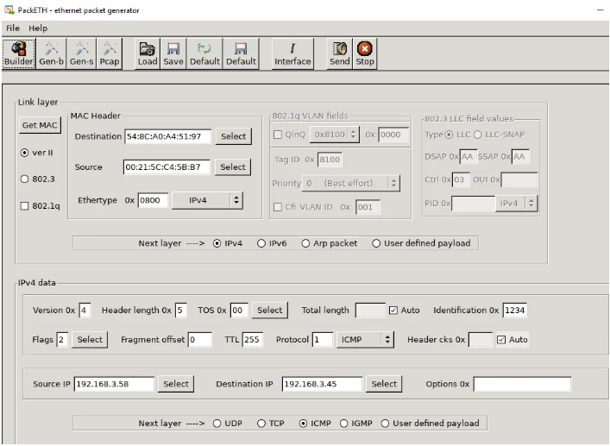

Figure 1. PackETH

So, it was concluded that a new tool with features from different existing tools was required to craft packets specifically for testing intrusion detection systems.

# **3. Feasibility Study**

This section covers operational, technical, economic feasibility of the project.

3.1 Operational feasibility

During research, it was concluded that existing tools were not able to automate packet crafting to perform probe and evasion tests. The proposed tool was able to automate and craft packets to perform pings, scan, traceroutes, network attacks (DoS, MiTM), evasion techniques with little user input.

3.2 Technical feasibility

The proposed tool performs packet crafting with python library/tool – Scapy. The tool also uses other python dependencies and libraries for encryption, , obfuscation, socket connections. The tests are performed on open source intrusion detection systems – Snort and Suricata. The test environment needs at least three virtual machines – attacker machine, Router (with IDS), and target internal host.

3.3 Economic feasibility

This packet crafting tool only uses open source tools and applications. The tool and its testing environment are available at testbed environment at National Cybersecurity R&D Lab.

# **4. Analysis and Requirements**

4. 1 Functionality

The tool is expected to have pre-defined methods to craft packets. These methods should be able to craft packets that can probe (scan, ping, attack) and evade (evasion techniques) the IDS. It should have a feature that has a defined method to encrypt packets before sending and decrypting them once it reaches target.

4.2 Usability

The tool is expected to have a simple user interface that requires basic or limited user input. It should be suitable for users with basic or advanced knowledge in TCP/IP protocols and networking. Users like researchers/student should be able to edit, add new features and further develop the tool.

# **5. Design**

The project focuses on developing and testing Packet Ninja – A proof of concept packet crafting tool that focuses on testing intrusion detection systems. The testing is conducted in an environment divided into two networks – Internal network and External network.

The External network consists of attacker’s virtual machine (Kali Linux). The Internal network consists of ubuntu server and client machines. Both networks are connected by an ubuntu virtual machine that acts as a gateway router. Network intrusion detection systems - Snort and Suricata are installed on the gateway router.

## **5.1 Project Layout**

1) Testing Environment

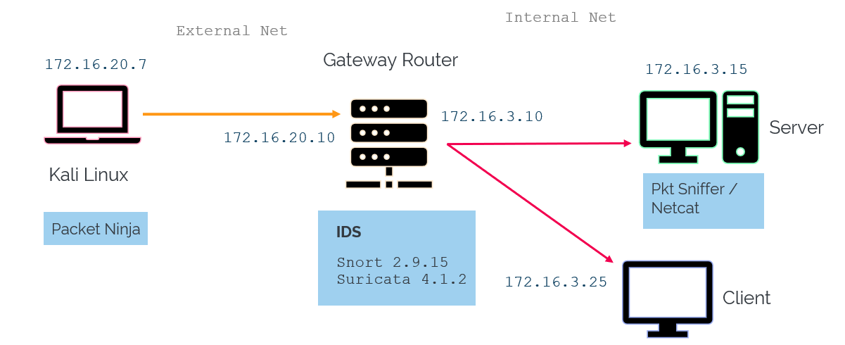

Figure 2. Testing Environment

2) Network Configuration

|  |  |  |  |
| --- | --- | --- | --- |
| Virtual Machine | Network | Location | IP address |
| Kali Linux | 172.16.20.0/24 | External Network | 172.16.20.7 |
| Gateway Router  (with NIDS) | 172.16.20.0/24 | External Network / Perimeter | 172.16.20.10 |
|  | 172.16.3.0/24 | Internal Network / Gateway | 172.16.3.10 |
| Server1 (ubuntu) | 172.16.3.0/24 | Internal Network | 172.16.3.15 |
| Client1 (ubuntu) | 172.16.3.0/24 | Internal Network | 172.16.3.25 |

## **5.2 Product Design**

1) Packet Ninja

Packet Ninja is run on the attacker machine (Kali). It has a menu driven interface that consists of primary features – Scan, Ping & Attack Testing(1), IDS Evasion Testing (2), Import and send file (3), Packet Payload encryption (4), AES encrypted server/client (a), File sniffer (s), and Pcap Editor (p). The features were developed automate and perform probe testing and evasion testing.

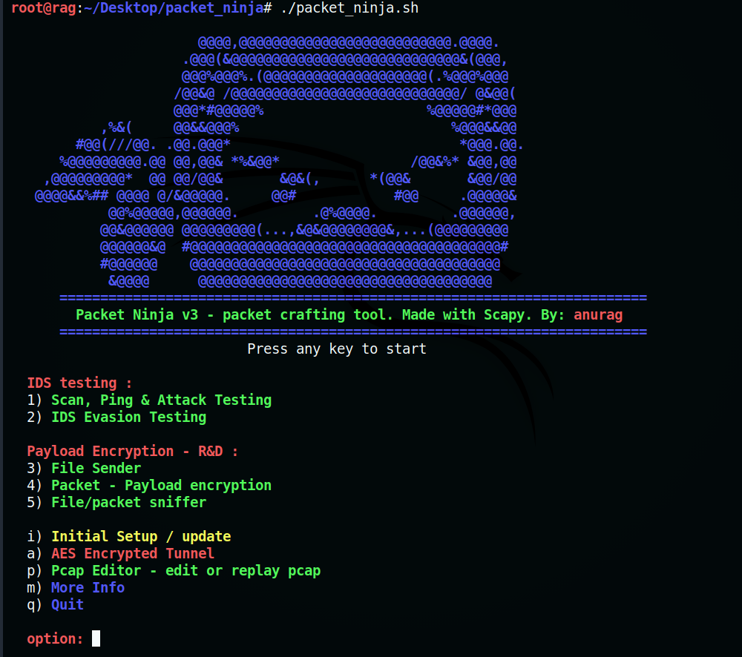

Figure 3. Packet Ninja - UI

As mentioned earlier, packet crafting methods for different features are predefined in Packet Ninja. The user is only expected to input basic details like source/destination IP address, source/destination port numbers and other details like time to live value, IP/TCP checksum, and TCP flag when prompted.

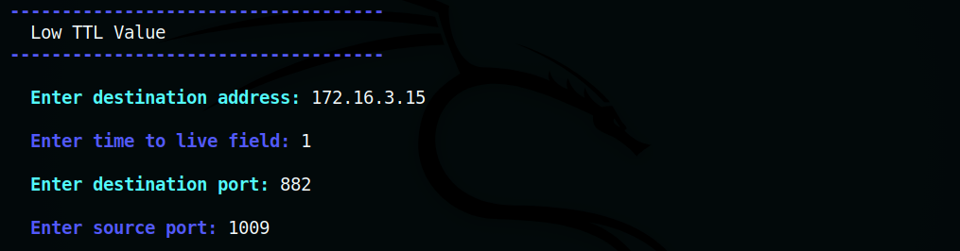

Figure 4. input interface

2) NIDS

Open Source Network Intrusion Detection Systems installed in the gateway router are Snort and Suricata which are primarily being subjected to IDS tests. Both IDSs are configured to monitor on external and internal interface of the gateway router. A script entitled ‘Test NIDS’ is run on the router with options to read live logs of Snort and Suricata on console mode.

Snort/Suricata uses rule-based language together with signature, protocol and anomaly detection. Rules are written to check activities on the network and notify administrators of potential intrusion. They are compatible to act immediately and take necessary measures. Rules are expected to be short, precise and easy to understand.

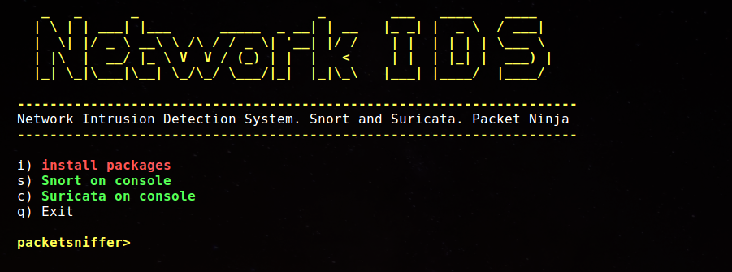

Figure 5. Network IDS running script - UI

2.1) Snort v2.9.15

Snort is an open source IDS developed in 1998. It is capable of performing real time traffic analysis, content matching, protocol analysis to detect attacks, probes and scans.

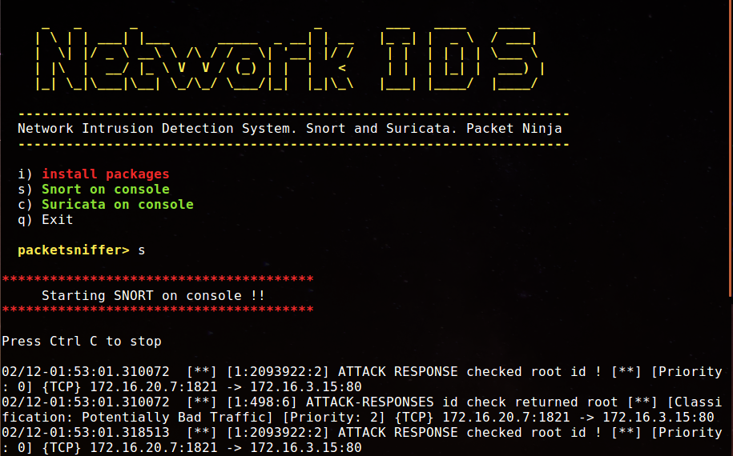

Figure 6. Snort IDS

2.2) Suricata 4.1.2

Suricata is also an open source IDS developed in 2009 capable of real time intrusion detection. It is compatible with Snort rules and supports multithreading which means it can process rules across faster networks with larger volume of traffic.

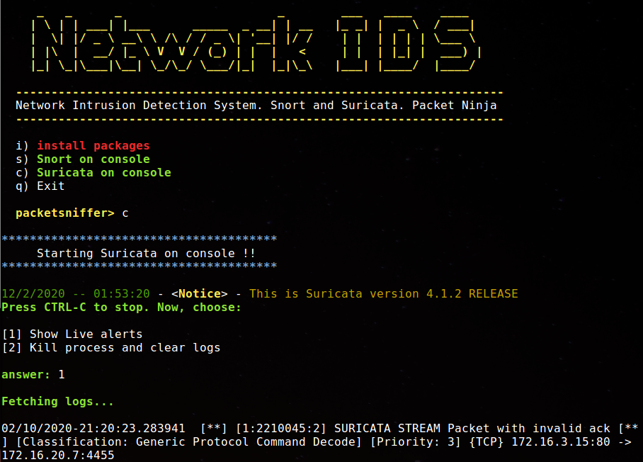

Figure 7. Suricata IDS

3) Packet Sniffer

Packet Sniffer is run on the target – server in the internal network and is used to decrypt the encrypted data sent from the attacker. It features a file sniffer (1), decrypt/decoder (d) and an option to install packages (i). This script was developed to receive incoming traffic from attacker.

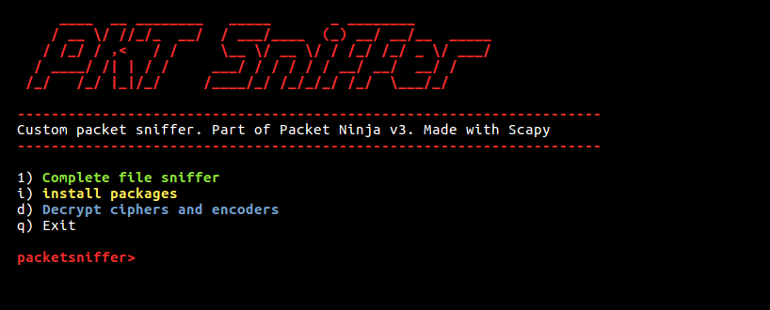

Figure 8. Packet Sniffer UI

# **6. Implementation**

## 1. Scan, Ping, Attack Testing

This probe testing section automates packet crafting to perform pings, scans, traceroutes and network attacks based on official scapy documentation (Biondi, n.d). Apart from probes, this section has payload testing feature where payload can be input and sent through the IDS to test signature detection

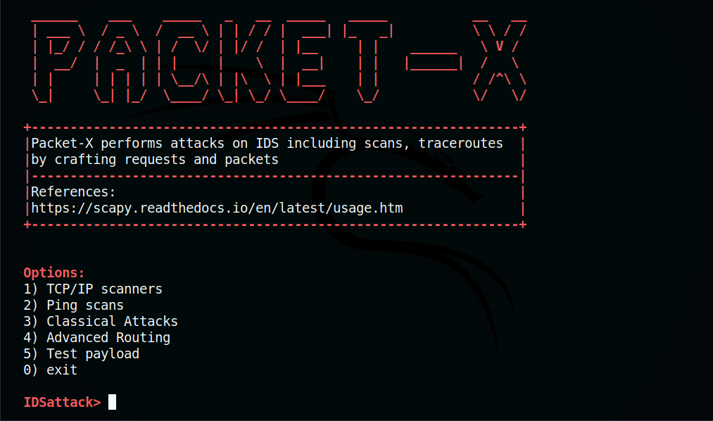

Figure 9. Packet X – First Section

**1. TCP/IP Scanners**

This option can be used to perform TCP port scanning techniques including SYN, ACK, FIN, X-MAS scans and an IP protocol scanner.

1.1 TCP SYN Scanner

TCP SYN packet is sent to every port of target in an attempt to initiate a TCP handshake. If the target responds with TCP SYN/ACK packet, it can be concluded that the port is open. By pressing enter, each packet response will be shown along with TCP flags.

* Test : Perform TCP SYN scan on the gateway router

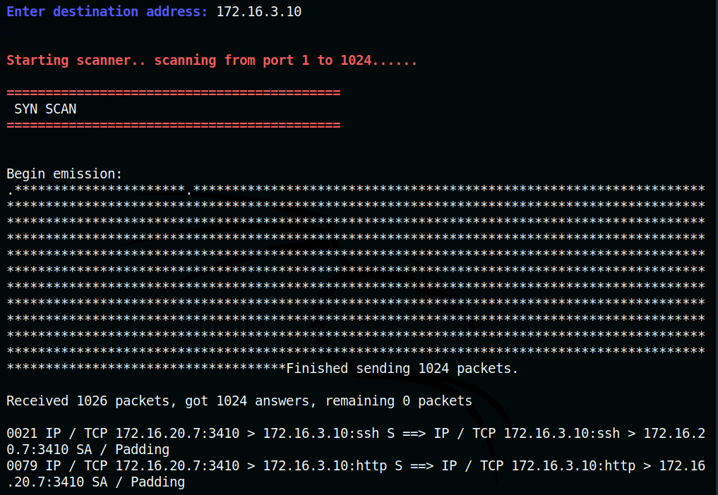

Figure 10. TCP SYN scan – open ports

* IDS alerts :

1. Snort

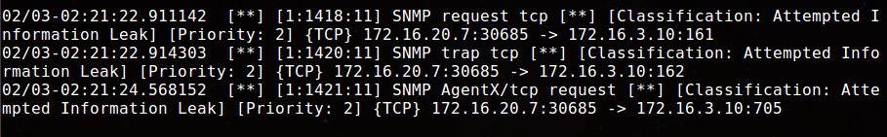

Figure 11. Snort alert – TCP syn scan

* Result :

|  |  |
| --- | --- |
| Test Result | Open ports are port 80 (http) and port 22 (ssh) |
| Snort alert | SNMP request tcp, SNMP trap tcp, SNMP AgentX/tcp request |
| Observation (if any) | Snort detected the tcp request at SNMP ports |
| Suricata alert | None |
| Observation (if any) | None |

1.2 TCP ACK Scanner

This scan is used to determine if the ports of a target are filtered. TCP ACK packet is sent to each port on the target. If there is no response, it means stateful firewall is present. If the target responds with RST packet, it means that the port is unfiltered .

* Test : Perform TCP ACK scan on gateway router.

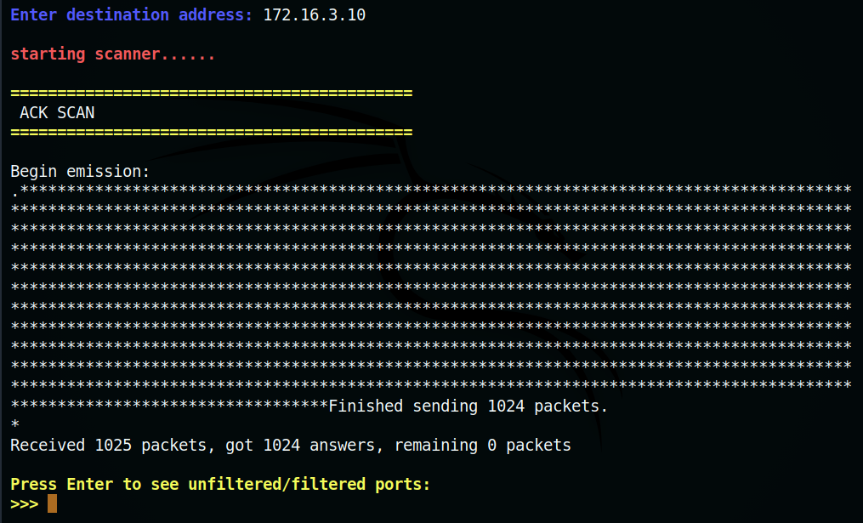

Figure 12. TCP Ack Scan

* Filtered and unfiltered ports are displayed after scan.

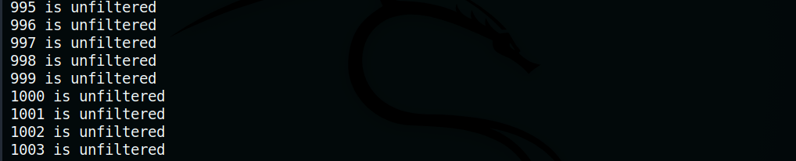

Figure 13. Filtered/unfiltered ports

* IDS alerts :

1. Snort

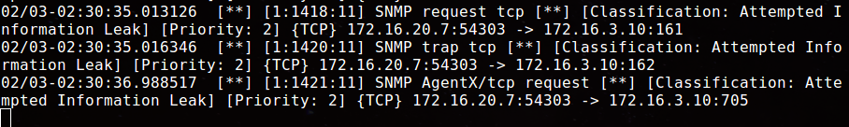

Figure 14. Snort alert – TCP ack scan

2. Suricata

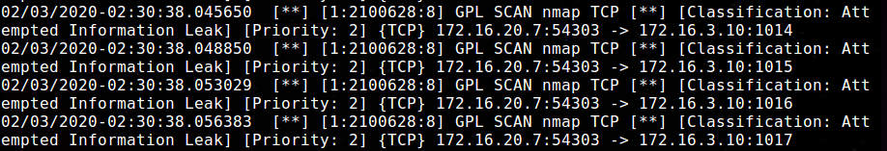

Figure 15. Suricata alert – TCP ack scan

* Result :

|  |  |
| --- | --- |
| Test Result | Ports 1-1024 are unfiltered |
| Snort alert | SNMP request tcp, SNMP trap tcp, SNMP AgentX/tcp request |
| Observation (if any) | Snort detected the scan at SNMP ports. The alert was classified as attempted information leak |
| Suricata alert | GPL SCAN nmap TCP |
| Observation (if any) | Suricata detected TCP nmap scan on all ports. The alert was classified as attempted information leak |

1.3 TCP FIN Scanner

A TCP FIN packet is sent without establishing a connection to every port on the target. If an RST packet is received in response, it means the port is closed. No response can indicate that the port is open.

* Test : Perform TCP FIN scan on gateway router.

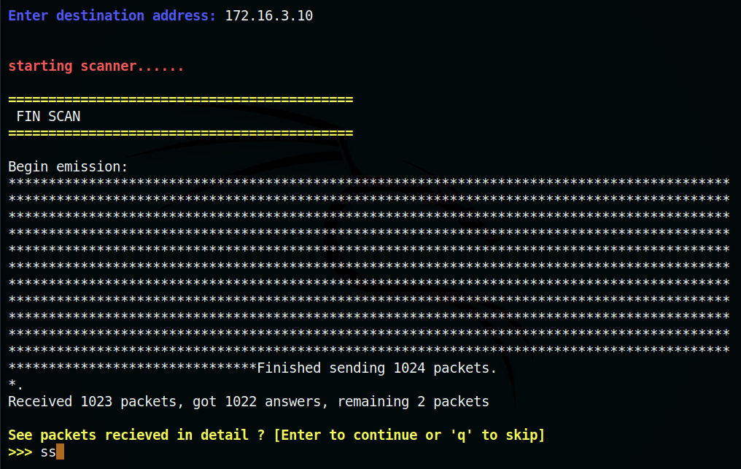

Figure 16. TCP Fin Scan

* Open ports are displayed when scan is completed.

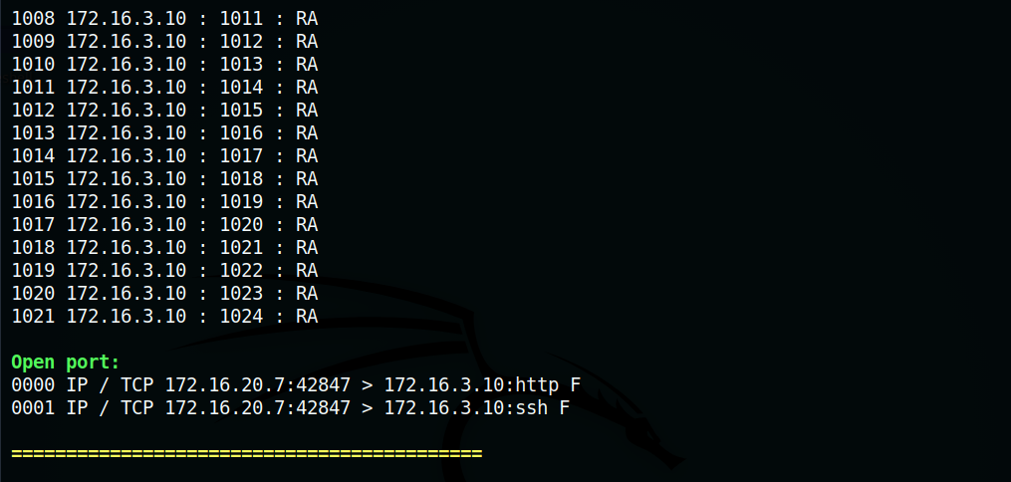

Figure 17. TCP Fin scan Open ports

* IDS Alerts :

1. Snort

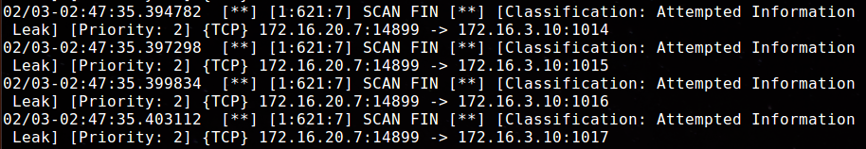

Figure 18. Snort alert – TCP fin scan

2. Suricata

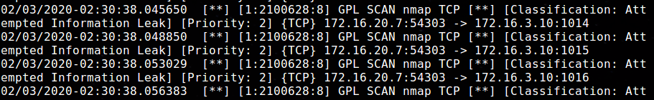

Figure 19. TCP Ack Scan

* Result :

|  |  |
| --- | --- |
| Test Result | Port 80 (http) and port 22 (ssh) are open |
| Snort alert | SCAN FIN |
| Observation (if any) | Snort detected the TCP FIN scan. The alert was classified as attempted information leak. |
| Suricata alert | GPL SCAN nmap TCP |
| Observation (if any) | Suricata detected a TCP nmap scan. The alert was classified as attempted information leak. |

1.4 XMAS scanner

A TCP packet with URG, PSH, FIN flags are sent to each port on target. If there is no response it indicates the port is open. On the contrary, if an RST packet is received, it means the port is closed.

* Test : Perform XMAS scan on gateway router.

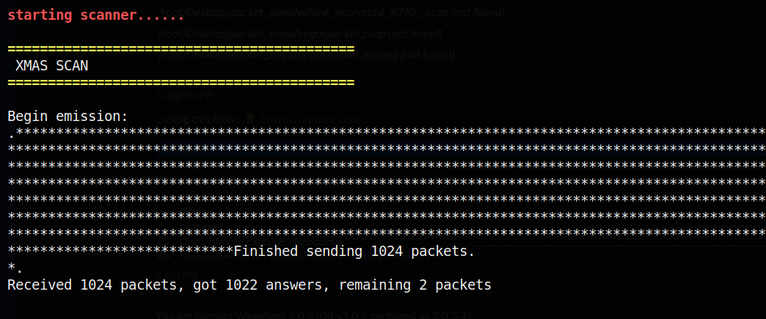

Figure 20. TCP XMAS scan

* No response indicates that port is open.

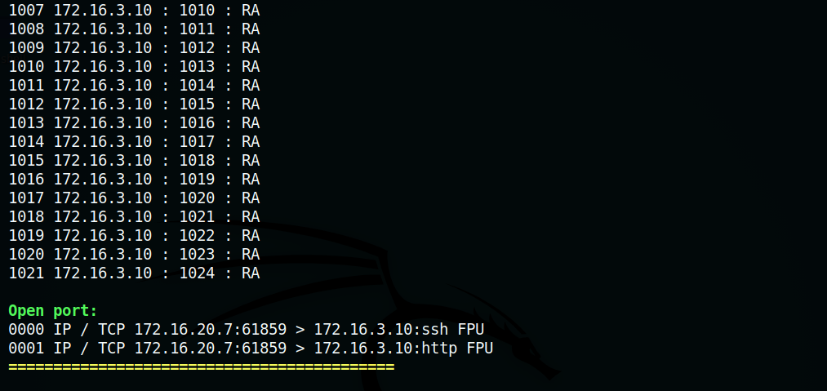

Figure 21. TCP XMAS scan – open ports

* IDS Alerts :

1. Snort

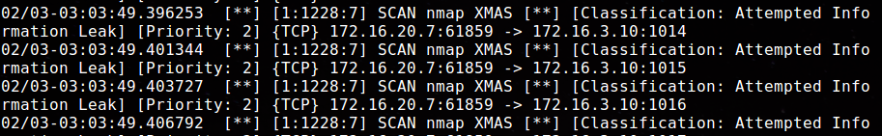

Figure 22. Snort alert – XMAS scan

2. Suricata

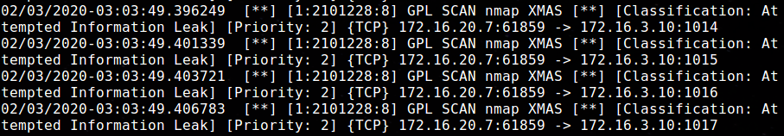

Figure 23. Suricata – XMAS scan

* Result :

|  |  |
| --- | --- |
| Test Result | Port 80 (http) and port 22 (ssh) are open |
| Snort alert | SCAN nmap XMAS |
| Observation (if any) | Snort detected the XMAS scan. The alert was classified as attempted information leak. |
| Suricata alert | GPL SCAN nmap XMAS |
| Observation (if any) | Suricata detected the XMAS scan. The alert was classified as attempted information leak. |

1.5 IP Protocol Scanner

IP protocol scan is used to determine IP Protocols like (ICMP, IGMP, TCP, SCTP) supported by the target machine. Error messages like destination unreachable indicates that port is closed. Ports are considered open or filtered if no response was received.

* Test : Perform IP protocol scan on gateway router.

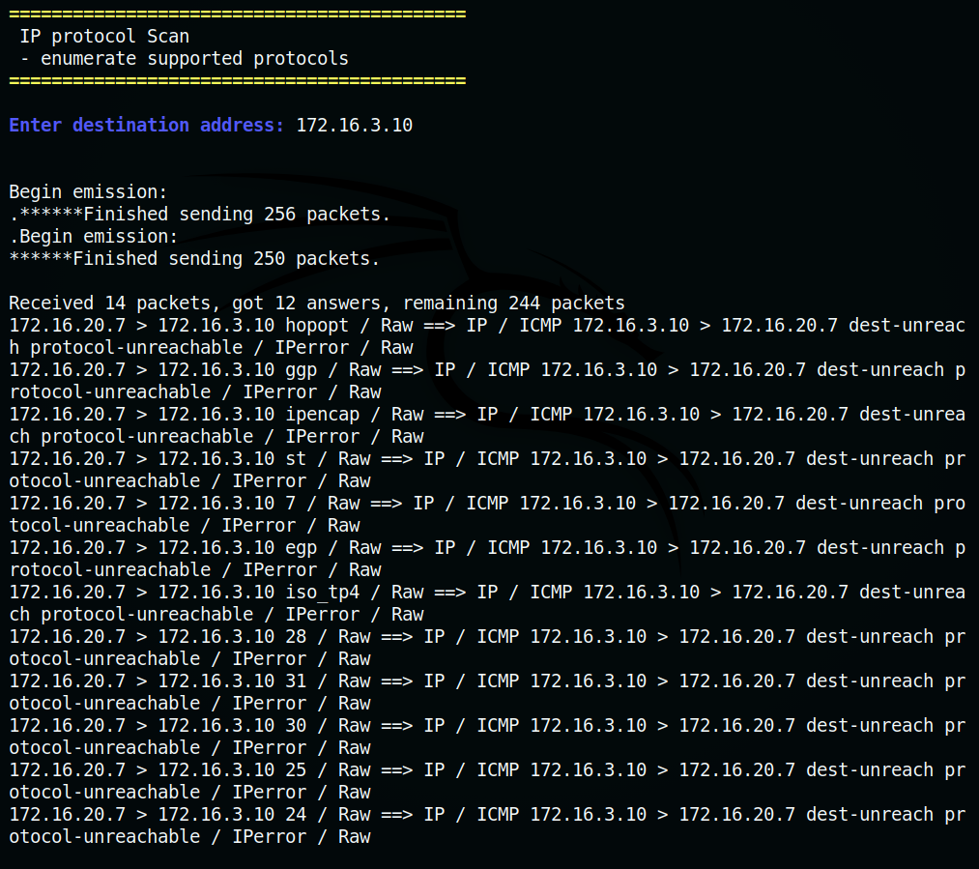

Figure 24. IP proto scan

* Unanswered ports :

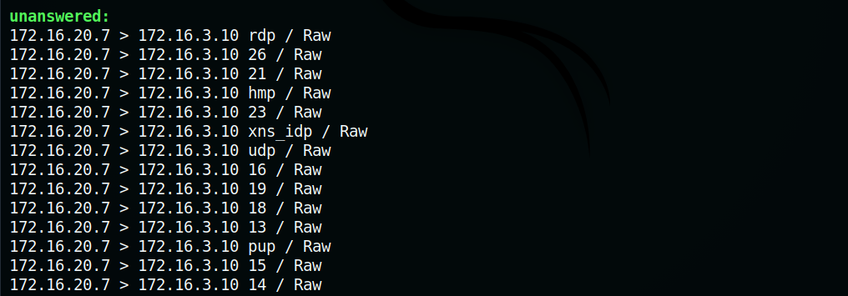

Figure 25. IP proto scan – unanswered ports

* IDS Alerts :

1. Snort

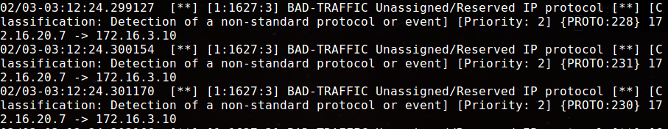

Figure 26. Snort alert – IP proto scan

2. Suricata

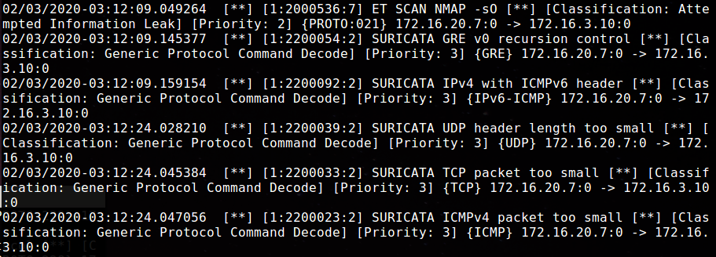

Figure 27. Suricata alert – IP proto scan

* Result :

|  |  |
| --- | --- |
| Test Result | Supported protocols are icmp, igmp, tcp and udp |
| Snort alert | BAD-TRAFFIC Unassigned/Reserved IP protocol |
| Observation (if any) | Snort detected protocol scan. The alert was classified as detection of non-standard protocol or event. |
| Suricata alert | ET SCAN NMAP -sO, GRE v0 recursion control, IPv4 with ICMPv6 header, UDP header length too small, TCP packet too small, ICMPv4 packet too small |
| Observation (if any) | Suricata not only detected the scan, it detected the nmap command for protocol scan. It also detected anomalies in ICMP/IPv4, TCP, UDP packets. It was classified as generic protocol command decode. |

1.6 NULL scanner

Series of TCP packets with no flags and 0 as sequence numbers are sent to the target ports. Since the flags are not set, the target does not know how to respond and discards the packet. No response indicates the port is open. If port is closed, an RST packet is sent back as response.

* Test : Perform NULL scan on gateway router.

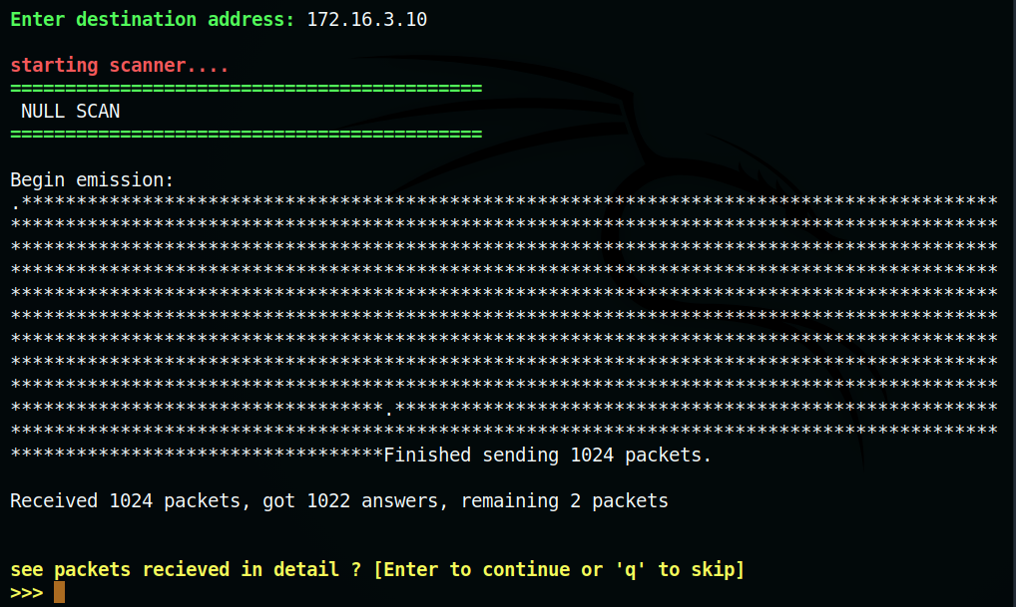

Figure 28. NULL Scan

* Open ports :

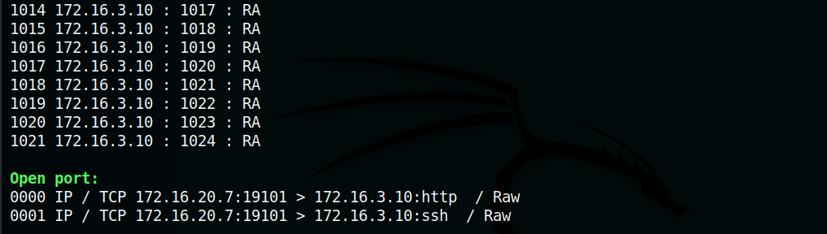

Figure 29. TCP NULL scan – open ports

* IDS Alerts :

1. Snort

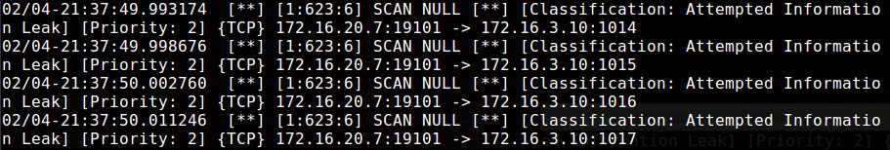

Figure 30. Snort alert – NULL scan

2. Suricata

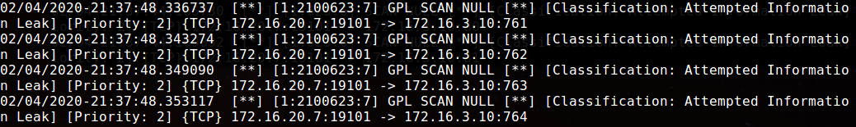

Figure 31. Suricata alert- TCP NULL scan

* Result :

|  |  |
| --- | --- |
| Test Result | Ports 80 (http) and port 22 (ssh) are open |
| Snort alert | SCAN NULL |
| Observation (if any) | Snort detected the null scan and classified it as an attempted information leak. |
| Suricata alert | GPL SCAN NULL |
| Observation (if any) | Suricata also detected the null scan and classified it as an attempted information leak. |

**2. Ping scans**

Ping scans are used to find live hosts in a range of IP addresses. This option contains ARP, ICMP, UDP, TCP ping scans. Note that pressing CTRL-C will skip to the next ping.

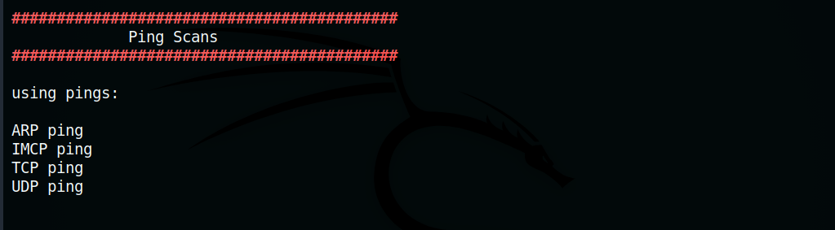

Figure 32. Ping scans

2.1 ARP ping

This ping helps to ping MAC addresses on local area network using ARP packets. The results are verified by arping command.

Test: Perform ARP ping on internal network – 172.16.3.0/24

* + The internal IP address of gateway (172.16.3.10 ) was deplayed.

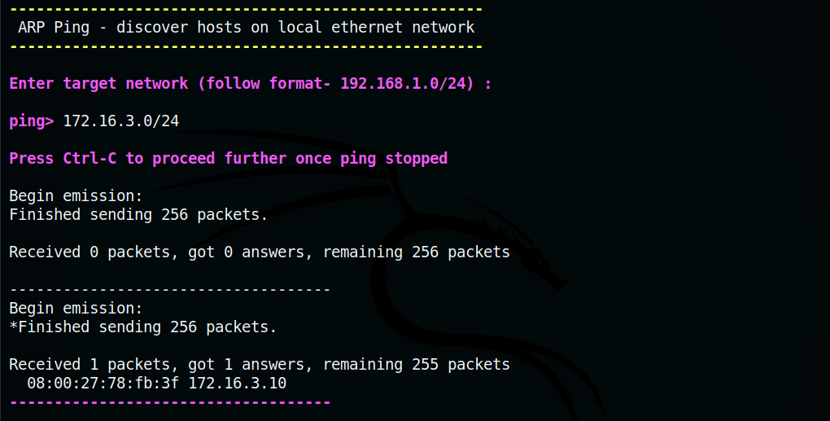

Figure 33. ARP ping

* IDS Alerts :

1. Snort

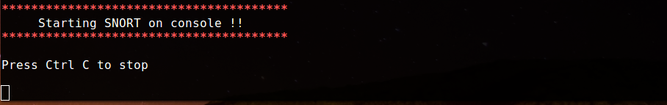

Figure 34. Snort alert – None – Arp ping

2. Suricata

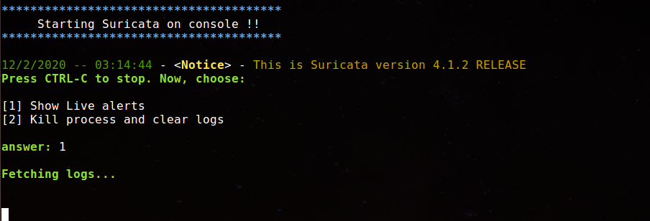

Figure 35. Suricata alert – None – Arp ping

* Result :

|  |  |
| --- | --- |
| Test Result | ARP ping was not detected by both IDS. |
| Snort alert | None |
| Observation (if any) | None |
| Suricata alert | None |
| Observation (if any) | None |

2.2 ICMP ping

This ping sends an ICMP Echo Request packet to the target. If you receive an ICMP Echo Reply, it means the target is reachable. It also allows to determine the time to reach target.

Test: Perform ICMP ping on first 10 subnets of Internal network (172.16.3.1-10)

* + Attacker machine and gateway router (internal interface) were found as alive hosts.

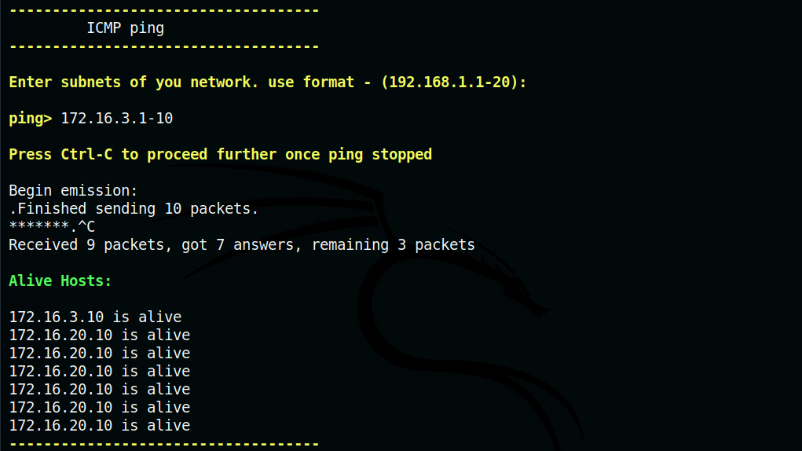

Figure 36. ICMP ping

* IDS Alerts :

1. Snort

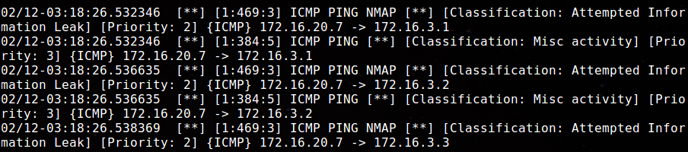

Figure 37. Snort alert- ICMP ping

2. Suricata

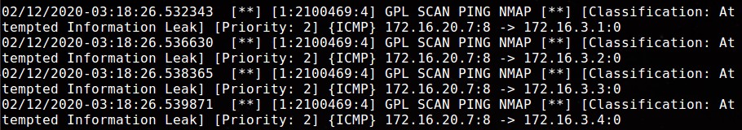

Figure 38. Suricata alert – ICMP ping

* Result :

|  |  |
| --- | --- |
| Test Result | Both IDS were able to detect the ICMP ping. |
| Snort alert | ICMP Ping, ICMP Ping NMAP |
| Observation (if any) | Snort classified the ICMP ping as ‘attempted information leak’ and ‘misc. activity’. |
| Suricata alert | GPL SCAN PING NMAP |
| Observation (if any) | Suricata classified the ping scan as ‘attempted information leak’. |

2.3 TCP ping

This ping uses TCP SYN packet with destination port of 80 (likely to be open) to range of IP addresses. If the target is reachable it sends TCP response packet.

Test: Perform TCP ping on first 10 subnets in the internal network (172.16.3.1-10)

* + Attacker machine and gateway router (internal interface) were found as alive hosts.

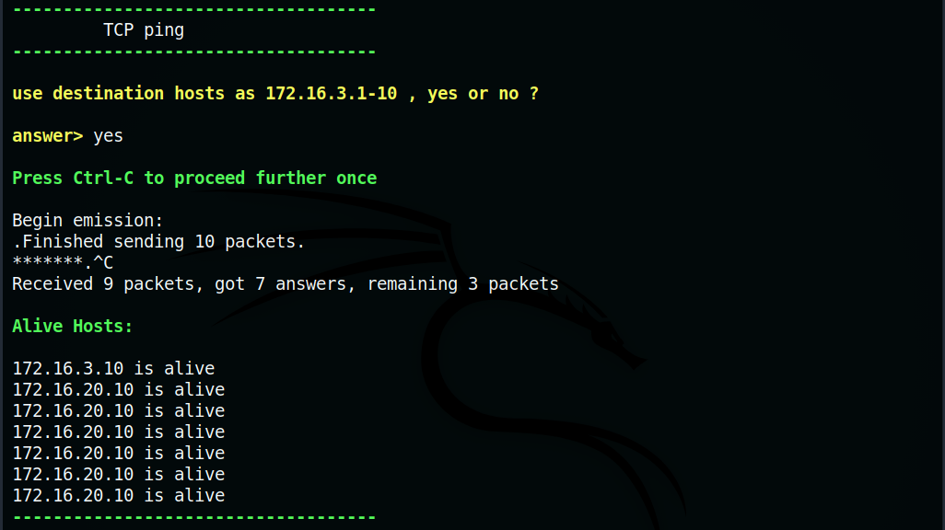

Figure 39. TCP Ping

* IDS Alerts :

1. Snort



Figure 40. Snort alert – None – TCP ping

2. Suricata



Figure 41. Suricata alert – None- TCP ping

* Result :

|  |  |
| --- | --- |
| Test Result | Both IDS were unable to detect the TCP ping. |
| Snort alert | None |
| Observation (if any) | None |
| Suricata alert | None |
| Observation (if any) | None |

2.4 UDP ping

This ping sends a UDP packet to a port likely to be closed in a range of IP addresses. The ping then listens to all incoming ICMP packets. The UDP ping returns a success code and IP address if it receives an ICMP error (destination/port unreachable). If UDP ping did not receive any messages it exits with failure code. Wireshark shows UDP ping and an ICMP error received from host.

Test: Perform UDP ping on first 10 subnets in the internal network (172.16.3.1-10)

* + Attacker machine and gateway router (internal interface) were found as alive hosts.

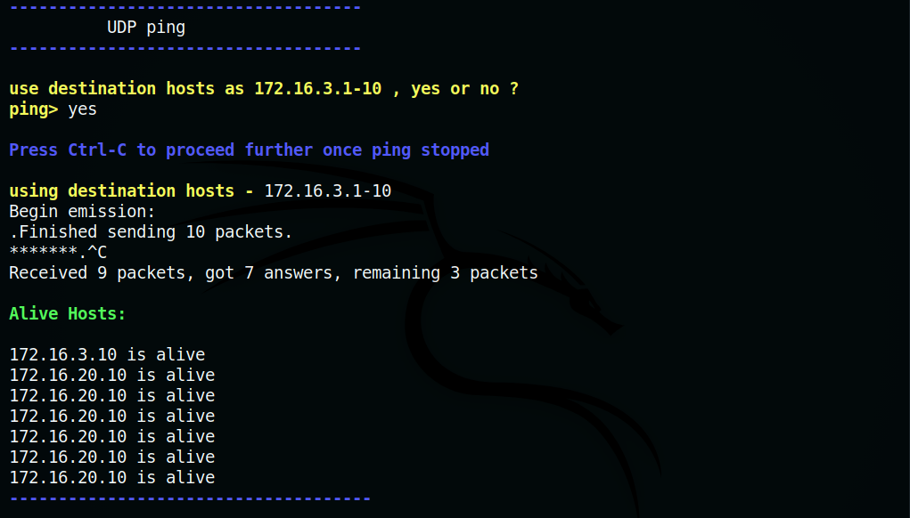

Figure 42. UDP ping

* IDS Alerts :

1. Snort

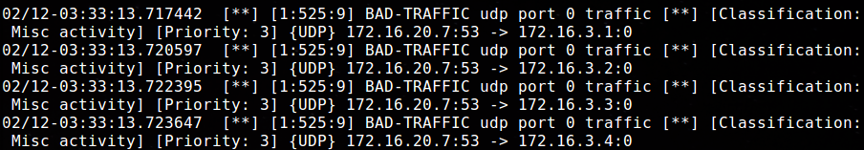

Figure 43. Snort alert – udp ping

2. Suricata



Figure 43. Suricata alert – udp ping

* Result :

|  |  |
| --- | --- |
| Test Result | Since the UDP ping was performed on port 0 on target, Snort was able to detect bad traffic at port 0. |
| Snort alert | BAD TRAFFIC udp port 0 traffic |
| Observation (if any) | Snort classified the UDP ping scan as misc. activity |
| Suricata alert | None |
| Observation (if any) | None |

**3. Classical Attacks**

This option enables crafting packets for the purpose of attacking the target machine. Some of the attacks are focused on outdated systems. Others include DoS, flooded attack and Man-in-the-middle attacks like ARP cache poisoning. Some attacks need multiple compromised hosts to disrupt or crash the target machine (Distributed Denial of Service). Network Packets for these attacks are crafted based on official Scapy documentation. These attacks should be performed only for testing Intrusion Detection System’s ability to foresee network attacks.

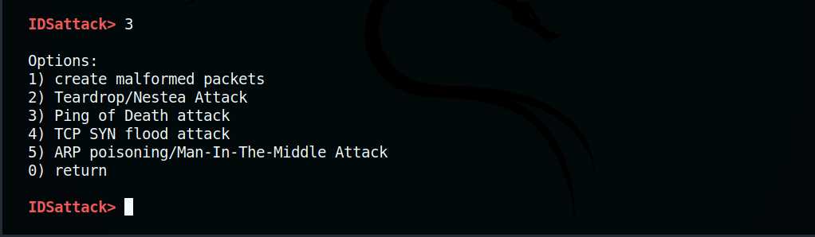

Figure 42. TCP Ack Scan

3.1 Malformed packets

Malformed packet attack is an outdated denial of service attack technique where malformed packets are crafted to crash or degrade performance in the target system.

Test: Send malformed packets to the target.

* + Here, malformed IP packets with wrong IP version (3) were generated and sent to target.

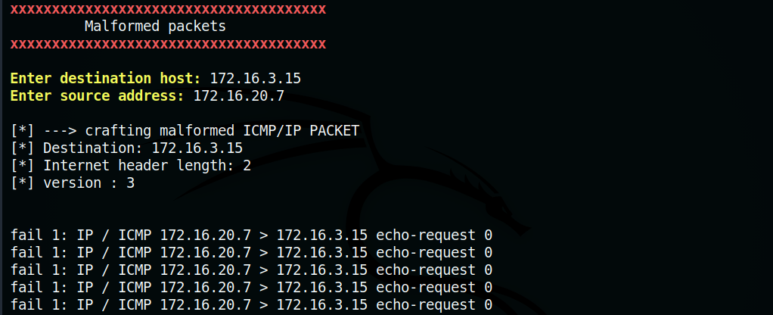

Figure 43. Malformed packets

* IDS Alerts :

1. Snort



Figure 44. Snort-alert – None – Malformed packets

2. Suricata

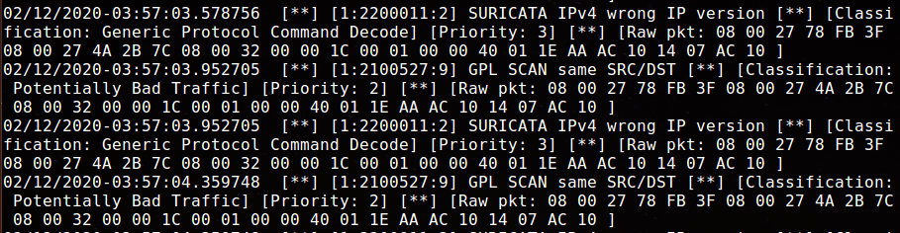

Figure 45. Suricata alerts – malformed packets

* Result :

|  |  |
| --- | --- |
| Test Result | Suricata detected the malformed packets and the wrong IP version. |
| Snort alert | None |
| Observation (if any) | None |
| Suricata alert | IPv4 wrong IP version |
| Observation (if any) | Suricata classified alert as generic protocol command decode. |

3.2 Teardrop Attack

Teardrop attack or overlapping fragment attack exploits the fragmentation offset field in IP packet. Overlapping Fragmented packets are created and sent to the target making them unable to reassemble the fragments and eventually crash. This attack is targeted towards older operating systems like Windows 3.1x, Windows 95, Windows NT and Linux kernel version before 2.1.63.

Test: Start Netcat Listener on target and perform teardrop attack on target. Target may not be affected if OS is not outdated.

* + Packets with overlapping fragments were sent to target.

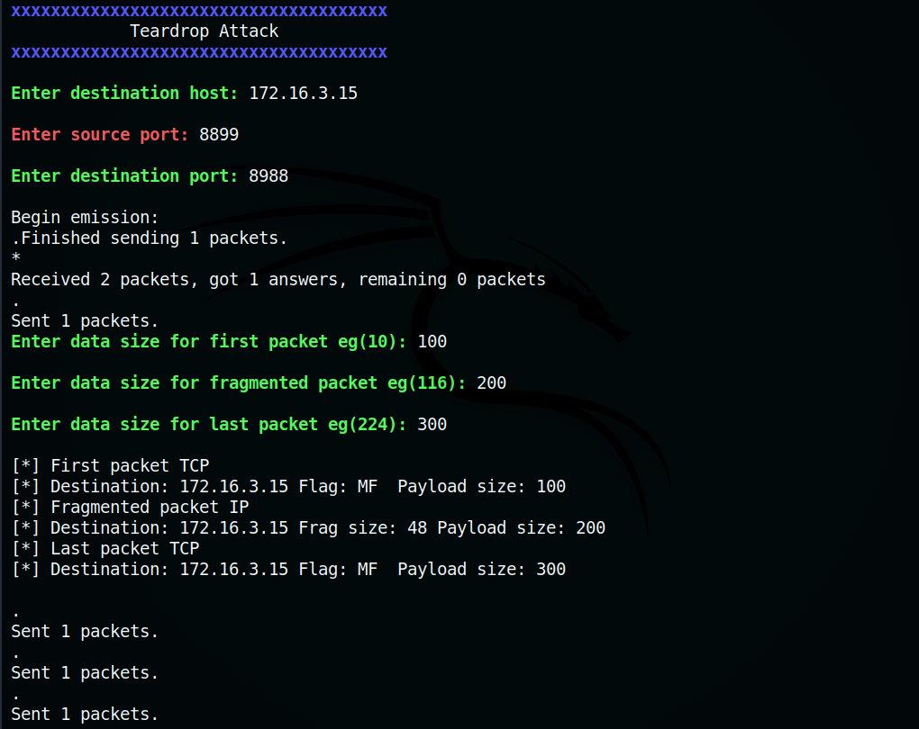

Figure 46. Teardrop attack



Figure 47. Craft – teardrop attack

* IDS Alerts :

1. Snort



Figure 48. Snort alerts – none- teardrop attack

2. Suricata

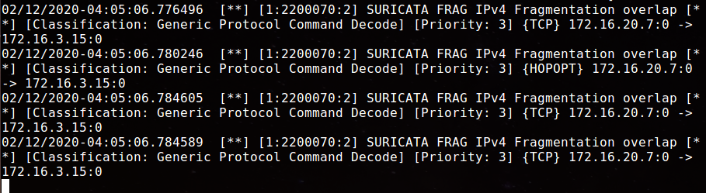

Figure 49. Suricata alerts – teardrop attack

* Result :

|  |  |
| --- | --- |
| Test Result | Suricata detected the overlapped fragments. The target was unaffected by the DoS attack since its Linux kernel was updated |
| Snort alert | None |
| Observation (if any) | None |
| Suricata alert | FRAG IPv4 Fragmentation overlap |
| Observation (if any) | Suricata classified alert as generic protocol command decode. |

3.3 Ping of Death

Ping of death is an outdated DOS attack where packet larger than maximum allowable size - 65,535 bytes causing target to crash. Systems and devices created after 1998 are not generally affected by this attack.

Test: Create large ICMP packet and send to router. (Press Ctrl-C to stop the ping)

* + Large ICMP ping sent to target.

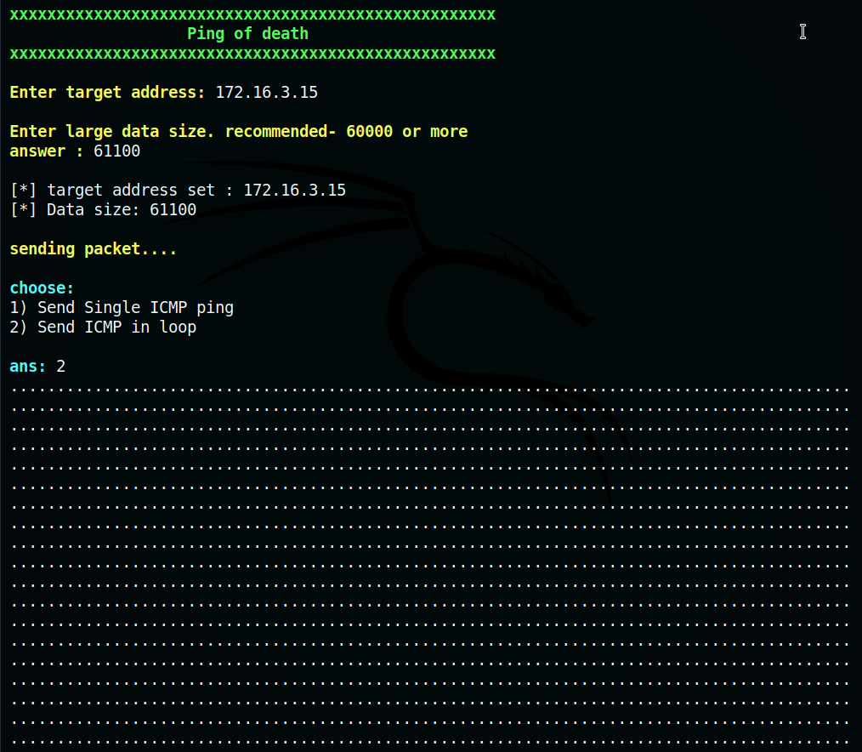

Figure 50. Ping of death attack

* + IDS Alerts :

1. Snort

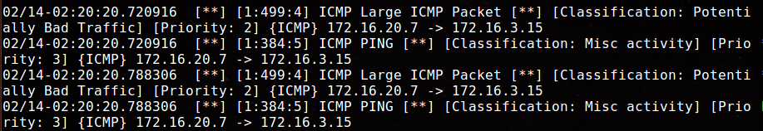

Figure 51. Snort alerts- Ping of death

2. Suricata

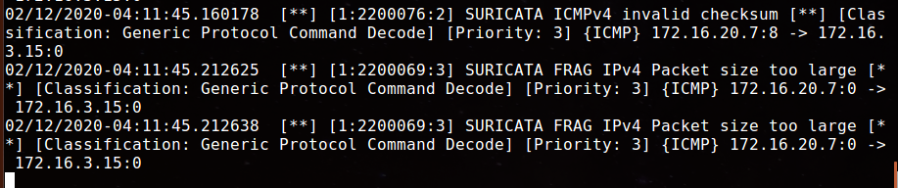

Figure 52. Suricata alerts- Ping of death

* Result :

|  |  |
| --- | --- |
| Test Result | Both Snort and Suricata detect large IPv4 packet. |
| Snort alert | ICMP Large ICMP packet |
| Observation (if any) | Snort detected the large ICMP packet. Alert was classified under misc. activity. |
| Suricata alert | ICMPv4 invalid checksum, FRAG IPv4 Packet size too large |
| Observation (if any) | Suricata detected large IPv4 packet with invalid icmpv4 checksum. |

3.4 TCP SYN flood attack

This is a Denial of Service attacker where SYN packets are sent to every or single port on target system. The target responds with SYN+ACK packets to all requests from open ports but does not receive ACK packets in return from attacker. These packets can flood, crash the system and deny legitimate service to clients.

Test : Generate and send TCP SYN packets to the target.

* + Netcat listener was started on a port at the target.

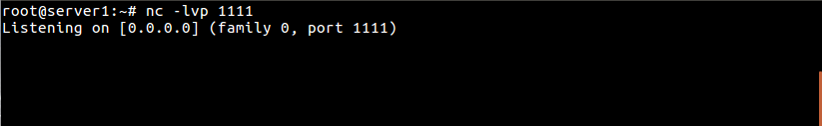

Figure 53. SYN flood attack – Netcat

* + SYN packets were crafted with common id

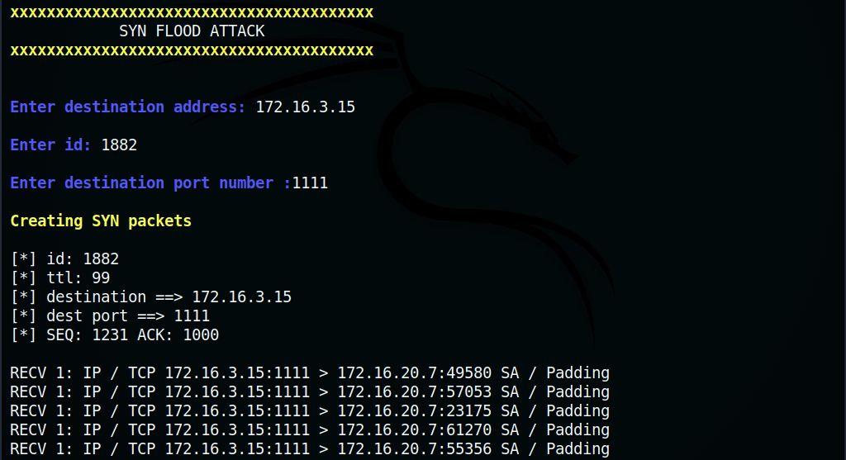

Figure 54. SYN flood attack

* + Created SYN packets were sent to target.



Figure 55. Crafting syn packets

* + IDS Alerts :

1. Snort

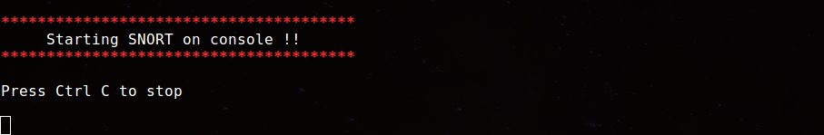

Figure 56. Snort alerts – none – syn flood

2. Suricata

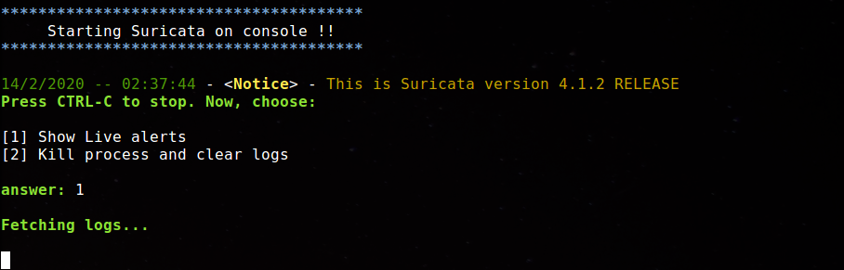

Figure 57. Suricata alerts- none -syn flood

* Result :

|  |  |
| --- | --- |
| Test Result | Both IDS did not detect the SYN packets |
| Snort alert | None |
| Observation (if any) | None |
| Suricata alert | None |
| Observation (if any) | None |

3.5 ARP Cache Poisoning

ARP cache poisoning is a man in the middle attack where an attacker sends spoofed ARP packets in a local area network. The false ARP packets associates the mac address of the attacker with IP address of a target machine. So incoming traffic for target will be redirected to the attacker allowing the attacker to intercept traffic between target and gateway (or another machine in the LAN). In the test case, an attacker machine remotely controls a client inside the network to perform ARP cache poisoning. Target machine starts echo server and gateway router sends random plain text messages through an echo client *(Please refer to figure in appendix A4, page 114)*.

Test : Use Packet Ninja’s arp poisoning feature (DEFALT, 2015) on client to sniff traffic between router and server and find plain text messages.

* + ARP table of router was observed before attack.

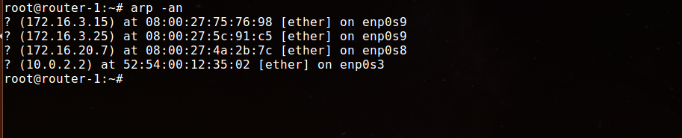

Figure 60. MAC address of internal hosts

* + ARP venom was started to redirect traffic from server to gateway and vice versa through client.

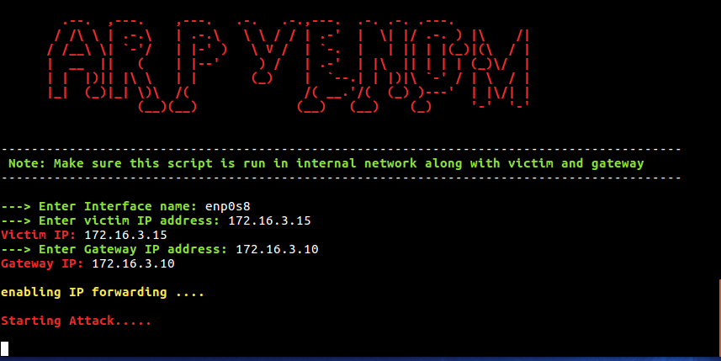

Figure 61. ARP venom (packet ninja)

* + ARP table of router were displayed again. It can be observed that the MAC address of server and client were same.

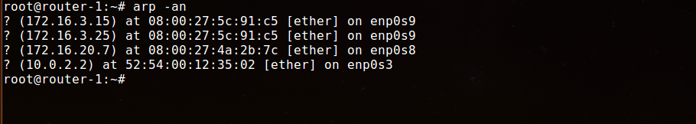

Figure 62. Same MAC address in 2 hosts

* + Netcat session was started at router and server and plain text messages were sent.

1. Router

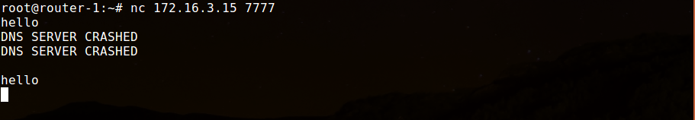

Figure 63. Sending messages with Netcat

2. Server

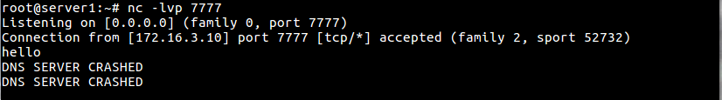

Figure 64. Receiving messages at server

* + ARP venom was stopped by pressing CTRL-C.

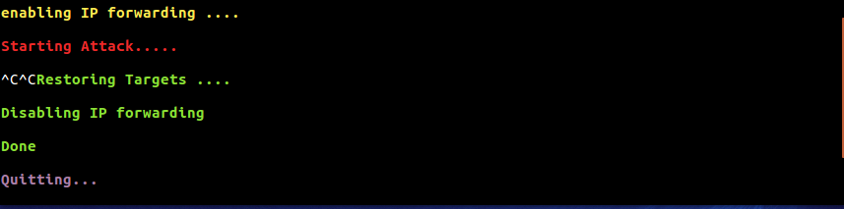

Figure 65. Restoring IP addresses

* + A new pcap file was created at client. It contained the messages sent from gateway router to server.

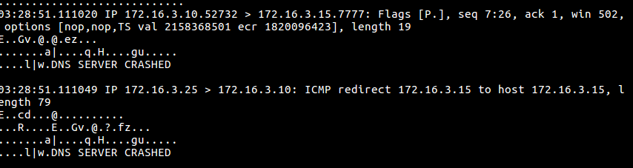

Figure 66. Intercepted messages in pcap file

* IDS Alert :

1. Snort



Figure 67. Snort alerts- None- arp poisoning

2. Suricata



Figure 68. Suricata alerts- none -arp poisoning

* Result :

|  |  |
| --- | --- |
| Test Result | Both IDS did not detect ARP poisoning and redirection of traffic. |
| Snort alert | None |
| Observation (if any) | None |
| Suricata alert | None |
| Observation (if any) | None |

**4. Advanced Tracerouting**

This option includes ICMP traceroutes and other advanced traceroutes using TCP and UDP. It also checks for info leaks in packets due to incorrect handling of frame padding or bugs in TCP/IP stack.

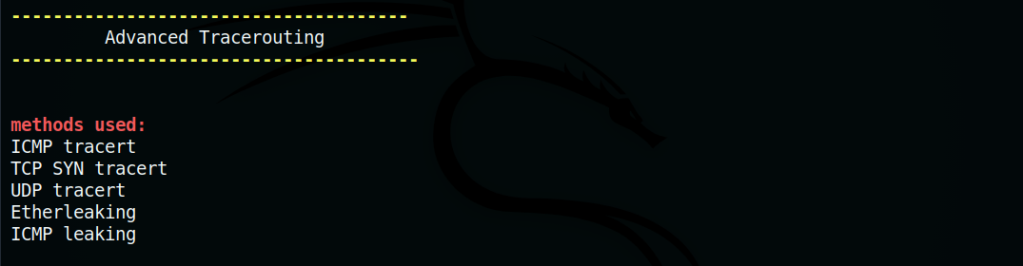

Figure 69. Tracerouting

4.1 ICMP traceroute

ICMP Echo packets are sent to the target. The Time to live value increases by each packet sent. The traceroutes ends with the timeout value (here, 5 seconds).

Test : Perform ICMP traceroute on server.

* + ICMP traceroute was performed at destination port 53 in 5 second timeout.

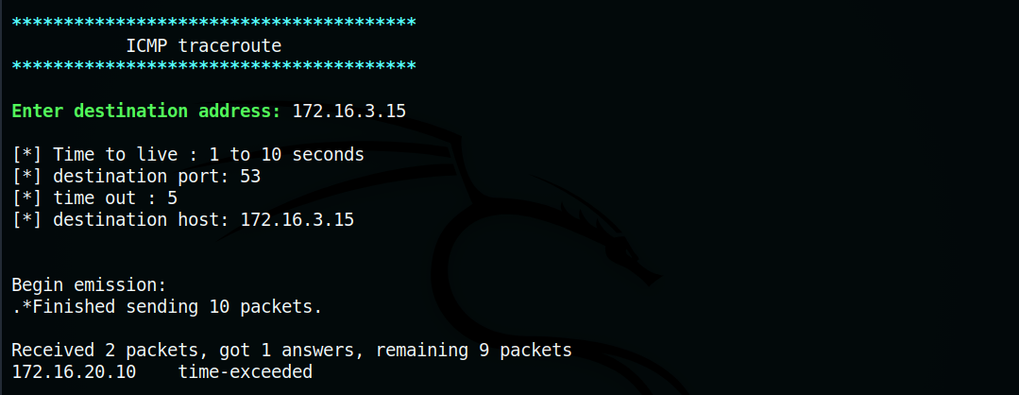

Figure 70. ICMP traceroute

* IDS Alert :

1. Snort

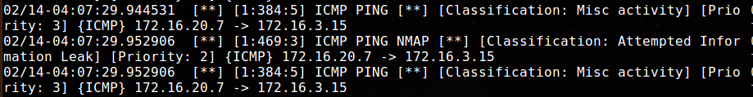

Figure 71. Snort alerts – ICMP traceroute

2. Suricata

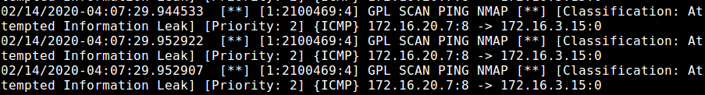

Figure 72. Suricata alerts- ICMP traceroute

* Result :

|  |  |
| --- | --- |
| Test Result | Traceroute revealed the route from attacker to server as 172.16.20.7 🡪 172.16.20.10 🡪 172.16.3.15  Snort and Suricata was able to detect the ICMP packets sent to server. |
| Snort alert | ICMP Ping, ICMP PING NMAP |
| Observation (if any) | Snort classified the alert as attempted information leak and misc. activity. |
| Suricata alert | GPL SCAN PING NMAP |
| Observation (if any) | Suricata also classified the alert as attempted information leak |

4.2 TCP traceroute

TCP traceroute is a traceroute implementation where TCP SYN packets are sent to a target. The time to live value increases by each packet sent. The trace ends with timeout value set. (here, timeout is set to 5 seconds).

Test : Perform TCP traceroute on the server.

* + TCP SYN traceroute was performed on server in 5 second timeout.

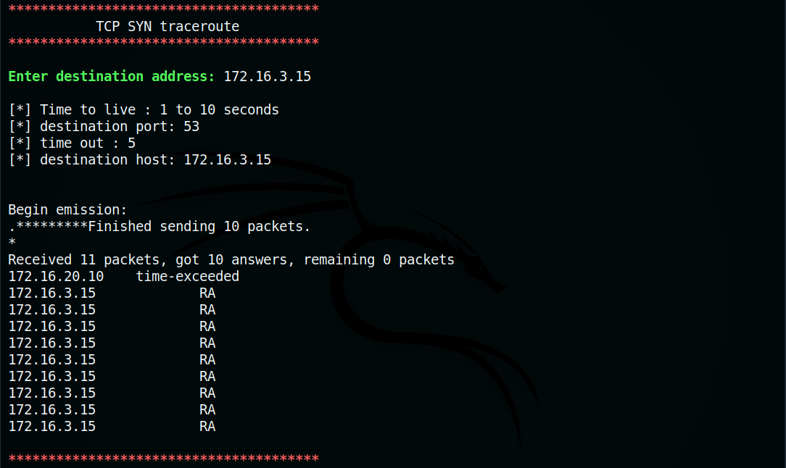

Figure 73. TCP SYN traceroute

* IDS Alerts :

1. Snort

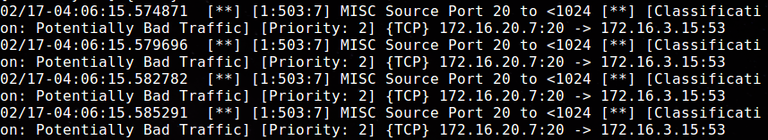

Figure 74. Snort alerts – TCP traceroute

2. Suricata



Figure 75. Suricata alerts – TCP traceroute

* Result :

|  |  |
| --- | --- |
| Test Result | Traceroute revealed the route from attacker to server as 172.16.20.7 🡪 172.16.20.10 🡪 172.16.3.15 |
| Snort alert | MISC source port 0 to <1204 |
| Observation (if any) | Snort detected miscellaneous traffic between port 0 and port 1024. It was classified as potentially bad-traffic. |
| Suricata alert | None |
| Observation (if any) | None |

4.3 UDP traceroute

A UDP datagram is sent to target with increasing TTL value. If it's close to the target, destination/port unreachable error is generated and ends the trace. Since UDP is not reliable and does not perform handshake like TCP, an applicative payload like DNS is given to the UDP datagram.

Test : Perform UDP traceroute on server.

* + UDP packets (DNS queries) were sent to server on 5 seconds timeout.

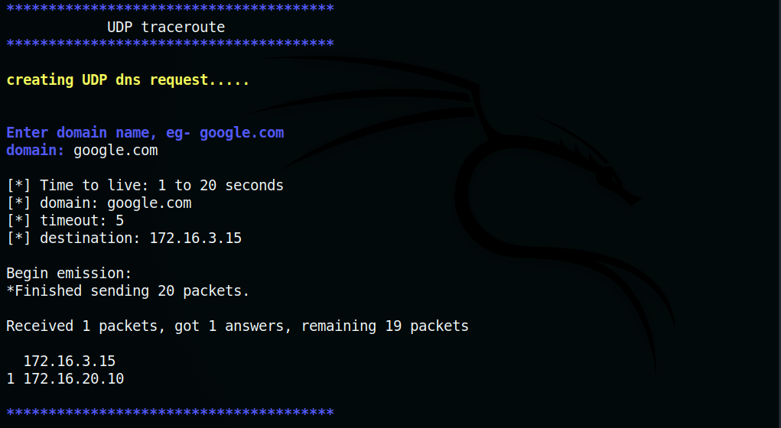

Figure 76. UDP traceroute

* + IDS Alerts :

1. Snort



Figure 77. Snort alerts – UDP traceroute

2. Suricata



Figure 78. Suricata alerts- UDP traceroute

* Result :

|  |  |
| --- | --- |
| Test Result | Traceroute revealed the route from attacker to server as 172.16.20.7 🡪 172.16.20.10 🡪 172.16.3.15 |
| Snort alert | None |
| Observation (if any) | None |
| Suricata alert | None |
| Observation (if any) | None |

4.4 Ether Leak

NIC device drives may handle frame padding incorrectly exposing information about previously transmitted packets or kernel memory. This can be checked by sending ICMP echo and observing the packet’s padding.

Test: Perform Ether leak test on server/target.

* + ICMP echo was sent to server. It was observed that the padding of the reply packet was empty.

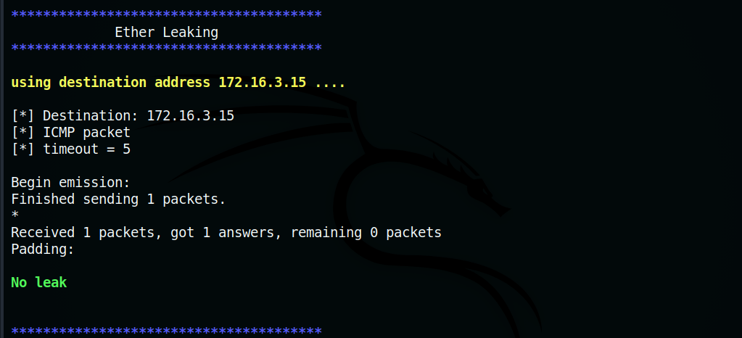

Figure 79. Ether leak

* + IDS Alerts :

1. Snort

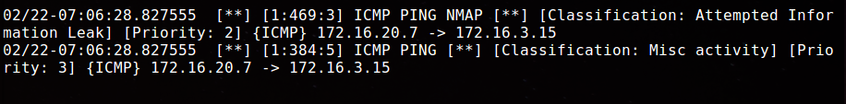

Figure 80. Snort alerts- ether leak

2. Suricata

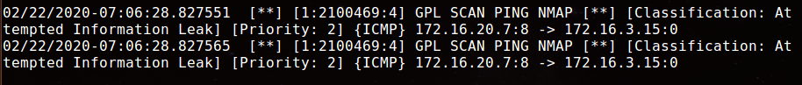

Figure 81. Suricata alerts – ether leak

* Result :

|  |  |
| --- | --- |
| Test Result | No leak was detected. |
| Snort alert | ICMP PING NMAP, ICMP PING |
| Observation (if any) | The snort alerts were detected as attempted information leak and misc. activity |
| Suricata alert | GPL SCAN PING NMAP |
| Observation (if any) | The Suricata alerts were detected as attempted information leak |

4.5 ICMP Leak

Due to a bug in TCP/IP stack in Linux 2.0, ICMP Error message contains fragments of kernel memory.

Test: Perform ICMP leak test on server/target.

* + ICMP packet was crafted to receive an ICMP error message

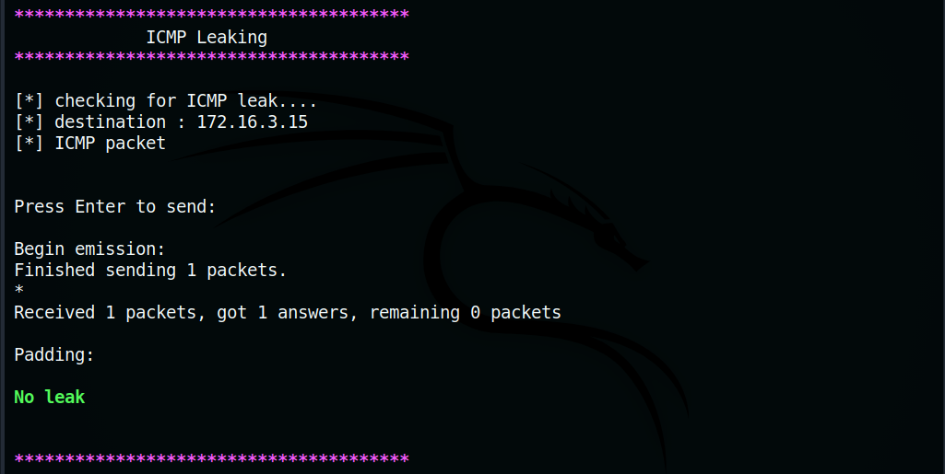

Figure 82. ICMP leaking

* + The received ICMP error messages were found to be empty



Figure 83. ICMP leak result

* + IDS Alerts:

1. Snort

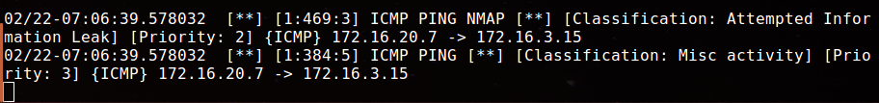

Figure 84. Snort alerts – ICMP leak

2. Suricata

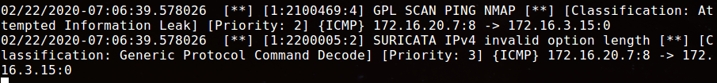

Figure 85. Suricata alerts- ICMP leak

* Result :

|  |  |
| --- | --- |
| Test Result | No leak was detected. |
| Snort alert | ICMP PING NMAP, ICMP PING |
| Observation (if any) | The snort alerts were detected as attempted information leak and misc. activity |
| Suricata alert | GPL SCAN PING NMAP, SURICATA IPv4 invalid option length |
| Observation (if any) | The Suricata alerts were detected as attempted information leak |

## 2. IDS Evasion testing

This section helps to test vulnerabilities in the IDS. It can deploy different evasion techniques to trick signature-based IDS into accepting a crafted packet with malicious payload. Ambiguities in the TCP/IP stack, signature detection capability, fragment/stream reassembly are exploited to perform IDS evasion.

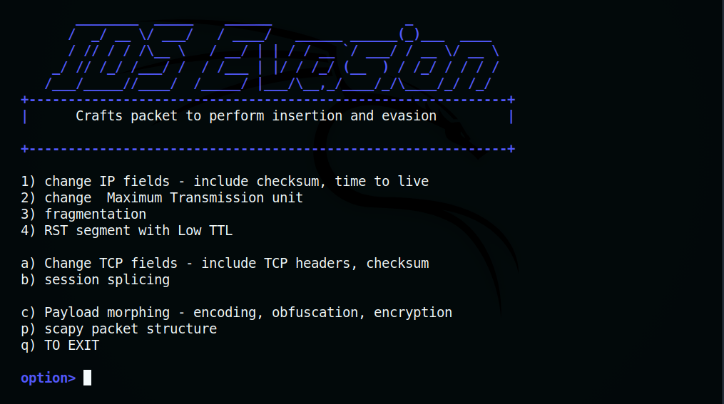

Figure 86. Evasion techniques

2.1 Changing IPv4 header

Manipulating IPv4 header fields like TTL field, IP checksum can lead to insertion/evasion attacks.

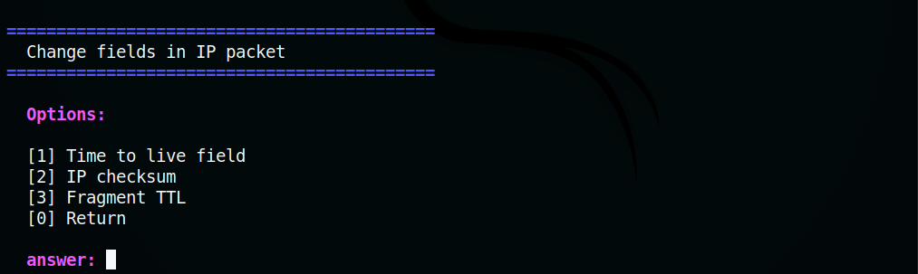

Figure 87. Change fields in packets

Invalid value in the header field can cause the packet to drop out before reaching the destination. This can be used to create a payload indifference at the router and server thus evading detection.

2.1.1 Low TTL Value

Set in the IP header, Time to live value or the hop limit is reduced at every router on route to destination. The maximum value for TTL is 255 and the default value is 64 seconds. When the ttl is reduced to zero, the packet will be dropped.

Test : Use Low TTL evasion technique on target/server

* + Netcat listener was started on a port at the server.

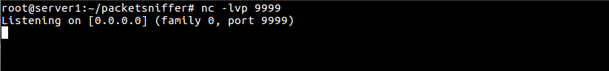

Figure 88. Low ttl value - netcat

* + Three packets were sent to destination. The first packet had payload – **cat**. The second packet that contained a bogus payload also had a low time to live value so that the latter does not reach the destination. The third packet has payload - **/etc/passwd**. In this scenario, there is only one router/IDS between attacker and target host. So, the TTL is set to 1.

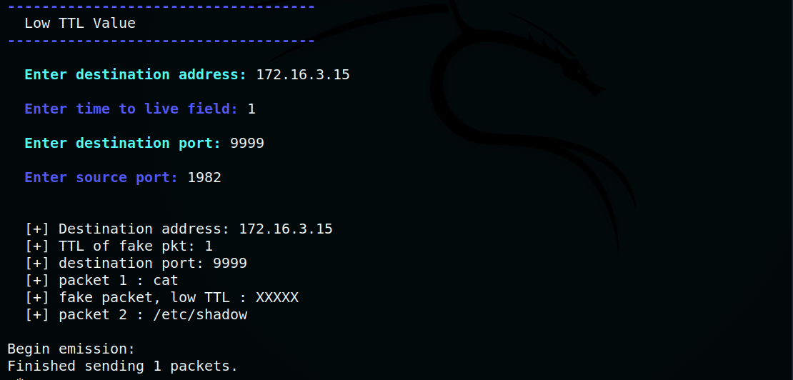

Figure 57. Low TTL attack

* + At the server, the TCP packets were reassembled to form payload – **cat /etc/shadow**.

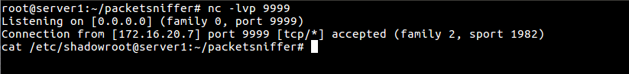

Figure 90. Payload reassembled – low ttl

* + IDS Alerts :

1. Snort



Figure 91. Snort alerts – low TTL

2. Suricata

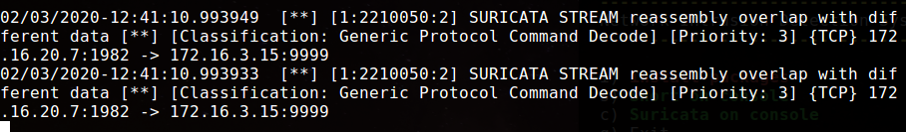

Figure 92. Suricata alerts – Low TTL

* + Result :

|  |  |
| --- | --- |
| Test Result | The payload was reassembled at the target evading detection. |
| Snort alert | None |
| Observation (if any) | None |
| Suricata alert | STREAM reassembly overlap with different data |
| Observation (if any) | Suricata detected an overlap due to different data during stream reassembly. |

2.1.2 Change IP checksum

Invalid packets are crafted with corrupted IP checksum. IP checksum is a 16-bit number computed from information in packet. Destination will not accept a packet with corrupted checksum, but IDS may consider it as part of stream. This can be exploited to perform insertion attacks.

Test: Use custom IP checksum on a packet to perform insertion attack.

* + Netcat listener was started on a port at the target/server.

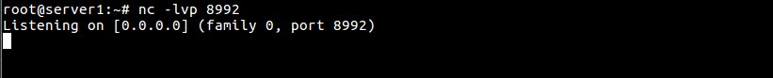

Figure 93. Change IP checksum

* + Three packets were sent to destination. First packet had payload - **cat /etc/.** Second packet had corrupted IPv4 checksum and a false payload. The third packet contained rest of payload - **shadow**.

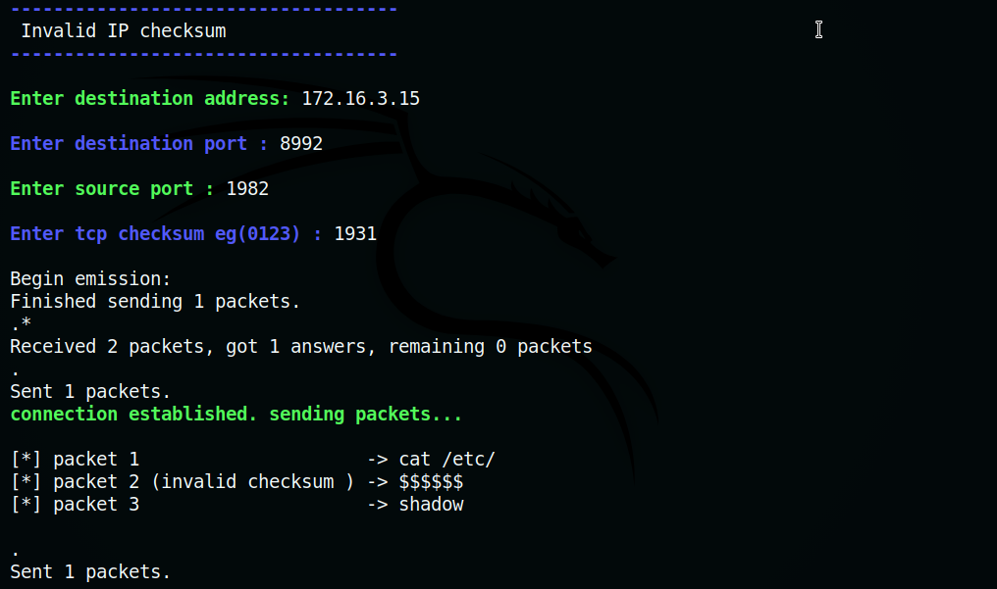

Figure 94. Craft packets with invalid checksum

* + At the server, the TCP packets were reassembled to form payload – **cat /etc/shadow**.

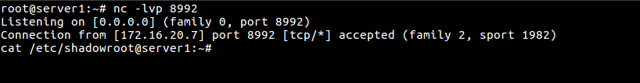

Figure 95. payload reassembled

* + IDS Alerts :

1. Snort

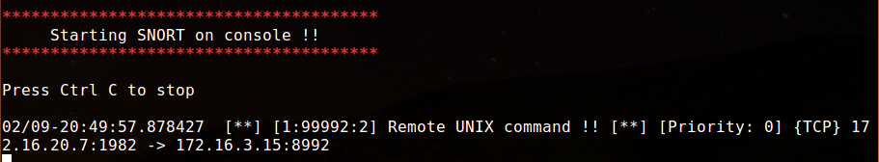

Figure 96. Snort alerts – invalid checksum

2. Suricata

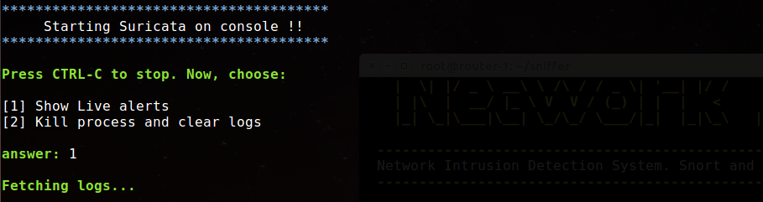

Figure 97. Suricata alerts- invalid checksum

* + Result :

|  |  |
| --- | --- |
| Test Result | Snort was able to detect the payload. |
| Snort alert | Remote UNIX command |
| Observation (if any) | Snort ignored the packet with invalid checksum and reassembled payload. |
| Suricata alert | None |
| Observation (if any) | None |

2.1.3 Fragment TTL

Set in the IP header, Time to live value or the hop limit is reduced at every router on route to destination. Packet with malicious payload can be split into fragments. A bogus fragment can be dropped between router and destination by setting a lower TTL value. Then the IDS will be forced to reassemble the bogus fragment along with real fragments evading signature detection.

Test: Use Fragment TTL method to evade IDS.

* + Netcat listener was started at a port on target/server.

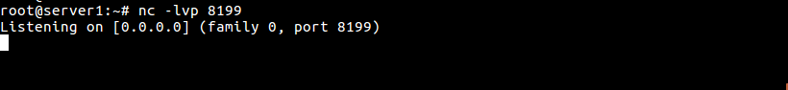

Figure 98. Fragment TTL- Netcat

* + Three fragments were sent to the target. First and third fragment had real payload – **cat /etc/shadow**. The second fragment has bogus payload and its TTL is set to 1. (since there is only one router between attacker and target)

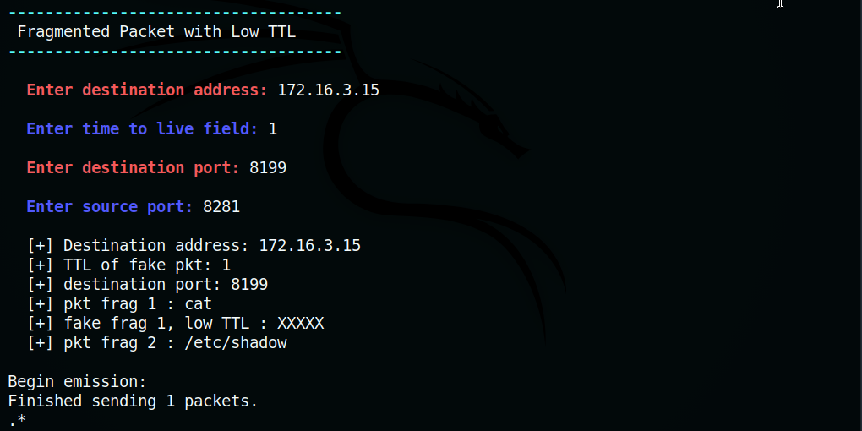

Figure 99. Fragmented TTL

* + At the target/server, TCP packets were reassembled to form payload – **cat /etc/shadow.**

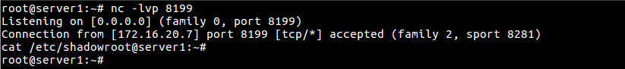

Figure 100. payload reassembled – fragment TTL

* + IDS Alerts :

1. Snort

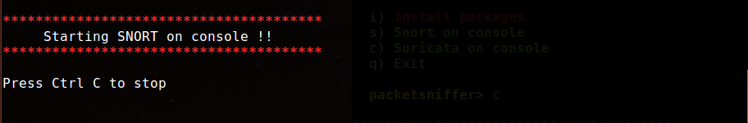

Figure 101. Snort alerts – fragment TTL

2. Suricata



Figure 102. Suricata alerts – fragment TTL

* + Result :

|  |  |
| --- | --- |
| Test Result | Both Suricata and Snort were unable to detect the payload. Payload was reassembled at target evading detection. |
| Snort alert | None |
| Observation (if any) | None |
| Suricata alert | None |
| Observation (if any) | None |

2.2 Changing Maximum Transmission Unit

Largest data unit that can be transferred from an interface is maximum transmission unit. If there is a difference in MTU from attacker to IDS and IDS to target, insertion/evasion attack can be performed. This method may not be applicable for some environment since current Ethernet MTU is set a standard value.

Test: Use this method to perform evasion attack.

* Netcat Listener started on target/server.



Figure 103. Change MTU - Netcat

* Change MTU from router to target to lower value eg 400

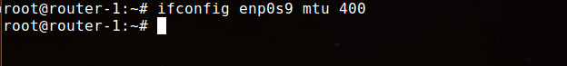

Figure 104. Changing MTU

* + Three packets were sent. First and third packet had payload – **cat /etc/shadow**. The MTU between attacker and router is 1500 bytes by default and the MTU between router and target is 400 bytes. The second packet had bogus payload of size more than 400 bytes. The second packet did not reach the server. The IDS reassembled 3 packets whereas the server reassembled the first and third packets.

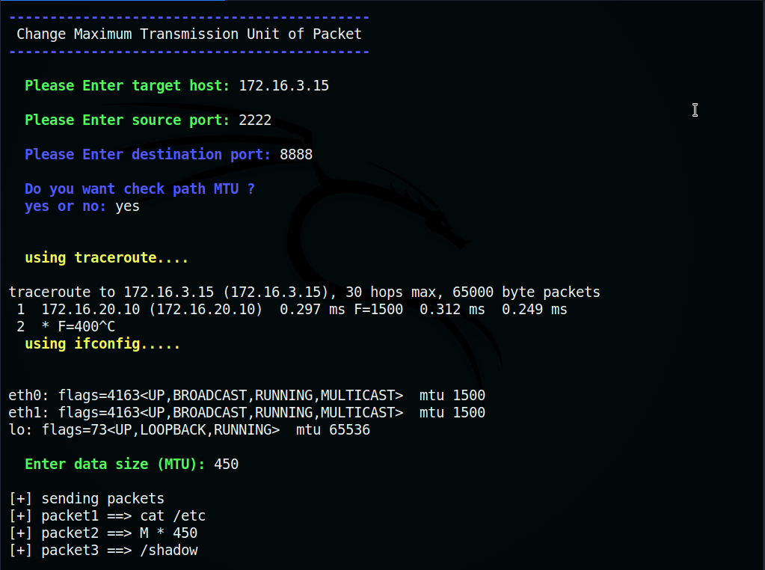

Figure 105. Checking MTU



Figure 106. Change MTU – sending payload

* + At the target, packets were reassembled to form payload.

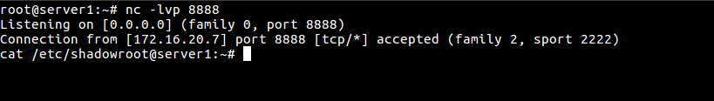

Figure 107. payload reassembled – change MTU

* IDS Alerts :

1. Snort

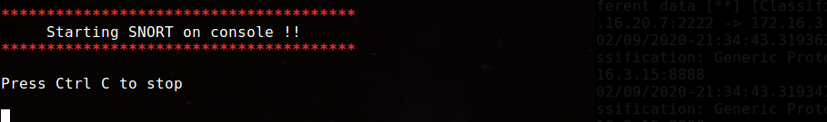

Figure 108. Snort alerts – none- change MTU

2. Suricata

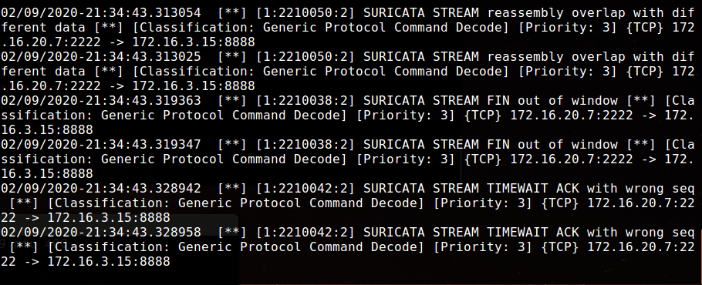

Figure 109. Suricata alerts- change MTU

* Result :

|  |  |
| --- | --- |
| Test Result | Both Suricata and Snort were unable to detect the payload. Payload was reassembled at target evading detection. |
| Snort alert | None |
| Observation (if any) | None |
| Suricata alert | STREAM reassembly overlap with different data, STREAM FIN out of window, STREAM TIMEWAIT ACK with wrong seq |
| Observation (if any) | Suricata detected an overlap due to different data during stream reassembly, difference in Window size at FIN packet and wrong sequence in ACK packet. |

2.3 Fragmentation (Reassembly timeout)

Fragment reassembly countdown starts when host receiving first fragment of a packet. Received fragments at the host are discarded if all fragments are received in reassembly time period. Reassembly timeout differences in IDS and host is exploited in this technique. Here, a fragment with false payload is sent with timeout of 60 seconds. Since default timeout for Linux is 30 seconds, the host drops the fragments, but it remains in the IDS buffer. Then, rest of fragments with real payload are sent. These fragments will reassemble properly at the host but will join the fragment with false payload at IDS buffer. So, the IDS will not able to detect the signature.

Test: Use fragmentation to evade IDS detection.

* Netcat listener is started on a port at target/server.

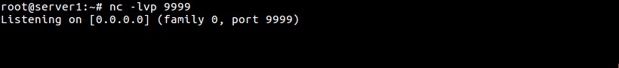

Figure 110. Netcat – fragment timeout

* Here, bogus payload is – **/xxx/shadow**. Real payload used is a Unix command – **cat /etc/shadow**. After establishing session, TCP packet with data – **cat** was sent. Then fragment with bogus payload was sent in 60 seconds. The victim received fragment and dropped it. The fragment remained on the IDS buffer. Then fragment with real payload was sent. Victim received **/shadow** from first fragment and **/etc/** from second fragment to form **/etc/shadow**.

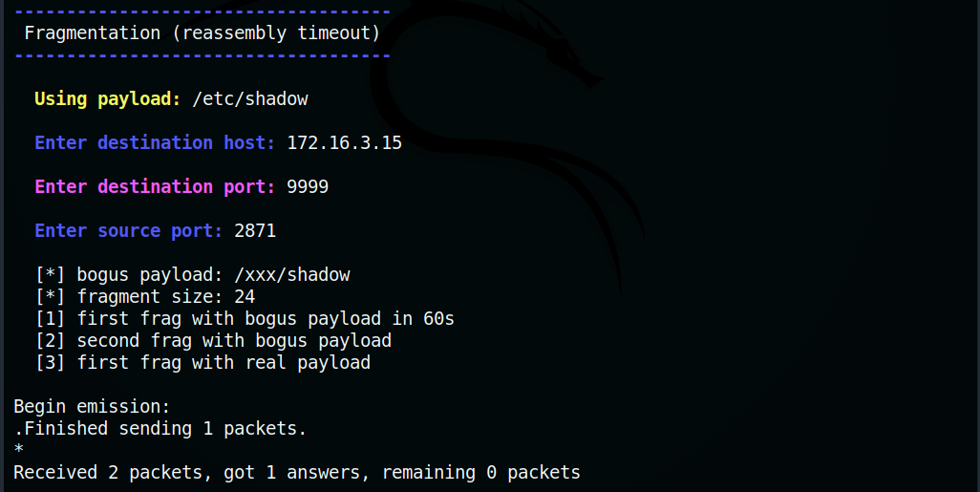

Figure 111. Fragment Reassembly timeout

* At the server, bogus packet was dropped, real payload was reassembled – **cat /etc/shadow**.

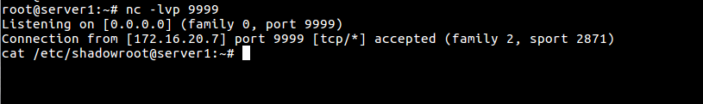

Figure 112. Payload reassembled – fragment timeout

* IDS Alerts:

1. Snort



Figure 113. Snort alerts – none – fragment timeout

2. Suricata

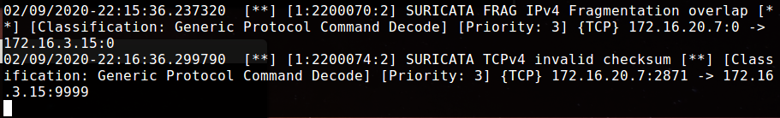

Figure 114. Suricata alerts- fragment timeout

* Result:

|  |  |
| --- | --- |
| Test Result | Both Suricata and Snort were unable to detect the payload. Payload was reassembled at target evading detection. |
| Snort alert | None |
| Observation (if any) | None |
| Suricata alert | FRAG IPv4 fragmentation overlap, TCPv4 invalid checksum |
| Observation (if any) | Suricata detected an overlap and invalid checksum in the incoming fragments. |

2.4 Change TCP Header fields

Packets with invalid TCP header fields are not accepted by destination but might be accepted by the IDS. This uncertainty can be exploited to perform insertion attacks. Here, TCP headers like flags and checksum are manipulated to craft invalid packets.

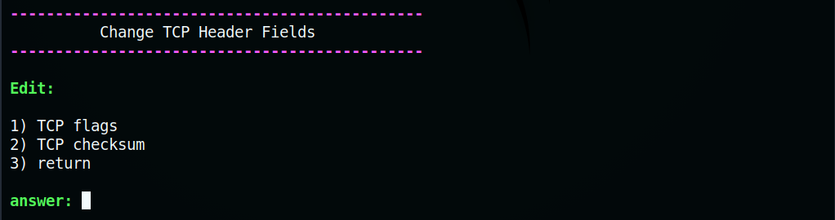

Figure 115. Change TCP header fields

2.4.1 TCP Flags

TCP flag combinations like RST and SYN are invalid. Packets with this combination will be rejected at the destination. IDS that perform stream reassembly assumes the packet is part of stream.

Test: Use invalid TCP flags to perform insertion attack.

* + Netcat Listener was started on a port at the target/server.

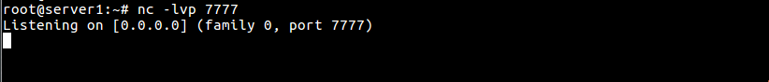

Figure 116. TCP flags – Fragment reassembly timeout

* + Three packets were sent to the destination. First packet had payload – **cat /etc**. Next packet had invalid flags and a false payload. Third packet had payload - **/shadow**.

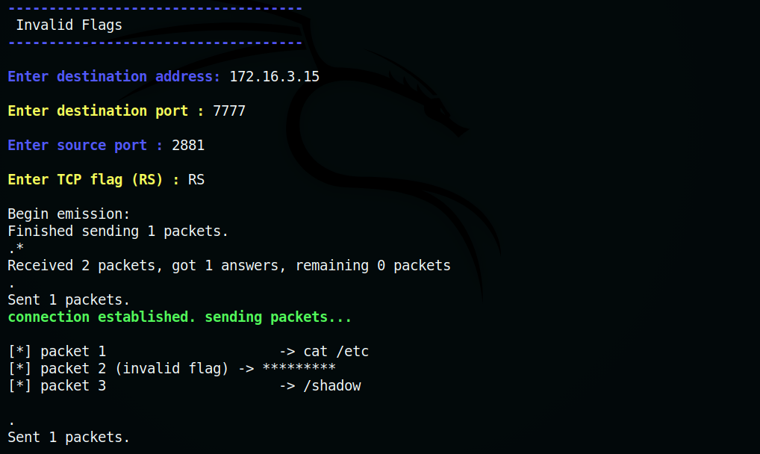

Figure 117. Invalid flag

* + At the server, the packets were reassembled to form payload – **cat /etc/shadow**.

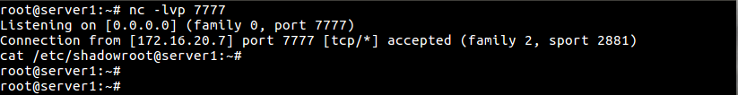

Figure 118. payload reassembled – invalid flag

* + IDS Alerts:

1. Snort



Figure 117. Snort alerts – invalid flag

2. Suricata

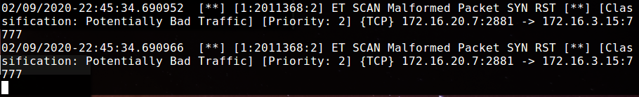

Figure 120. Suricata alerts- invalid flag

* + Result:

|  |  |
| --- | --- |
| Test Result | Both Suricata and Snort were unable to detect the payload. Payload was reassembled at target evading detection. |
| Snort alert | None |
| Observation (if any) | None |
| Suricata alert | ET SCAN Malformed Packet SYN RST |
| Observation (if any) | Suricata detect the malformed packet with invalid flag combination (SYN, RST) |

2.4.2 TCP Checksum

Invalid packets can be crafted with corrupted TCP checksum. Destination does not accept packets with invalid checksum but an IDS may consider it as part of stream. This is exploited to evade detection.

Test: Use Packet with invalid TCP checksum to perform insertion attack.

* + Netcat Listener was started on port at target/server.



Figure 121. TCP checksum – Netcat

* + Three packets were sent after establishing TCP connection. The first packet has payload – **cat /etc/.** Second packet had bogus payload. Third packet has rest of the real payload – **shadow**.

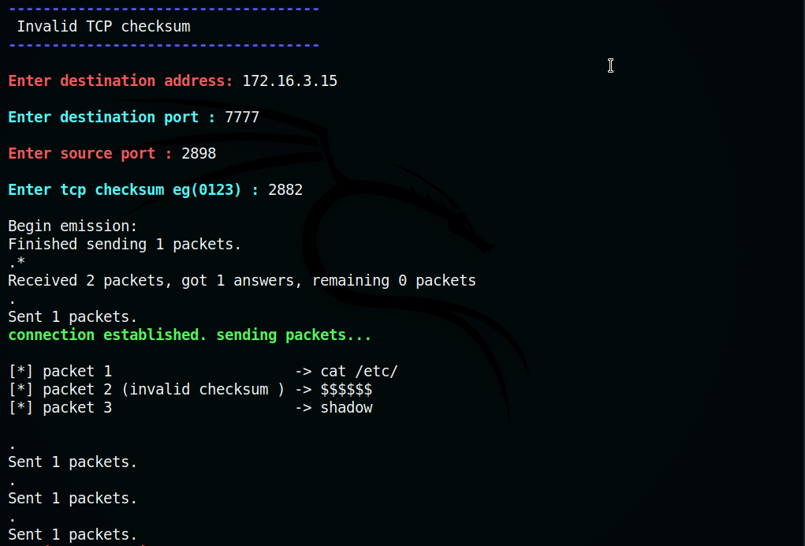

Figure 122. Invalid checksum

* + At the target/server, the packets reassembled to form payload – **cat /etc/shadow**.



Figure 123. payload reassembled – invalid checksum

* + IDS Alerts:

1. Snort

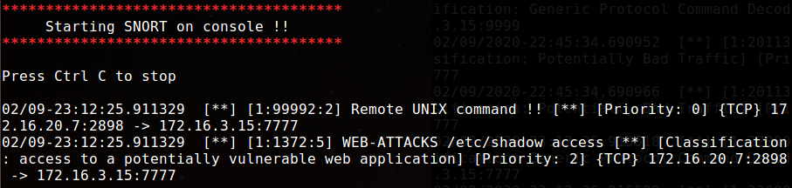

Figure 124. snort alerts – invalid checksum

2. Suricata

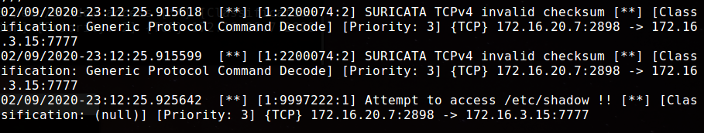

Figure 125. Suricata alerts – invalid checksum

* + Result:

|  |  |
| --- | --- |
| Test Result | Both Suricata and Snort detected the payload. Both IDS ignored the packet with invalid checksum and reassembled the valid packets. |
| Snort alert | Remote UNIX command, WEB-ATTACKS /etc/shadow access |
| Observation (if any) | Snort classified the alert as ‘access to a potentially vulnerable web application’. |
| Suricata alert | TCPv4 invalid checksum, Attempt to access /etc/shadow |
| Observation (if any) | Suricata detected the invalid checksum in the packet. |

2.5 Session Splicing

It is an evasion technique that exploits intrusion detection systems that does not reconstruct sessions before pattern matching. The payload data is split between packets so that IDS cannot identify any signatures. If IDS reassemble tcp streams, delays could be added between packets in a session. IDS may stop reassembling streams if the session exceeds a reasonable amount of time.

Test : Split single payload into multiple segments and send them to the target/server.

* + Netcat listener was started on a port at the target.

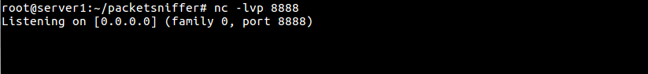

Figure 126. Netcat – session splicing

* + The payload – **cat /etc/shadow** was split and embedded into four TCP segments in a session (**cat, /etc/, /sha, dow**) and sent to target.

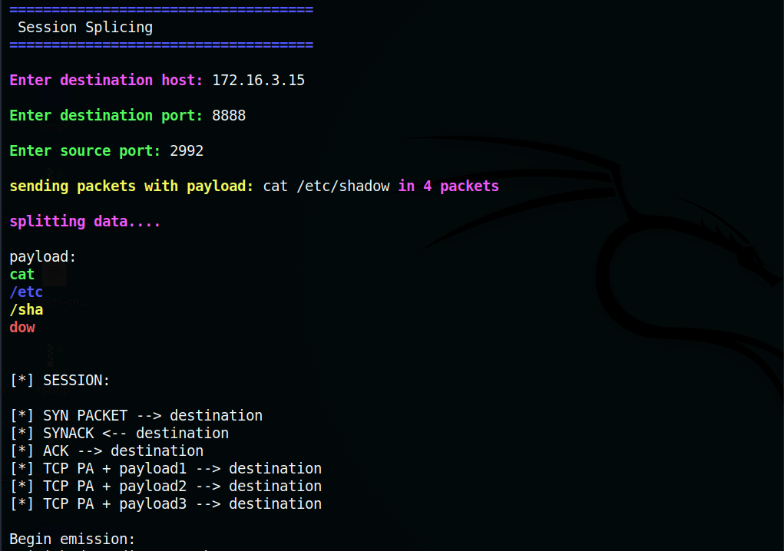

Figure 127. Session splicing

* + At the target, the payload was reassembled to form the payload.

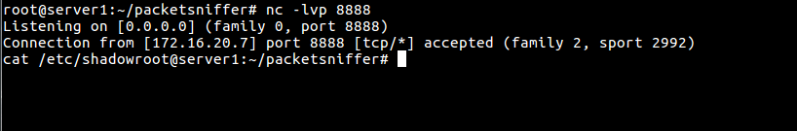

Figure 128. payload reassembled – session splicing

* + IDS Alerts :

1. Snort

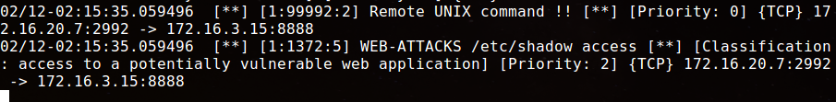

Figure 129. Snort alerts – session splicing

2. Suricata

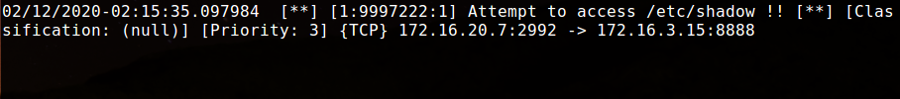

Figure 130. Suricata alerts – session splicing

* + Result :

|  |  |
| --- | --- |
| Test Result | Both Suricata and Snort detected the payload after performing stream reassembly |
| Snort alert | Remote UNIX command, WEB-ATTACKS /etc/shadow access |
| Observation (if any) | Snort classified the alert as ‘access to a potentially vulnerable web application’. |
| Suricata alert | Attempt to access /etc/shadow |
| Observation (if any) | Suricata detected it as an attempt to access /etc/shadow file. |

## 3. File Sender

This feature uses two scripts – File sender and File sniffer run at attacker and a target respectively to send and receive data. File sender is used by the attacker to import a file, extract and encrypt (xor) content and embed inside TCP/IP packet. This packet is sent to a remote target host along with normal traffic in the network. File sender supports 4 file formats (py, zip, txt, and pcap file). The File Sniffer at target uses source port or checksum to identify the file type in the crafted packet.

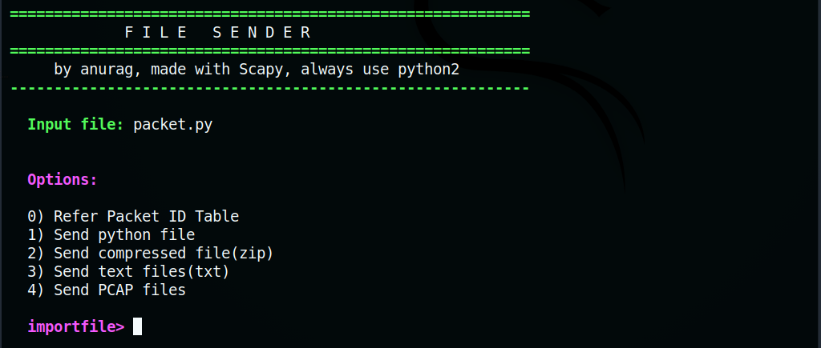

Figure 131. File sender

3.1 Packet ID table

Packet ID table contains all supported file types and its respective source port/checksum used to identify the packet.

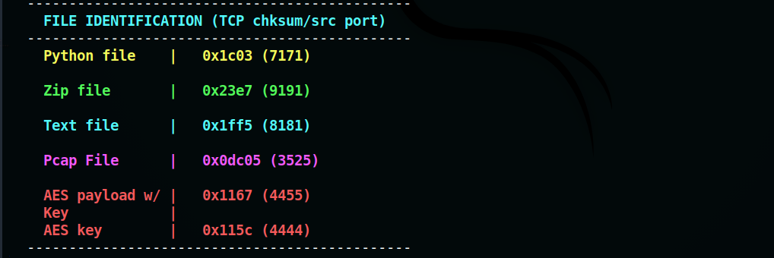

Figure 132. Checksum table

3.2 Send python file

This option is used to send python file to a target after encrypting its contents. The target uses source port 7171 or checksum 0x1c03 to identify the packet with encrypted python file.

* + SHA-256 checksum of a python file was observed.

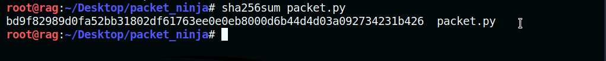

Figure 133. Checksum of python file

* + File sniffer at target was started. Python file was imported and sent to target/server with file sniffer. Since the file size was more than 1460 bytes, the contents were compressed with Zlib. The current content length was used as key, encrypted with XOR and sent to target.

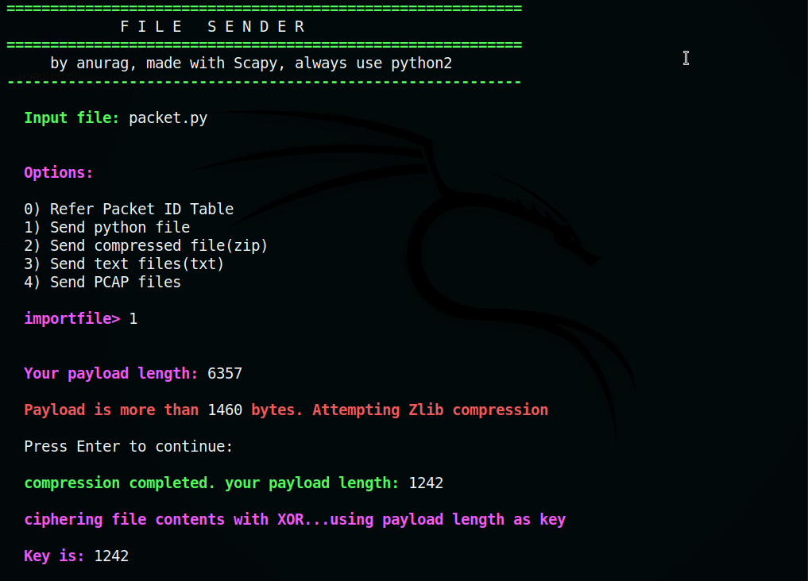

Figure 134. Invalid flag

* + An open port at the target was set as destination port.

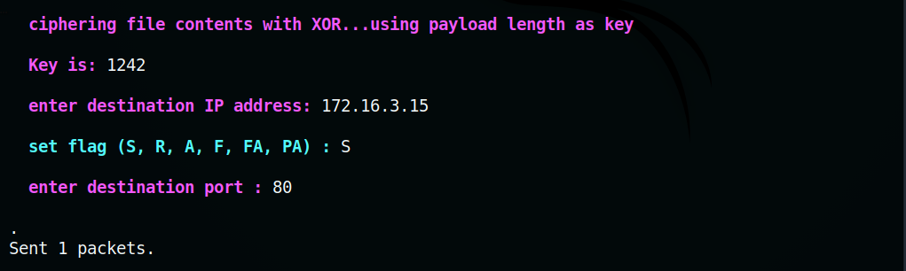

Figure 135. Setting flag

* + At the file sniffer running on the target, the payload was decrypted by using payload size as key and extracted into a python file with current timestamp.

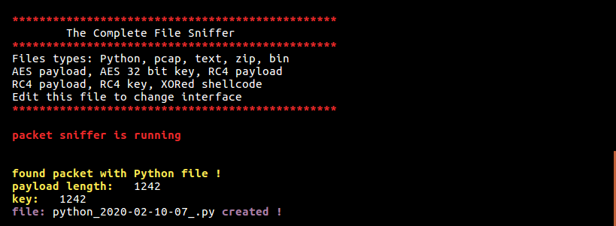

Figure 136. file sniffer

* + It can be observed that the SHA-256 checksum matches with that of the file in attacker machine.



Figure 137. checksum of python file in target

* + IDS Alerts :

1. Snort

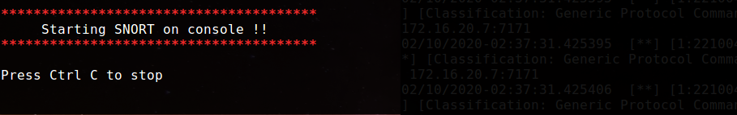

Figure 138. Snort alerts- file sender

2. Suricata

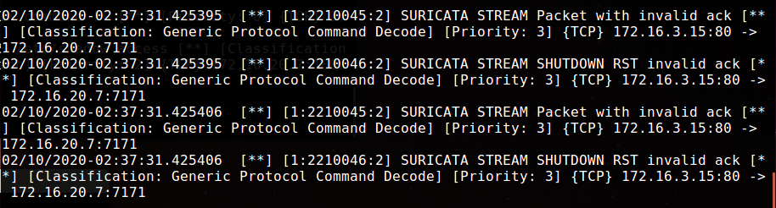

Figure 139. Suricata alerts – file sender

* + Result:

|  |  |
| --- | --- |
| Test Result | Both Snort and Suricata did not detect the encrypted payload. |
| Snort alert | None |
| Observation (if any) | None |
| Suricata alert | STREAM Packet with invalid ack, SHUTDOWN RST with invalid ack |
| Observation (if any) | Since the crafted packet was sent without establishing session, the server rejected the packet. This caused the alert invalid ack and RST with invalid ack. |

3.3 Send compressed (zip) files

This option can be used to send ZIP file to a target after encrypting its content with XOR. The target/file sniffer uses source port number 9191 or checksum 0x23e7 to identify the packet with zip file.

* + SHA-256 checksum of compressed zip file was observed.

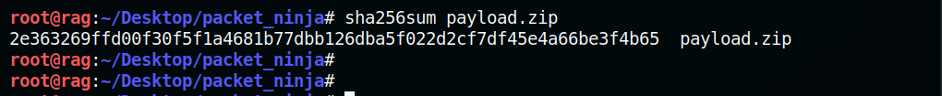

Figure 140. Checksum of ZIP file

* + File sniffer at target was started. A compressed zip file was imported and sent to target/server with file sniffer.

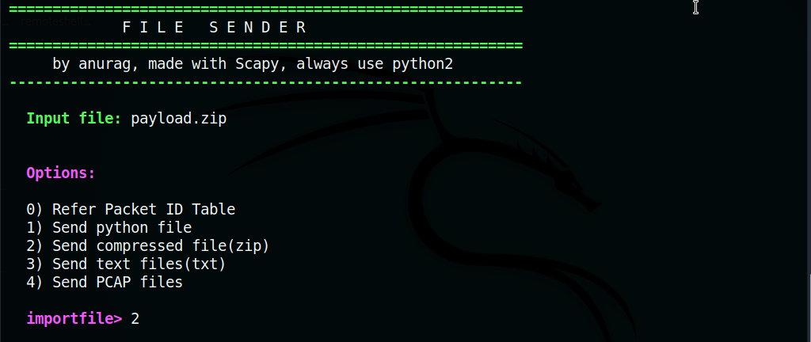

Figure 141. File sender – sending zip

* + Payload length is used as key to encrypt with XOR cipher. The packet with zip file was sent to an open port at the target.

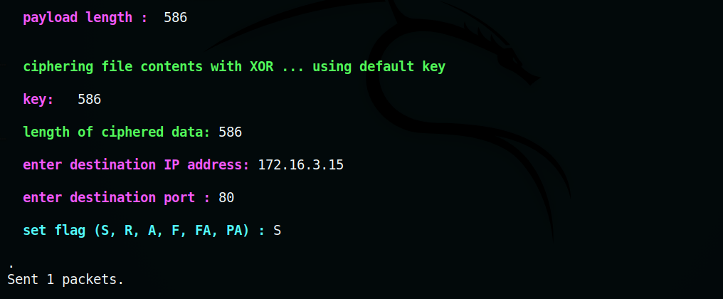

Figure 142. File sending

* + At the target/file sniffer, the payload was decrypted by using payload size as key and extracted into a zip file with current timestamp.

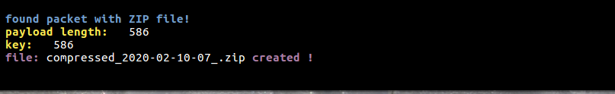

Figure 143. zip file created at target

* + It can be observed that the SHA-256 checksum matches that of the file in attacker machine.



Figure 144. checksum of zip file at target

* + IDS Alerts :

1. Snort



Figure 145. Snort alerts – file sender

2. Suricata

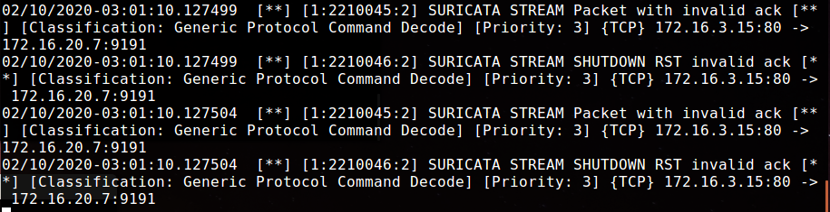

Figure 146. Suricata alerts- file sender

* + Result:

|  |  |
| --- | --- |
| Test Result | Both Snort and Suricata did not detect the encrypted payload. |
| Snort alert | None |
| Observation (if any) | None |
| Suricata alert | STREAM Packet with invalid ack, SHUTDOWN RST with invalid ack |
| Observation (if any) | Since the crafted packet was sent without establishing session, the server rejected the packet. This caused the alert invalid ack and RST with invalid ack. |

3.4 Send text files

This option can be used to send text file to a target after encrypting its content with XOR. The target/file sniffer uses source port number 8181 or checksum 0x1ff5 to identify the packet with text file.

* + SHA-256 checksum of a text file was observed.

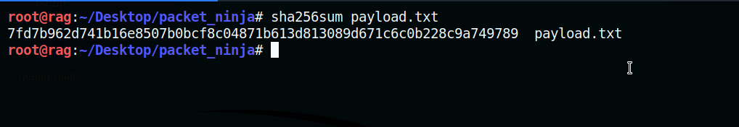

Figure 147. checksum of text files

* + File sniffer at target was started. A text file was imported and sent to target/server with file sniffer.

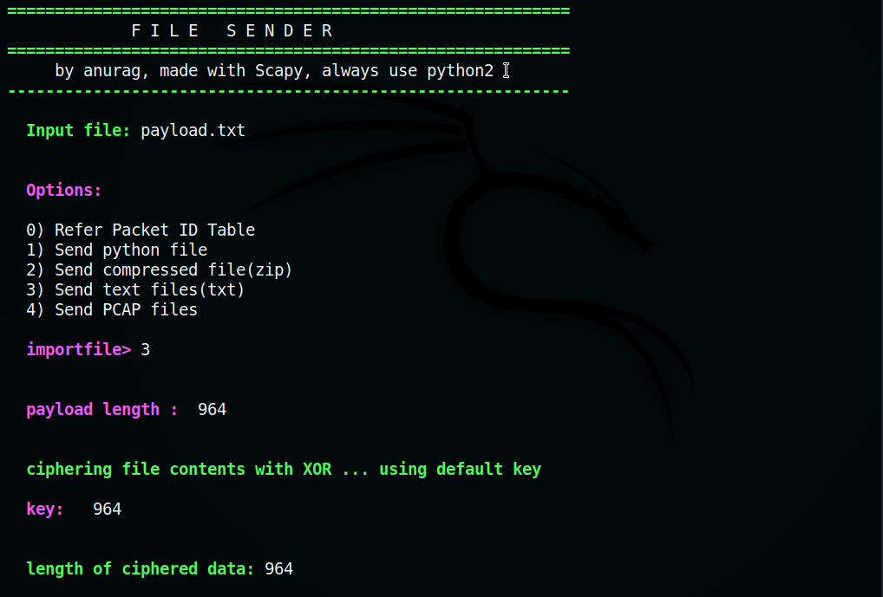

Figure 148. File sender – sending text files

* + Payload length is used as key to encrypt with XOR cipher. The packet with text file was sent to an open port at the target.

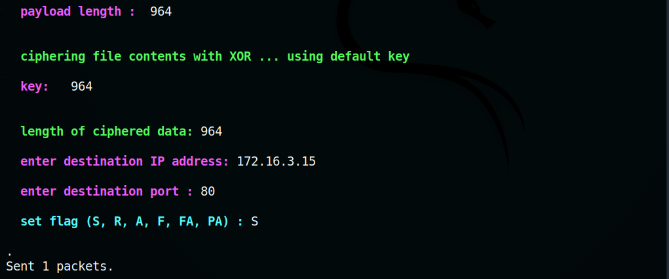

Figure 149. Sending text file

* + At the target/file sniffer, the payload was decrypted by using payload size as key and extracted into a text file with current timestamp.

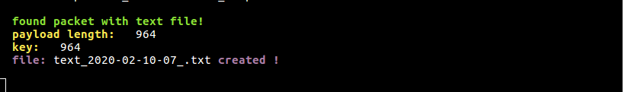

Figure 150. text file created at target

* + It can be observed that SHA-256 checksum matches that of the text file in attacker side.



Figure 151. checksum of file at target

* + IDS Alerts:

1. Snort



Figure 152. Snort alert – file sender

2. Suricata

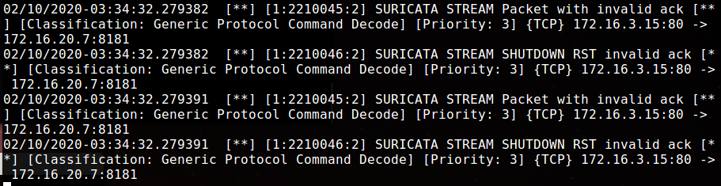

Figure 153. Suricata alerts – file sender

* + Result:

|  |  |
| --- | --- |
| Test Result | Both Snort and Suricata did not detect the encrypted payload. |
| Snort alert | None |
| Observation (if any) | None |
| Suricata alert | STREAM Packet with invalid ack, SHUTDOWN RST with invalid ack |
| Observation (if any) | Since the crafted packet was sent without establishing session, the server rejected the packet. This caused the alert invalid ack and RST with invalid ack. |

3.5 Send Pcap files

This option can be used to send Pcap file to a target after encrypting its content with XOR. The target/file sniffer uses source port number 3525 or checksum 0x0dc05 to identify the packet with Pcap file.

* + SHA-256 checksum of a pcap file was observed.



Figure 117. Invalid flag

* + File sniffer at target was started. A pcap file was imported and sent to target/server with file sniffer.

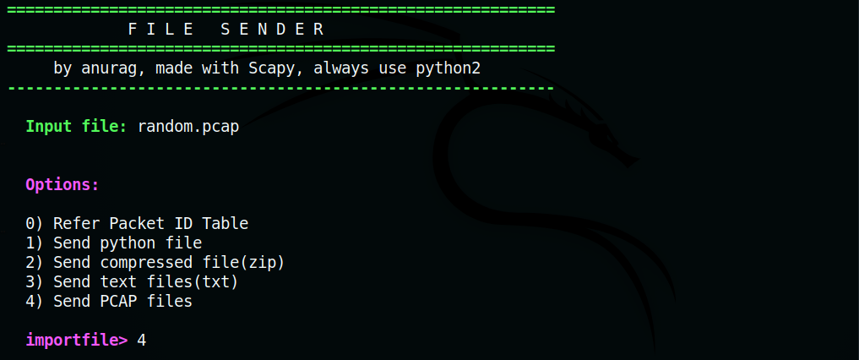

Figure 155. file sender – sending pcap

* + Payload length is used as key to encrypt with XOR cipher. The packet with pcap file was sent to an open port at the target.

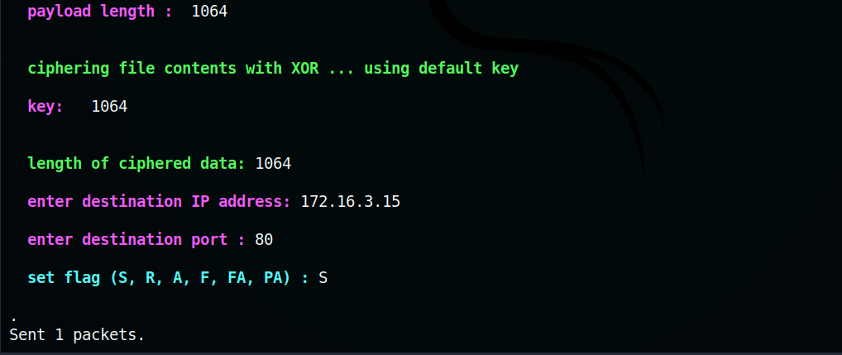

Figure 156. Sending pcap file

* + At the target/file sniffer, the payload was decrypted by using payload size as key and extracted into a pcap file with current timestamp.

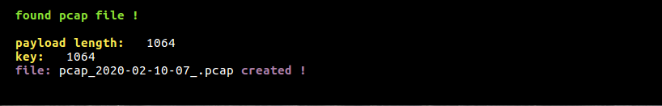

Figure 157. pcap file created at target

* + It can be observed that SHA256-checksum matches that of the pcap file at the attacker machine.

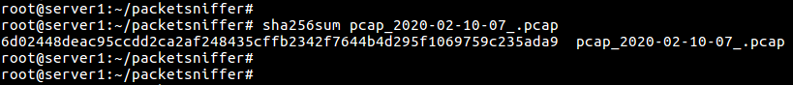

Figure 158. checksum of pcap file on target

* + IDS Alerts:

1. Snort



Figure 159. Snort alerts – sending pcap file

2.Suricata

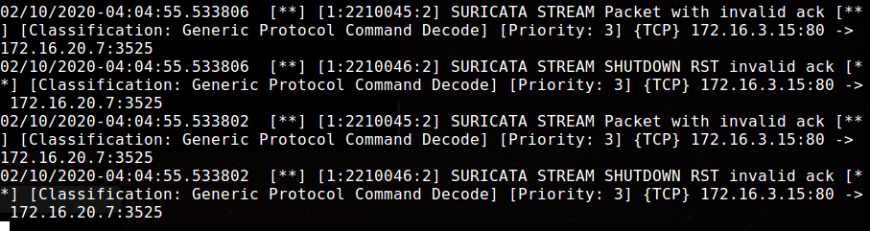

Figure 160. Suricata – sending pcap file

* + Result:

|  |  |
| --- | --- |
| Test Result | Both Snort and Suricata did not detect the encrypted payload. |
| Snort alert | None |
| Observation (if any) | None |
| Suricata alert | STREAM Packet with invalid ack, SHUTDOWN RST with invalid ack |
| Observation (if any) | Since the crafted packet was sent without establishing session, the server rejected the packet. This caused the alert invalid ack and RST with invalid ack. |

## 4. Packet payload encryption

AES ENCRYPTOR is a tool within Packet Ninja that offered payload AES-256 encryption and decryption. It uses a salt and key generator to create 32-byte salted keys. Encrypted payload can be sent to a remote target with running file sniffer. It also has an option to create packets with bogus data.

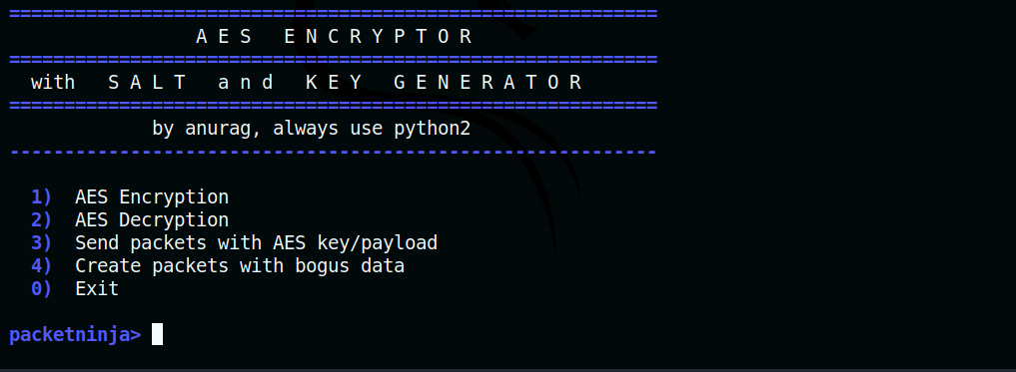

Figure 161. AES encryptor

4.1 AES Encryption

AES ENCRYPTOR performs encryption on payload after generating a 32-byte key.

Test: Generate salted key and then encrypt payload with AES-256.

* + Option to create a custom key is selected.

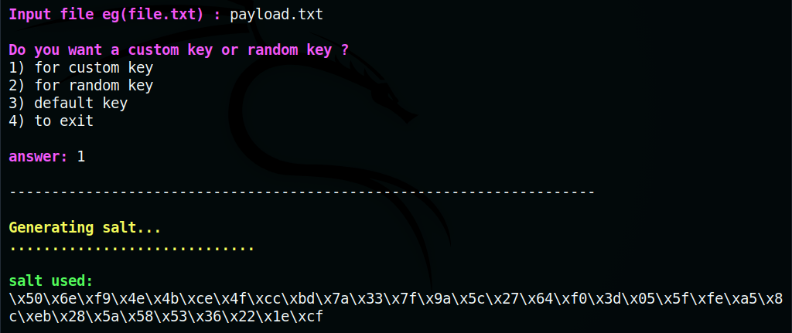

Figure 162. Creating key

* + Firstly, a salt was generated then followed by a salted key after entering a password.

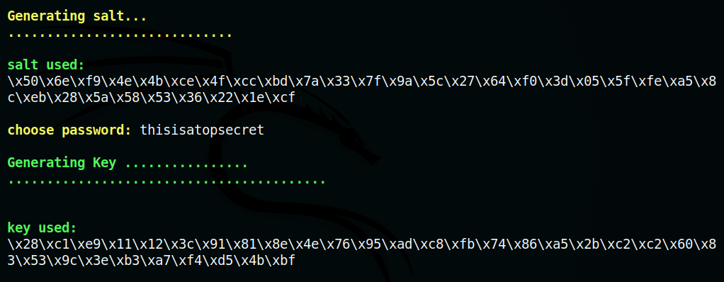

Figure 163. generating key

* + File content was displayed. It can be observed that length of payload before and after encryption was also displayed.

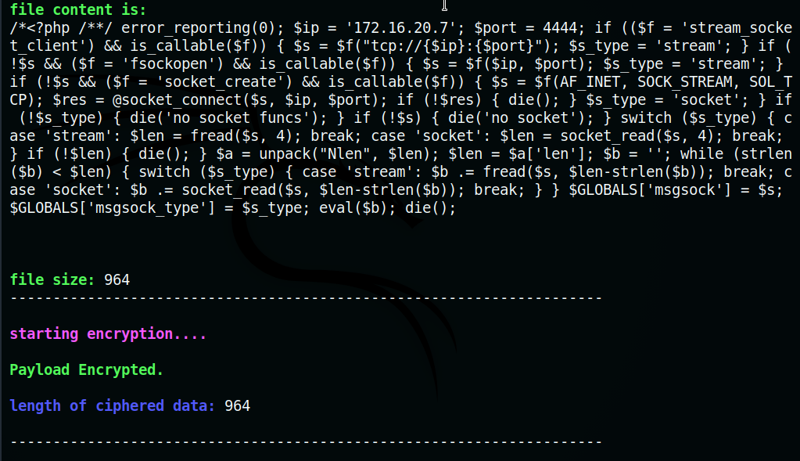

Figure 164. Encrypting payload

* + Encrypted payload and key were exported into respective bin files in saved_files directory.

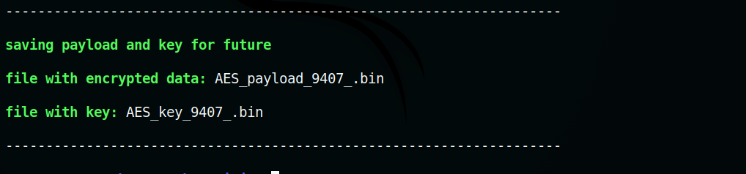

Figure 165. Saving bin files

* + Encrypted data was observed while opening the saved file.

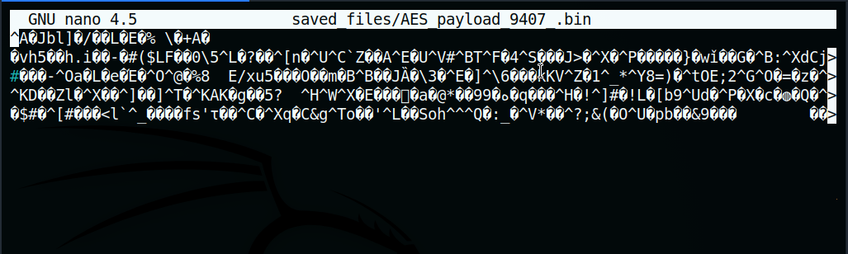

Figure 166. AES encrypted payload

4.2 AES Decryption

AES ENCRYPTOR also performs decryption on payload if 32-byte key is inserted.

Test: Decrypt the previously encrypted file.

* + The decrypted data was displayed after inserting file with encrypted payload and key respectively.

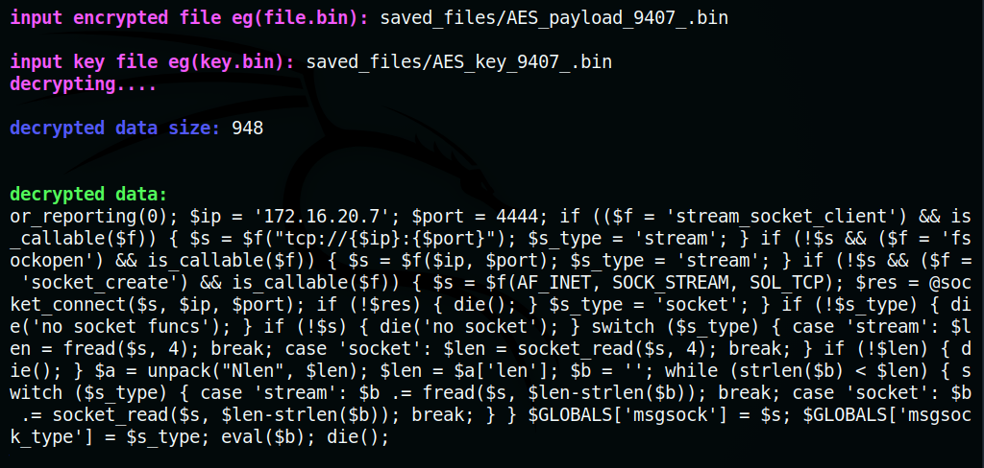

Figure 167. Decrypted payload

4.3 Send Packet with AES key/payload

A file with payload is imported and encrypted with AES-256. It is then embedded in the TCP data section along with its 32-byte key and sent to a target with file sniffer. The file sniffer identifies the packet with source port, extracts the 32-byte key and decrypts the payload.

Test: Send and decrypt the payload at a remote target.

* + File sniffer was started on the target.

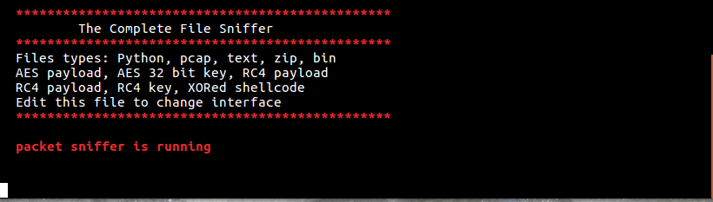

Figure 168. file sniffer

* + Files with encrypted payload and key were imported. Source port was chosen to identify the packet since packet with invalid checksum might be dropped. First 32 bytes of the TCP data segment was occupied by AES key while the rest 964 bytes was occupied by encrypted payload.

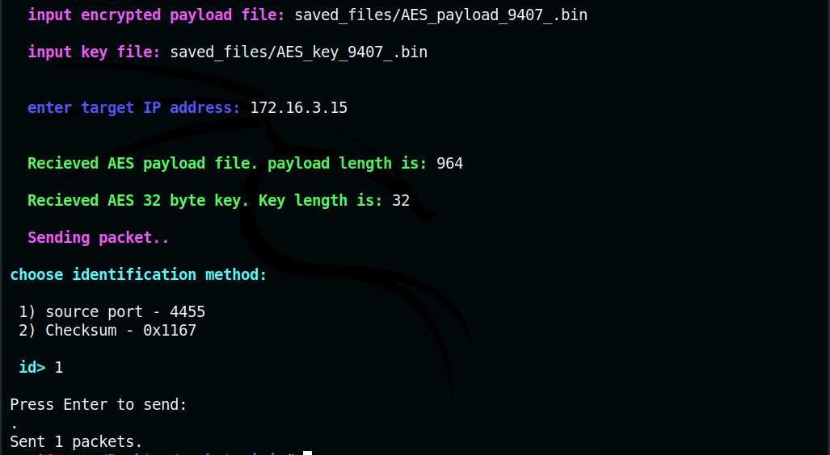

Figure 169. sending encrypted payload

* + At the target, the file sniffer extracted the first 32 bytes of incoming packet (with source port 4455) as AES key. The key was used to decrypt the rest of the data in TCP segment. Decrypted data, encrypted data, AES-32 key were also saved into different bin files.

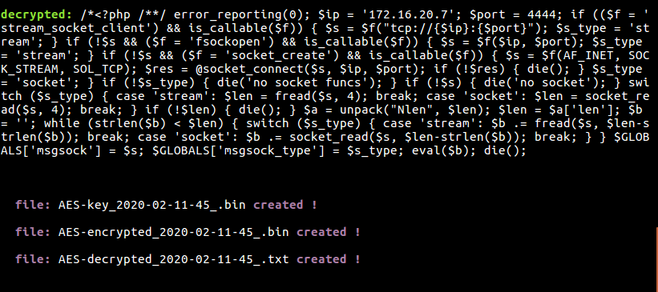

Figure 170. decrypted data at target

* + IDS Alerts :

1. Snort



Figure 171. Snort alerts- none

2. Suricata

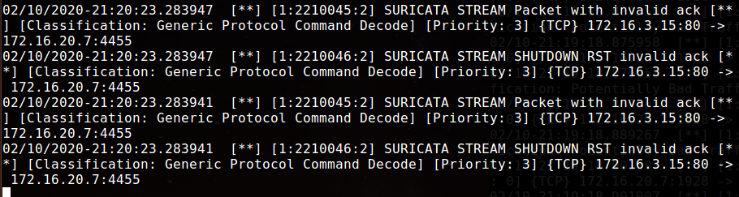

Figure 172. Suricata alerts – AES encryption

* + Result:

|  |  |
| --- | --- |
| Test Result | Both Snort and Suricata did not detect the encrypted payload. |
| Snort alert | None |
| Observation (if any) | None |
| Suricata alert | STREAM Packet with invalid ack, SHUTDOWN RST with invalid ack |
| Observation (if any) | Since the crafted packet was sent without establishing session, the server rejected the packet. This caused the alert invalid ack and RST with invalid ack. |

4.4 Send packet with bogus payload.

This option can be used to create packets with bogus payload. Here, bogus payload is generated based on the requested payload size. Each byte of the given payload size is occupied by ‘0’. These packets with bogus payload can be captured and replaced by a malicious/encrypted payload on route to destination.

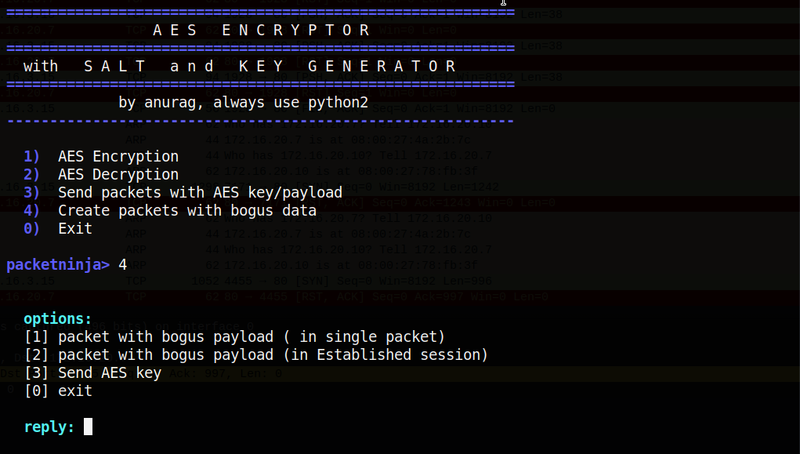

Figure 173. Sending bogus payload

4.4.1 Packet with bogus payload (single packet)

A single packet with bogus payload is created.

Test: Send a packet with bogus payload. The payload size should match a real malicious payload.

* + - Here the size of malicious payload used is 964 bytes.

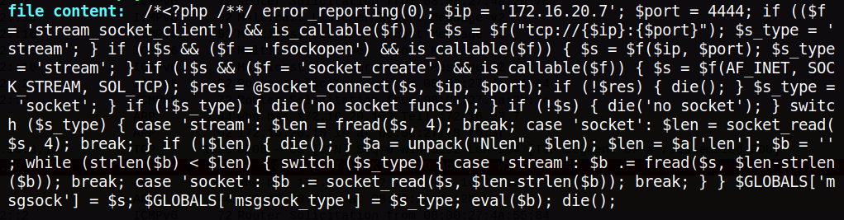

Figure 174. mal. payload

* + - Bogus payload is generated (length: 964 bytes)

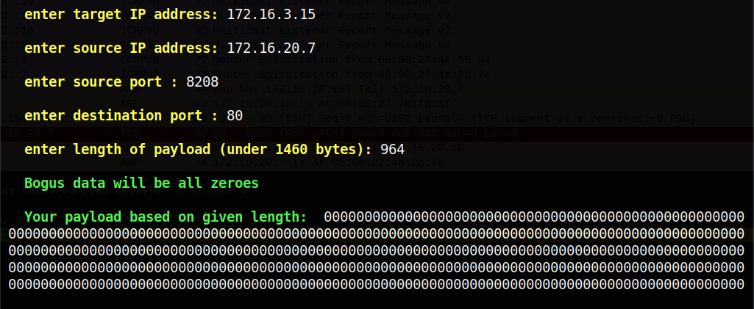

Figure 175. generated payload

4.4.2 Packet with bogus payload (established session)

Like the previous option, packet with bogus payload is crafted after establishing a tcp session.

Test: Establish a TCP session, send packet with bogus data and close the session.

* + - A port is opened at the target with Netcat listener. Bogus payload is generated (length: 964 bytes)

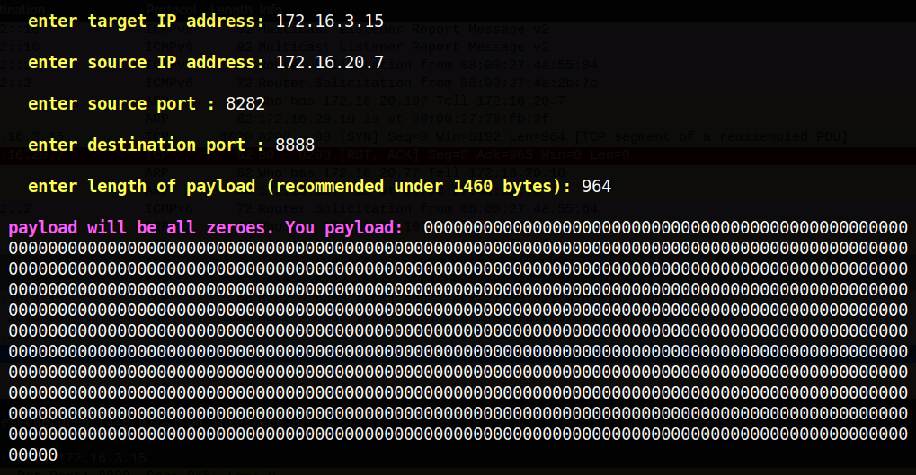

Figure 176. sending bogus payload

* + - Establishment and Closing of TCP connection is predefined in Packet Ninja.

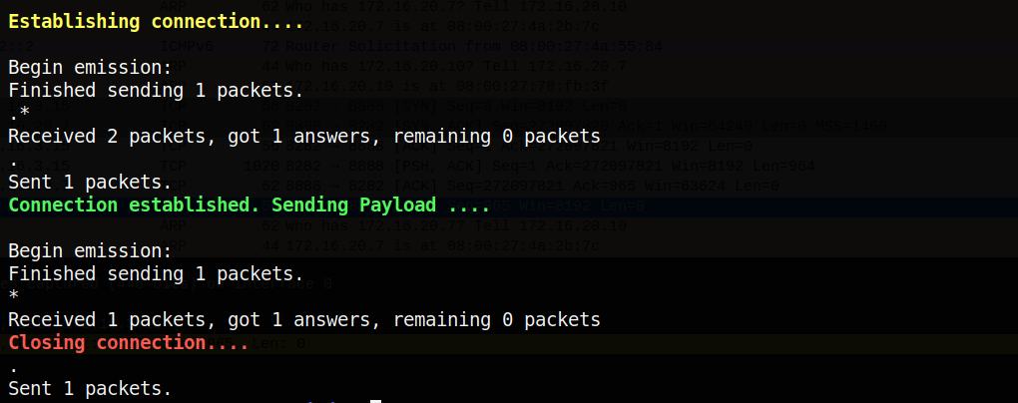

Figure 177. Establishing connection

4.4.3 Sending AES 32-byte key

In option 4.3 Sending AES payload/key, the 32-byte key is prepended along with encrypted payload and sent to target. This option can be used to send the key individually. The packet with just AES key is identified by source port 4444 at the target (refer to option 3.1 Packet ID table).

Test: Send 32-byte key to a target.

* + - Firstly, SHA-256 checksum of a bin with 32-byte key was observed



Figure 178. checksum of key file

* + - Key file was imported and sent to an open port at target.

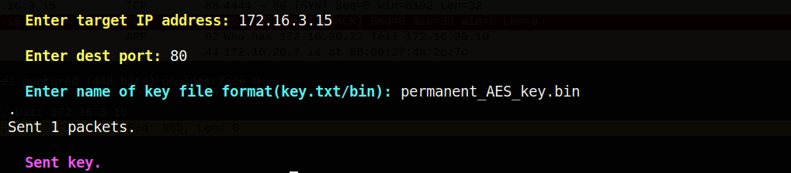

Figure 179. sending key

* + - At the target, the packet with key was identified by file sniffer and saved it into a file with current timestamp.

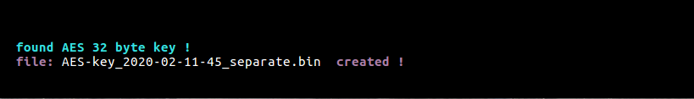

Figure 180. creating key file at target

* + - It was observed that SHA-256 checksum of the output bin file matched that of the key file on attacker machine.

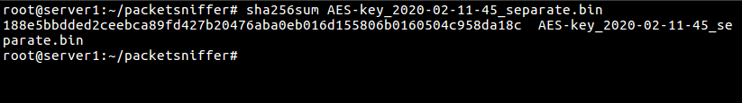

Figure 181. checksum of received key file

## 5. Pcap Editor

Scapy’s flexibility in crafting packets makes editing Pcap files easier. Packet Ninja’s pcap editor enables one to replace packet data, edit header fields like IP addresses and ports. This editor can also replay and read pcap files.

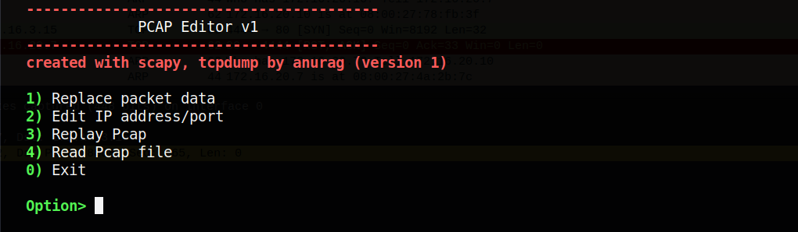

Figure 117. Invalid flag

5.1 Replace Packet data

This option can be used to replace bogus data in packets with a payload of same length. Once payload is replaced, the IP and TCP checksums are deleted, and new checksums are recalculated. The edited packets are then saved as a new pcap file.

Test: Packet sent at option 4.4.1 was captured as pcap file. Replace the bogus data and replace with malicious payload of same data length.

* + The packets in captured pcap file (here, traffic_w_bogus.pcap) were displayed with Wireshark.

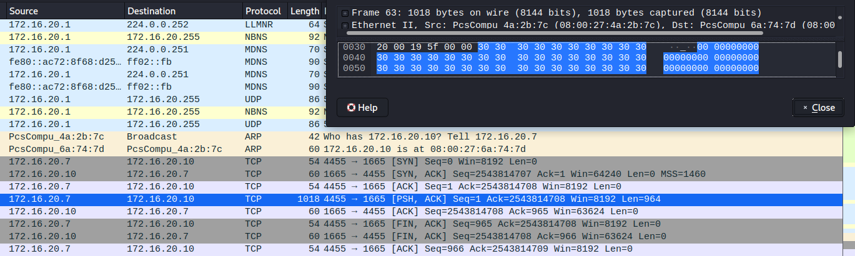

Figure 183. Wireshark with pcap file

* + Once pcap was inserted, number of packets in the file were shown. Payload file was also imported.

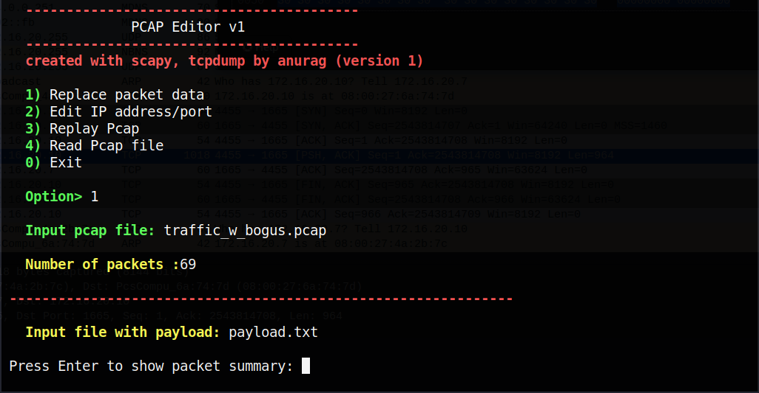

Figure 184. Number of packets

* + In the packet summary, packet number, source/destination IP address, source port, TCP checksum and flag were observed.

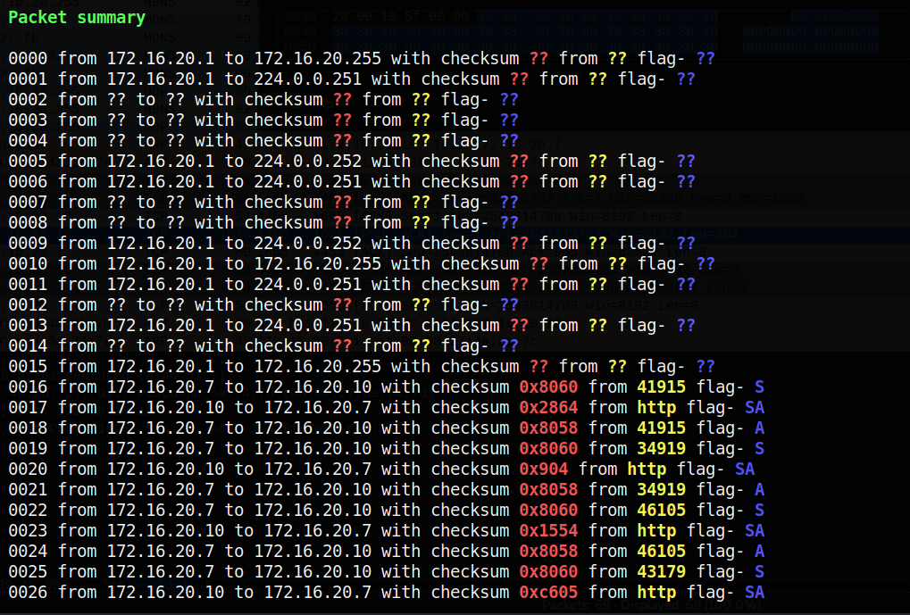

Figure 185. Packet summary

* + Packet with bogus payload was spotted based on TCP flag – PSH, ACK. Here, the packet was #62.

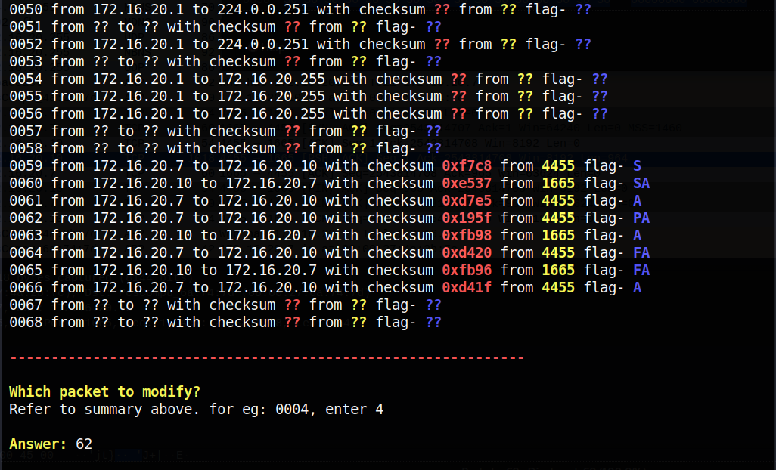

Figure 186. selecting packet

* + The payload was replaced, and the IP/TCP checksum was recalculated.

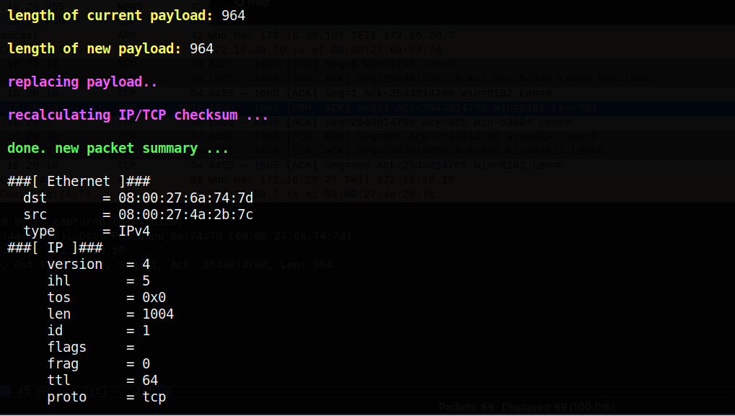

Figure 187. replacing payload

* + The replaced payload was observed in the summary of packet #62. A new pcap file was created under the name ‘edited_replace_method_’.pcap

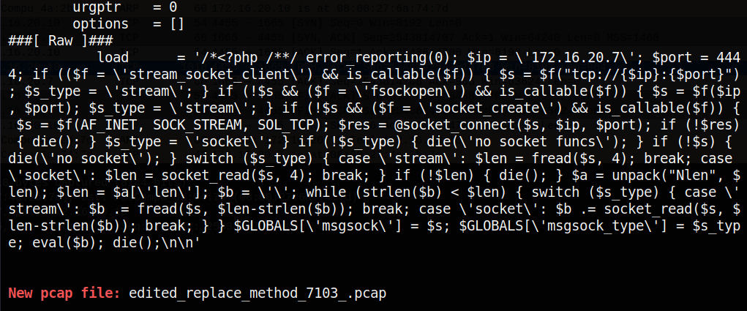

Figure 188. new pcap created

* + The newly created pcap was observed with Wireshark. The malicious payload was found in TCP data segment of packet #62.

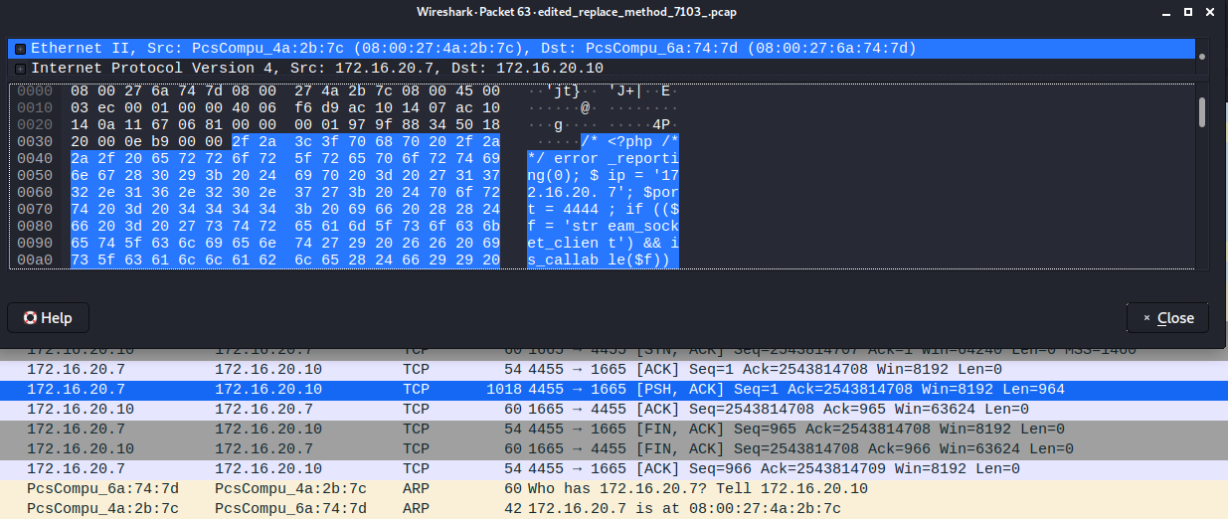

Figure 189. wireshark – new pcap

5.2 Edit IP address/Ports

This option can be used to change IP address and port numbers of packets. Once IP address or port number is replaced, TCP/IP checksums were deleted and recalculated. The edited packets were saved as new pcap file.

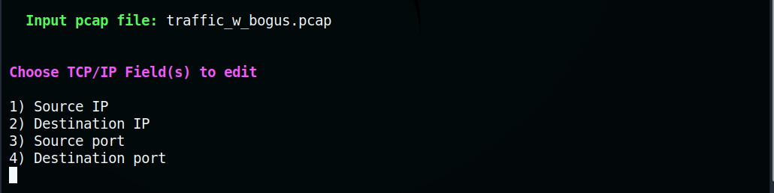

Figure 190. editing fields

5.2.1 Source IP address

The source IP address of a packet can be changed with this option.

Test: Use the pcap file from option 5.1 and replace source IP address of a packet.

* + - Random packet was selected for editing.

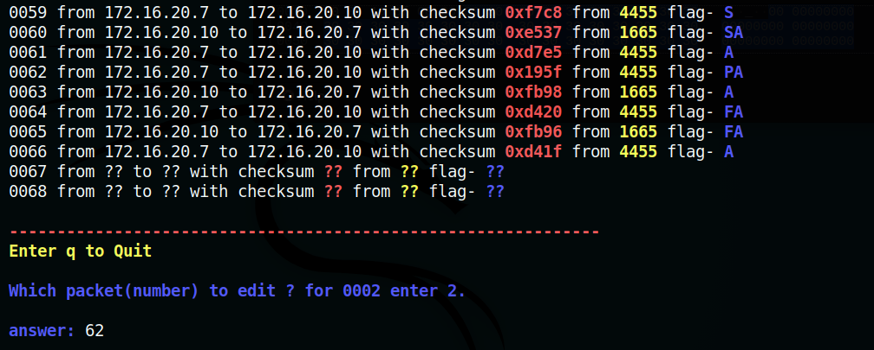

Figure 191. selecting packet

* + - Source IP address was replaced after entering a new IP address (here, 172.16.3.10). TCP/IP checksum was also recalculated.

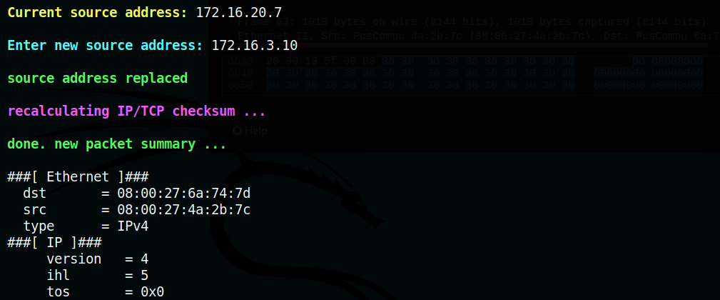

Figure 192. replacing source IP

* + - The edited packets were saved to a new pcap file under the name – ‘shost_replaced_’.pcap

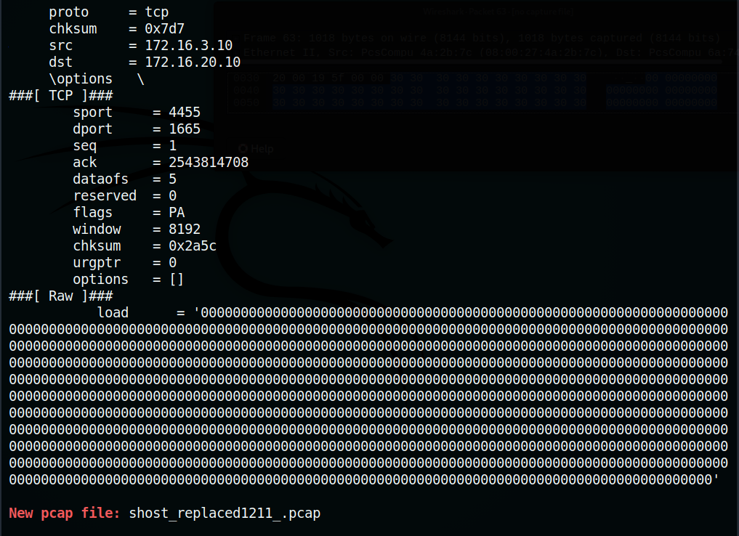

Figure 193. new pcap created

5.2.2 Destination IP address

The destination IP address of a packet can be changed with this option.

Test: Use the pcap file from option 5.1 and replace destination IP address of a packet.

* + - Random packet was selected for editing.

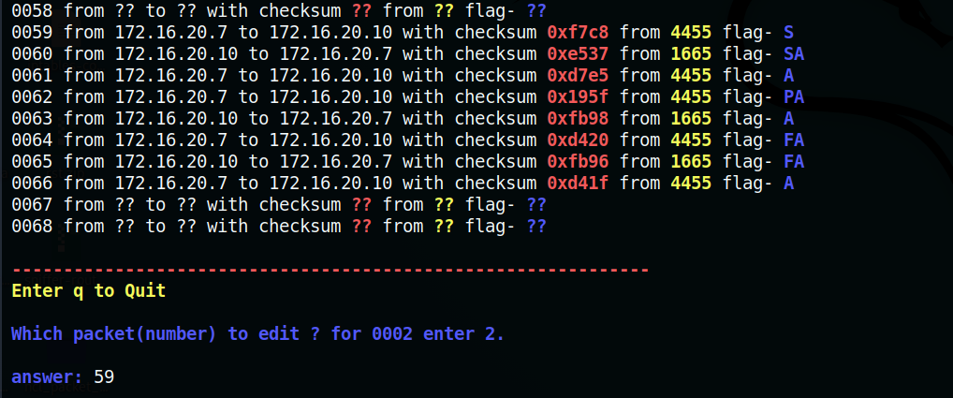

Figure 194. selecting packet

* + - Destination IP address was replaced after entering a new IP address (here, 172.16.3.10). TCP/IP checksum was also recalculated.

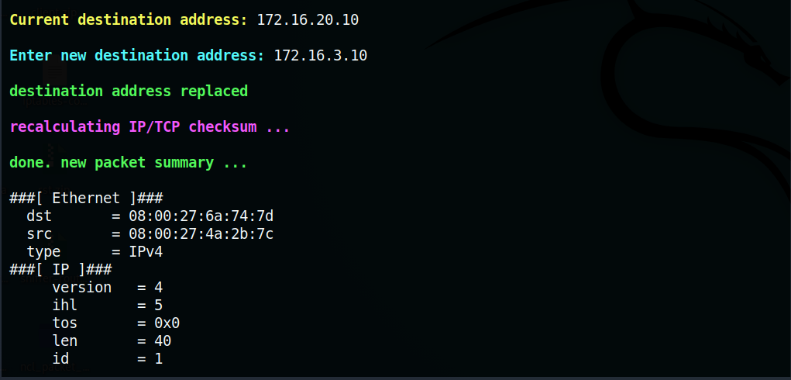

Figure 195. new destination IP

* + - The edited packets were saved to a new pcap file under name ‘dhost_replaced_’.pcap

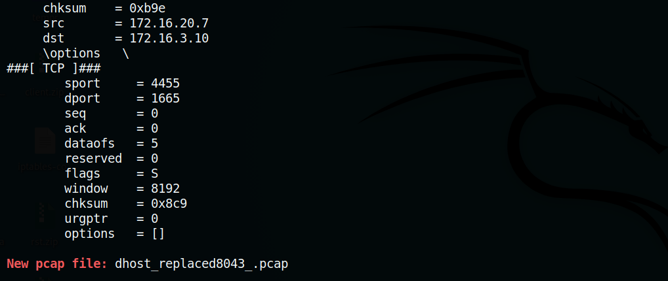

Figure 196. new pcap

5.2.3 Source Port number

The source port of a packet can be changed with this option.

Test: Use the pcap file from option 5.1 and replace source port of a packet.

* + - Random packet was selected for editing.

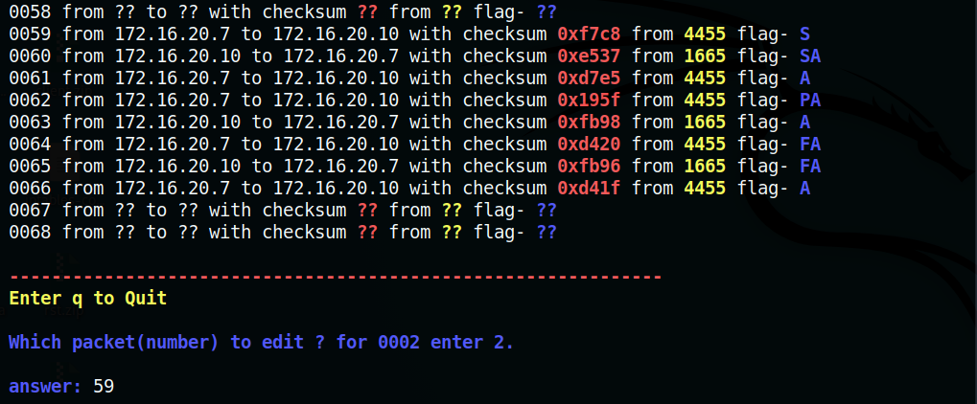

Figure 197. selecting packet

* + - Source port was replaced after entering a new port number (here, 8922). TCP/IP checksum was also recalculated.

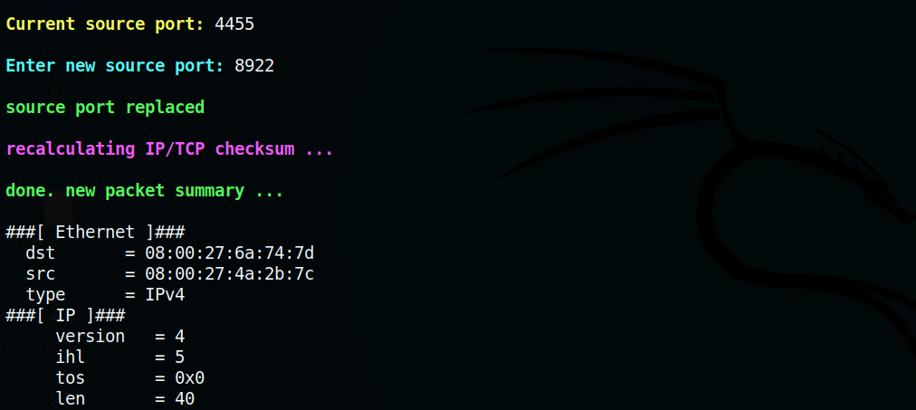

Figure 198. replacing src port

* + - The edited packets were saved to a new file under name ‘sport_replaced_’.pcap

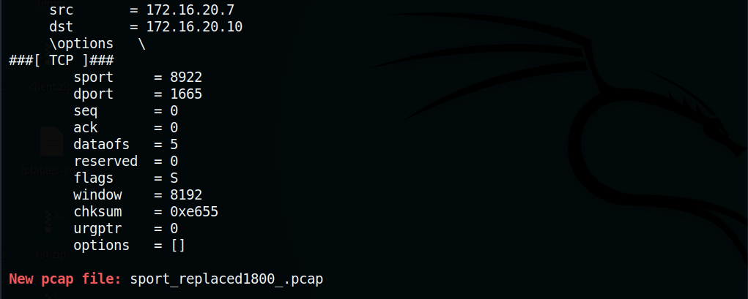

Figure 199. new pcap

5.2.4 Destination port number

The destination port of a packet can be changed with this option.

Test: Use the pcap file from option 5.1 and replace destination port of a packet.

* + - Random packet from pcap file was selected for editing.

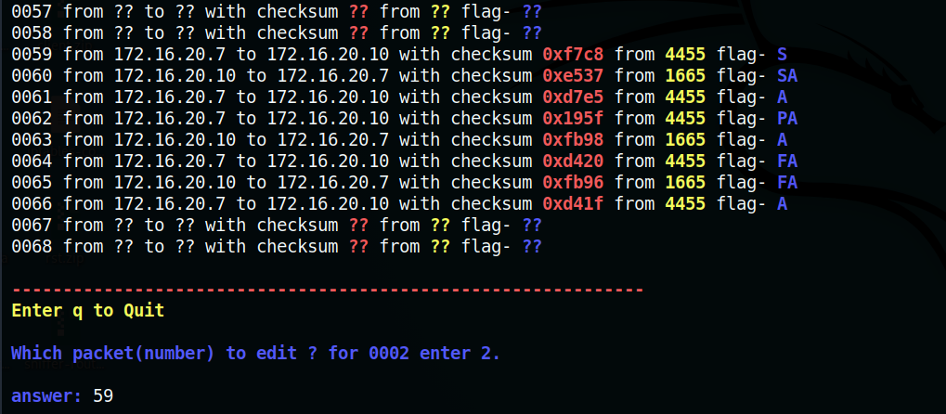

Figure 200. selecting packet

* + - Destination port was replaced by a new port number (here, 9000). TCP/IP checksum was also recalculated.

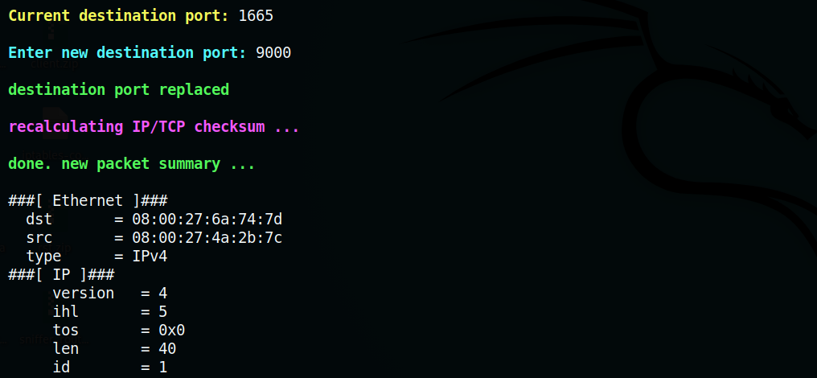

Figure 201. replacing dst port

* + - Edited packets were saved to a new pcap file under name ‘dport_replaced_’.pcap

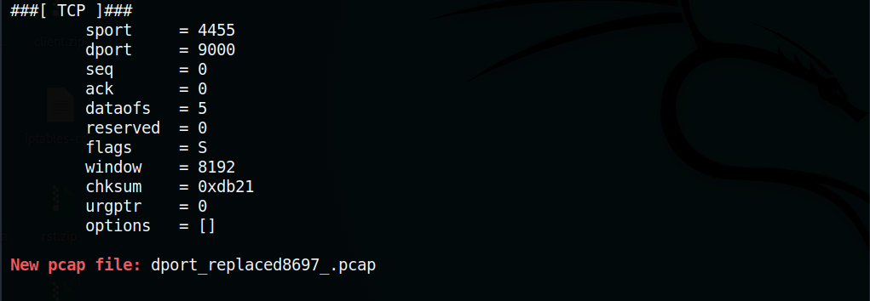

Figure 202. new pcap file

# **7. Evaluation**

Usability test was conducted on real users through tasks. The tasks included testing each feature in the tool. The test is concluded by user’s feedback on the tool’s usability and functionality.

**7.1 Usability Test**

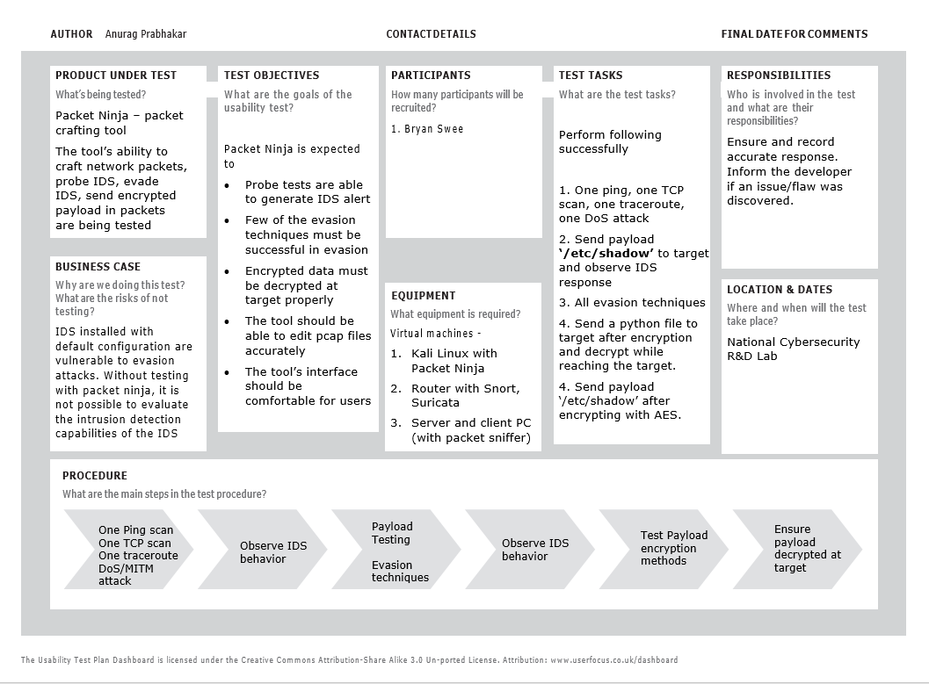

Figure 203. Usability test

**7.2 Feedback**

Users found the user interface of Packet Ninja easy to use as the prompts only included basic inputs like source/destination IP addresses, source/destination source ports, and TCP payloads and the rest (packet generation) was automated. The user also raised an issue that the tool’s features were quite extensive since each feature had many options and sub-options. He concluded that testing each feature of the tool was time consuming. Even though the interface of the tool was basic, the user suggested providing tool documentation for reference.

# **Recommendation**

Since Packet Ninja is a proof-of-concept tool, there exists room for improvement. Currently, the tool can be used to test detection capabilities of open source intrusion detection systems with minimal configuration. Packet Ninja be could further improved to test host-based IDS and different types of firewall. So, the evasion techniques should also be modified to bypass internal monitoring of the computer system and networking monitoring on the host’s network interfaces. Advanced evasion techniques like polymorphic encryption can also be added to Packet Ninja for research and development. Encryption techniques like polymorphic encryption changes it algorithm each time and simultaneously maintaining same outcome. This encryption could be added to Packet Ninja as an advanced evasion technique to evade anomaly-based intrusion detection. Finally, Packet Ninja does not support windows systems since it is written for Linux systems in bash and python. It could also be improved to support different OS versions.

# **Conclusion**

Since usage of intrusion detection systems with minimal/default configuration lead to ambiguities and synchronization issues among the IDS and its internal hosts, packet crafting was suggested to test the detection capabilities of an IDS before deployment. It was also found that existing tools were not adequate for testing an IDS. So, Packet Ninja was developed as proof-of-concept tool to perform probe testing, evasion testing and research and development of encrypted data transferring techniques.

Even though the project was completed on time *(Please refer to appendix A4)*, extension of internship gave more time to perform extensive tests and troubleshoot issues found with the tool. This project allowed me to understand various concepts of networking, TCP/IP protocols and structure, TCP sequencing, TCP/ICMP probes, address resolution protocols, TCP sessions, DoS & Man-in-the-Middle attacks, and most importantly packet crafting. Understanding the concept of packet crafting with Scapy, helped to perform pings, scans, traceroutes or even establish a TCP connection without depending common tools like NMAP, tracert, ping, Netcat, and Nping.

# **Bibliography**

***Research Papers, E-books, journals and PDF***

Biondi, P. (n.d). Scapy documentation. Retrieved from <https://scapy.readthedocs.io/>

Maxwell, A. (n.d). The Very Unofficial Dummies Guide to Scapy [eBook]. Retrieved from <https://theitgeekchronicles.files.wordpress.com/2012/05/scapyguide1.pdf>

Bukaˇc, V. (2010). IDS System Evasion Techniques [eBook]. MASARYKOVA UNIVERZITA FAKULTA INFORMATIKY. Retrieved from <https://is.muni.cz/th/d4739/MT_Bukac.pdf>

SANS Institute. *Scapy Cheat Sheet* [eBook]. Retrieved from <https://blogs.sans.org/pen-testing/files/2016/04/ScapyCheatSheet_v0.2.pdf>

SNORT User’s Manual 2.9.15.1. (2019). Retrieved from <http://manual-snort-org.s3-website-us-east-1.amazonaws.com/>

Suricata User Guide — Suricata unknown documentation. Retrieved from <https://suricata.readthedocs.io/en/suricata-5.0.0/>

***Articles from World Wide Web***

24 Apr Suricata, S. Suricata, Snort & Bro: IDS Open Source Technologies | Bricata. Retrieved from <https://bricata.com/blog/snort-suricata-bro-ids/>

Adding ethernet padding to packet using scapy. (2019). Retrieved from <https://stackoverflow.com/questions/25065645/adding-ethernet-padding-to-packet-using-scapy>

add option in tcp with scapy. Retrieved from <https://stackoverflow.com/questions/30098954/add-option-in-tcp-with-scapy>

Altering packets using Scapy - automatically update properties (length, checksum etc.) after editing packet's payload. (2018). Retrieved from

<https://stackoverflow.com/questions/51287871/altering-packets-using-scapy-automatically-update-properties-length-checksum>

Analysing TCP Header Options - Section 6. Retrieved from <http://www.firewall.cx/networking-topics/protocols/tcp/138-tcp-options.html>

Anicas, M. (2015). How To List and Delete Iptables Firewall Rules | DigitalOcean. Retrieved from <https://www.digitalocean.com/community/tutorials/how-to-list-and-delete-iptables-firewall-rules>

Building an Internal Network in VirtualBox. (2018). Retrieved from <https://sandilands.info/sgordon/building-internal-network-virtualbox>

DEFALT, T. (2015). How to Build a Man-in-the-Middle Tool with Scapy and Python. Retrieved from <https://null-byte.wonderhowto.com/how-to/build-man-middle-tool-with-scapy-and-python-0163525/>

Donato, R. (2014). How to Build a TCP Connection. Retrieved from <https://www.fir3net.com/Programming/Python/how-to-build-a-tcp-connection-in-scapy.html>

'Etherleak: Ethernet Frame Padding Information Leakage' - SecuriTeam. (2003). Retrieved from <https://securiteam.com/securitynews/5bp01208uo/>

Find number of udp and tcp packets in .pcap file with scapy. (2015). Retrieved from <https://stackoverflow.com/questions/30462638/find-number-of-udp-and-tcp-packets-in-pcap-file-with-scapy?rq=1>

How To Install and Configure Elasticsearch on Ubuntu 16.04 | DigitalOcean. (2016). Retrieved from <https://www.digitalocean.com/community/tutorials/how-to-install-and-configure-elasticsearch-on-ubuntu-16-04>

How to make all outgoing RST drop. (2012). Retrieved from <https://stackoverflow.com/questions/13215135/how-to-make-all-outgoing-rst-drop>

How to remove all files starting with a certain string in Linux. (2012). Retrieved from <https://superuser.com/questions/482435/how-to-remove-all-files-starting-with-a-certain-string-in-linux/482437>

How to Set Up Linux Server As A Router with NAT. (2014). Retrieved from <https://serverfault.com/questions/564866/how-to-set-up-linux-server-as-a-router-with-nat>

How to use SNORT. Retrieved from <http://usuaris.tinet.cat/sag/lsnort.htm>

Installing the latest syslog-ng on Ubuntu and other DEB distributions. (2018). Retrieved from <https://www.syslog-ng.com/community/b/blog/posts/installing-the-latest-syslog-ng-on-ubuntu-and-other-deb-distributions>

Intrusion detection system. Retrieved from <https://en.wikipedia.org/wiki/Intrusion_detection_system>

John, A. (2019). How to Build an ARP Spoofing Tool Using Python. Retrieved from <https://aaronjohn2.github.io/python,/arp/spoofing,/table/poisoning,/kali,/scapy,/layer/2.5,/data/link/2019/02/18/arp-spoof.html>

MartinGarcia, L. (2019). Protocol | An ASCII Header Generator for Network Protocols. Retrieved from <http://www.luismg.com/protocol/>

Miessler, D. (2019). A tcpdump Tutorial with Examples — 50 Ways to Isolate Traffic | Daniel Miessler. Retrieved from <https://danielmiessler.com/study/tcpdump/>

Multi-threaded socket programming in Python. Retrieved from <http://net-informations.com/python/net/thread.htm>

Packet crafting. Retrieved from <https://en.wikipedia.org/wiki/Packet_crafting>

Pachgare, S. (2011). SYN Flooding using SCAPY and Prevention using iptables - Open Source For You. Retrieved from <https://opensourceforu.com/2011/10/syn-flooding-using-scapy-and-prevention-using-iptables/>

Python: Importing urllib.quote. (2019). Retrieved from <https://stackoverflow.com/questions/31827012/python-importing-urllib-quote>

scapy, R. (2019). Reading PCAP file with scapy. Retrieved from <https://stackoverflow.com/questions/42963343/reading-pcap-file-with-scapy>

SCAPY, S. (2013). SYN Flood Attack using SCAPY. Retrieved from <http://techmightsolutions.blogspot.com/2013/05/syn-flood-attack-using-scapy.html>

Snort: Re: Failed to parse the IP address: $HOME_NET. (2012) from <https://seclists.org/snort/2012/q3/523>

Traceroute Over TCP vs UDP. (2014). Retrieved from <https://networkengineering.stackexchange.com/questions/5700/traceroute-over-tcp-vs-udp>

Writing Snort Rules. Retrieved from <http://manual-snort-org.s3-website-us-east-1.amazonaws.com/node27.html>

Vollebregt, B. (2018). Asymmetric Encryption and Decryption in Python. Retrieved from <https://nitratine.net/blog/post/asymmetric-encryption-and-decryption-in-python/>

Vollebregt, B. (2019). Python Encryption and Decryption with PyCryptodome. Retrieved from <https://nitratine.net/blog/post/python-encryption-and-decryption-with-pycryptodome/>

# **Appendices**

A1. Existing tools

1. Nping

Nping can generate TCP/UDP/ICMP probes can create packets in ethernet, network, and transport layer. In this tool, only one type of packet/probe can be generated and executed at a time. It does not have options to perform fragmentation reassembly evasion attack, session splicing method, or encrypt/decrypt payload.

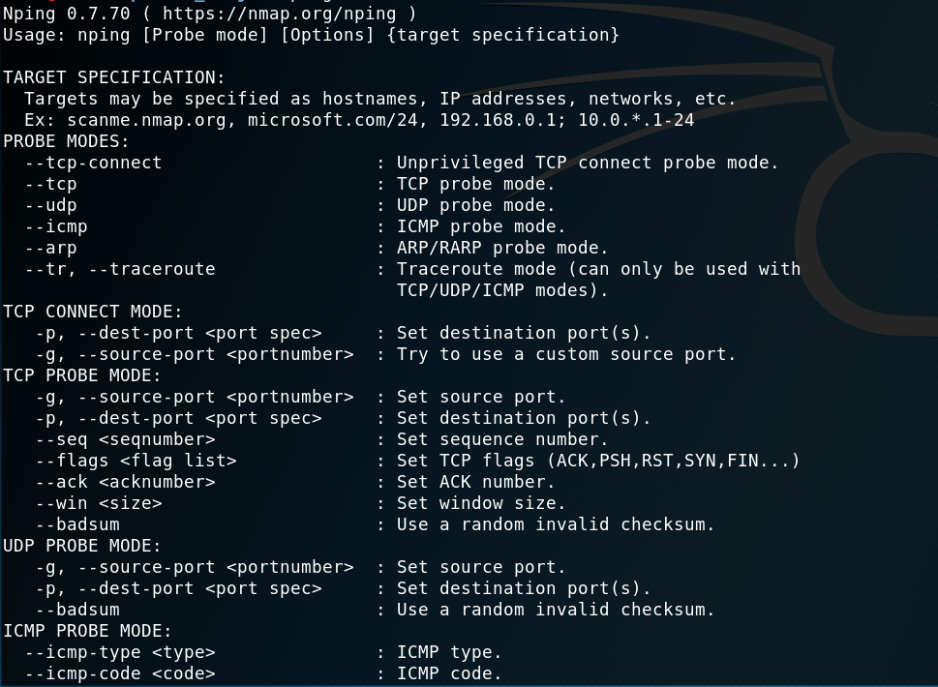

2. Hping3

This tool can edit each field in TCP/IP header. It can also set time interval between packets, assign packet count, set packet mode – ICMP mode, IP mode, Scan mode, Raw IP mode, input raw data or file data. It does not have option to fragment packet, change MTU, encrypt payload in packets.

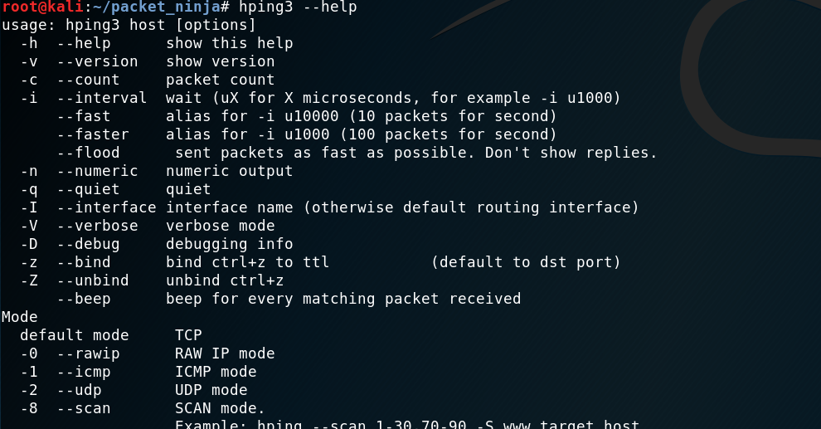

3. Ostinato

Ostinato is a widely used network traffic generator tool. It is not available as an open source tool for research and experimentation.

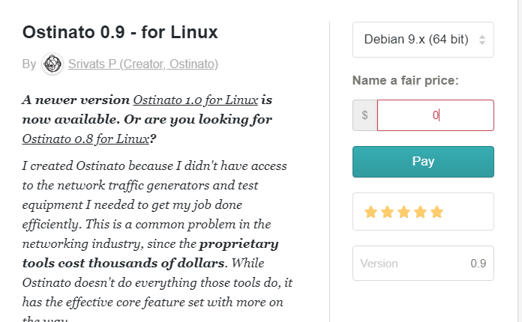

A2. ARP cache poisoning – concept

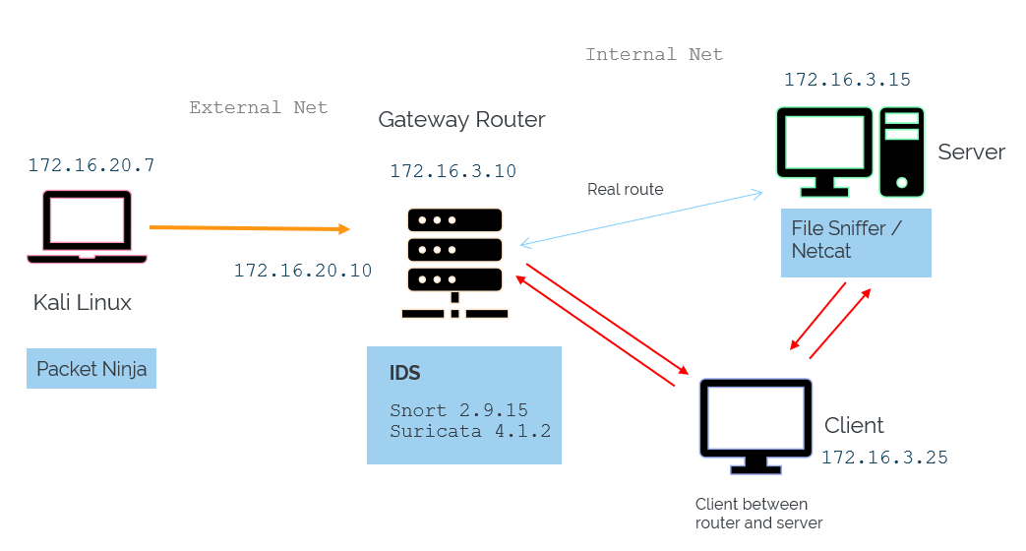

A3. Terms of Reference

Temasek Polytechnic

School of Informatics & IT

**Diploma in Cyber and Digital Security**

AY2019/2020 Semester Level 3

MP Terms of Reference

**Project Particulars**

|  |  |
| --- | --- |
| **MP Supervisor** | Logesh Madhavan |
| **Project ID** | 01 |
| **Project Title** | NIDS Evasion Techniques |
| **Student Matric Card Number** | 1705018H |
| **Student Name** | Anurag Prabhakar |

# 1. Introduction

Nowadays, Network Intrusion Detection Systems are a necessity in any network architecture. An Intrusion Detection System is a device or software that monitor a network for malicious or abnormal activities. These systems may use a signature database or specific pattern of traffic behaviour to scan for intrusions and anomalies. Network Intrusion Detection Systems logs, notifies and alerts the administrators if such event is discovered while scanning the packet data. Many of the malicious activities are simply ignored due to the high false positive rates that occur when bad packets created from corrupt data and bugs[1]. Most Intrusion Detection Systems are not properly tested by administrators as they tend to depend on claims of vendors and online reviews based on limited scope[2].

The functionality of an Intrusion Detection System is tested by its capability to detect the attack. Therefore, Intrusion Detection Systems should undergo functionality tests based on simple and comprehensive real-life attack scenarios. Here at National Cyber Security R&D Labs, we are developing python scripts to evade detection in Network and Transport layer. It involves using crafted network packets to manipulate the protocol layers and trick the Intrusion Detection System into accepting them. It also includes fragmenting, encrypting and obfuscating the data for evading detection.

# 2. Objectives of the Project

The objective of the project is to develop a tool that can automate packet crafting and perform IDS testing. It should be able to probe the IDS to generate alerts as well as evade the IDS detection. It also should have a feature to send encrypted packets through the network and decrypt it at the target.

# 3. Scope of the Project

* The project begins with basic understanding of NCL web-interface and nodes in NCL Testbed. Fundamental knowledge about Intrusion Detection Systems, its characteristics, limitations and evasion techniques are also essential. Next step involves deployment of necessary tools.
* Design a tool with guided interface that can automate packet crafting
* Ensure the tool can perform probe testing (ping, traceroutes, payload tests, network attacks) as well as evade intrusion detection through payload morphing, segmentation/fragmentation, packet manipulation, editing TCP headers etc.
* Implement different methods to encrypt data, send to a target and decrypt once it reaches the destination.
* Create a script to edit pcap files

A4. Project Timeline

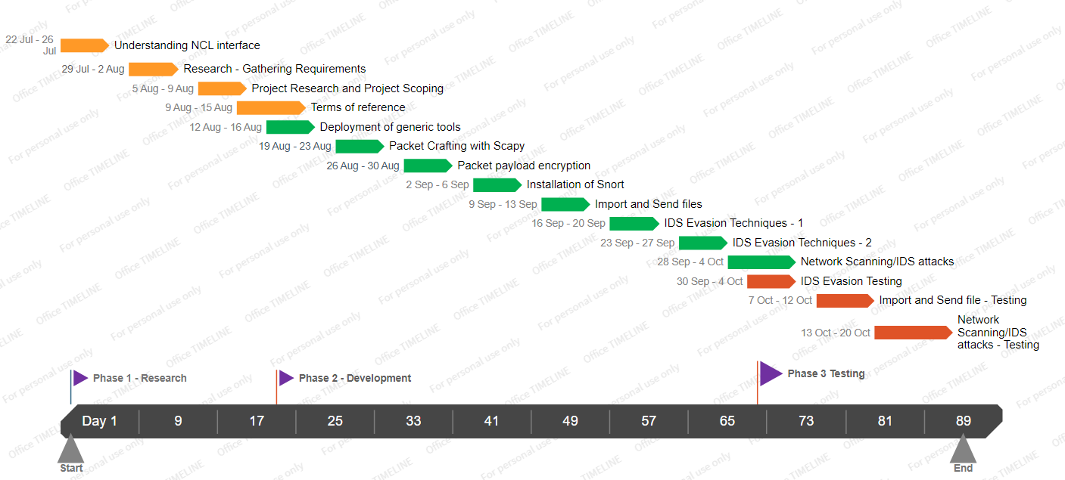

A5. Packet Ninja – Concept diagrams

1. Features

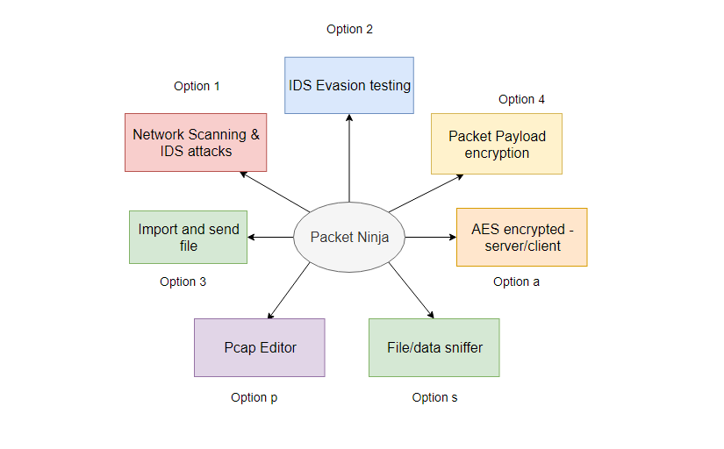

2. Probe testing (scan, pings, traceroutes, attacks, payload tests)

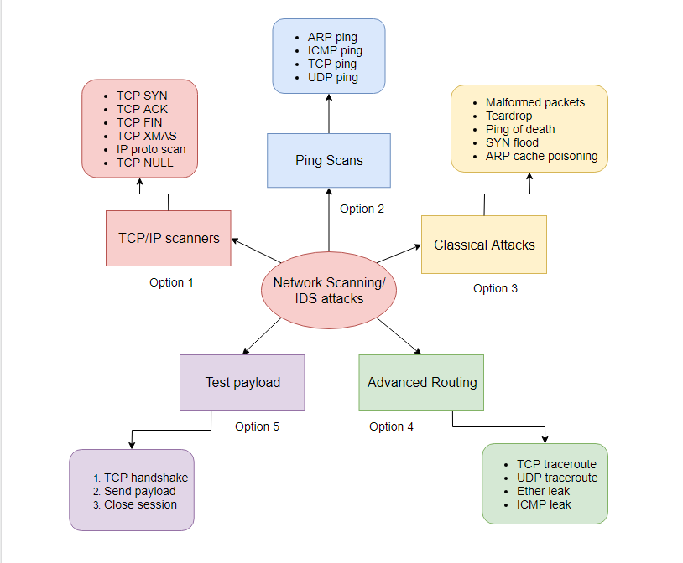

3. Evasion Testing

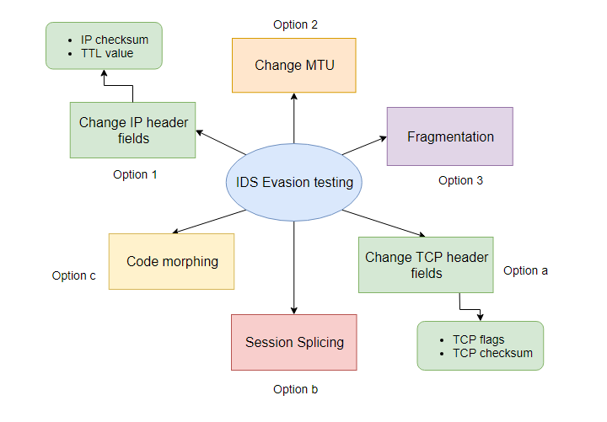

4.1 Manipulation of TCP/IP headers

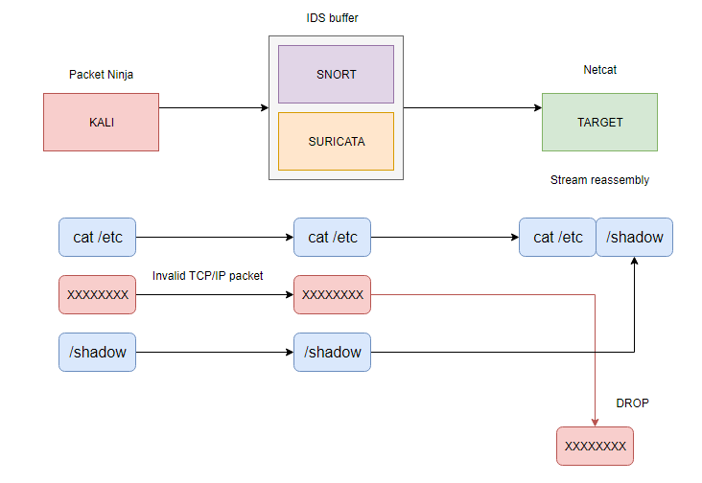

4.2 Low TTL attack

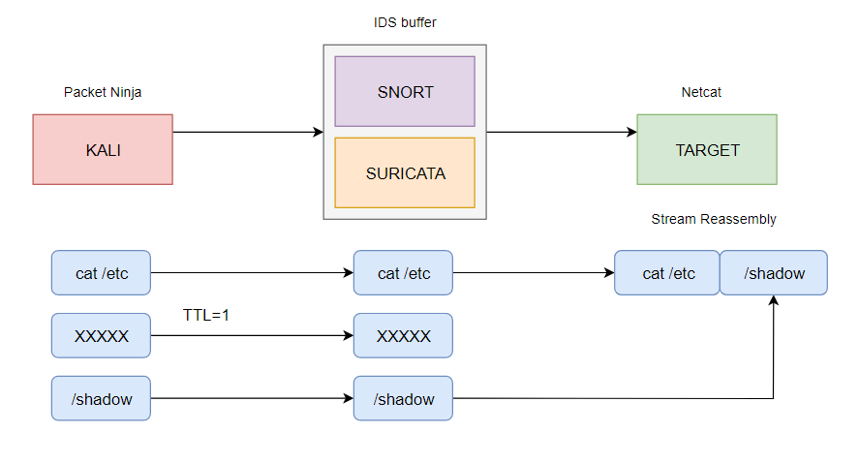

4.3 Change MTU size

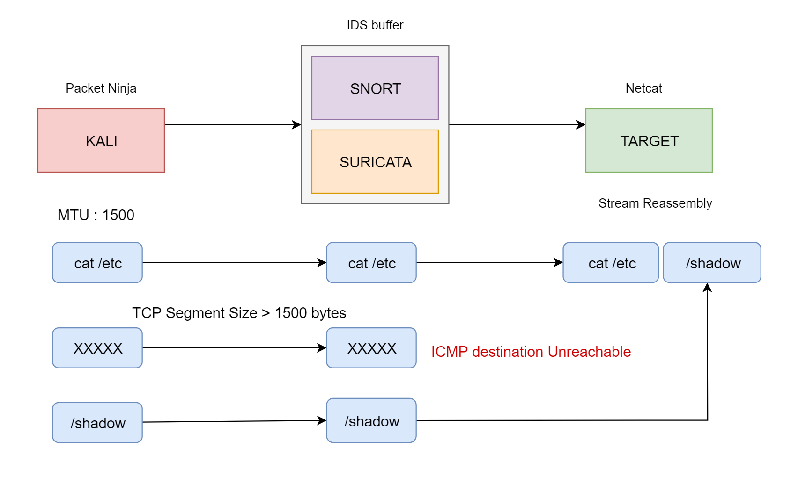

4.4 Fragmentation

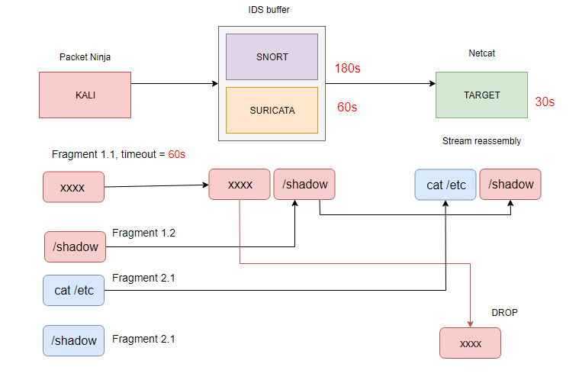

4.5 Session Splicing

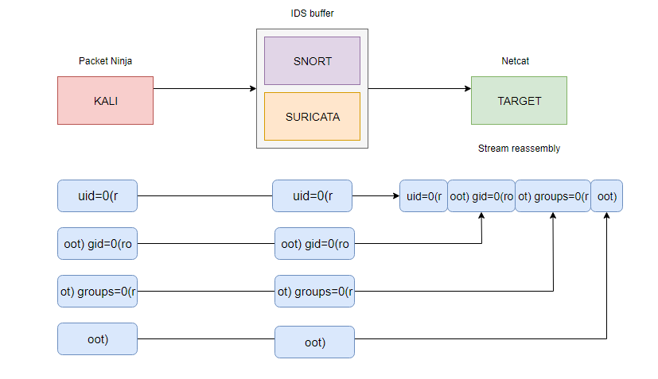

4.6 Payload morphing

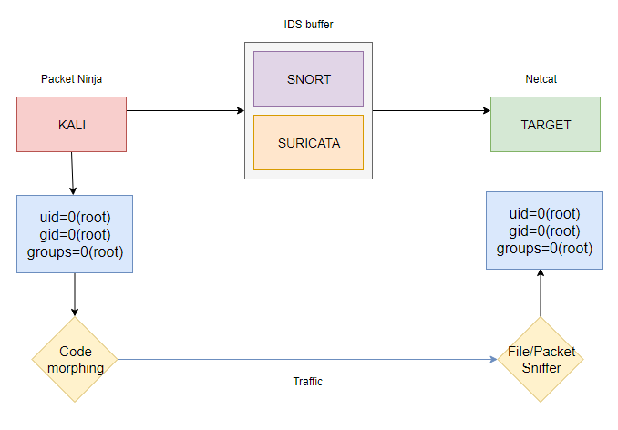

5. File Sender

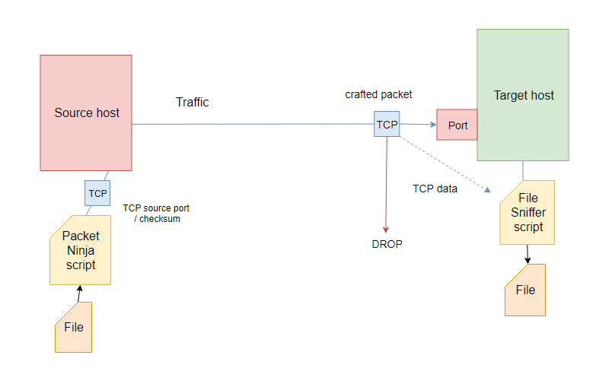

File data encryption with XOR and Zlib Compression

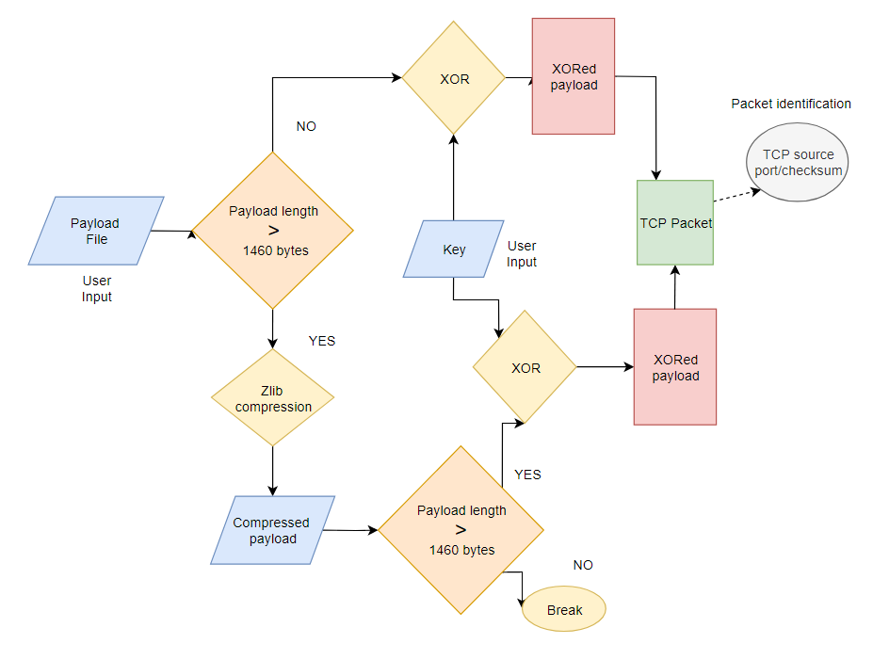

6. Packet payload encryption

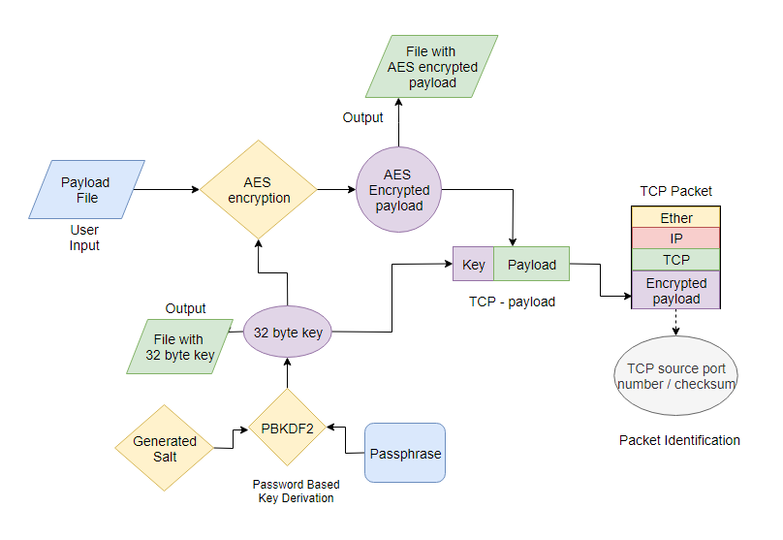

7. Pcap Editor

7.1 Edit packet header fields

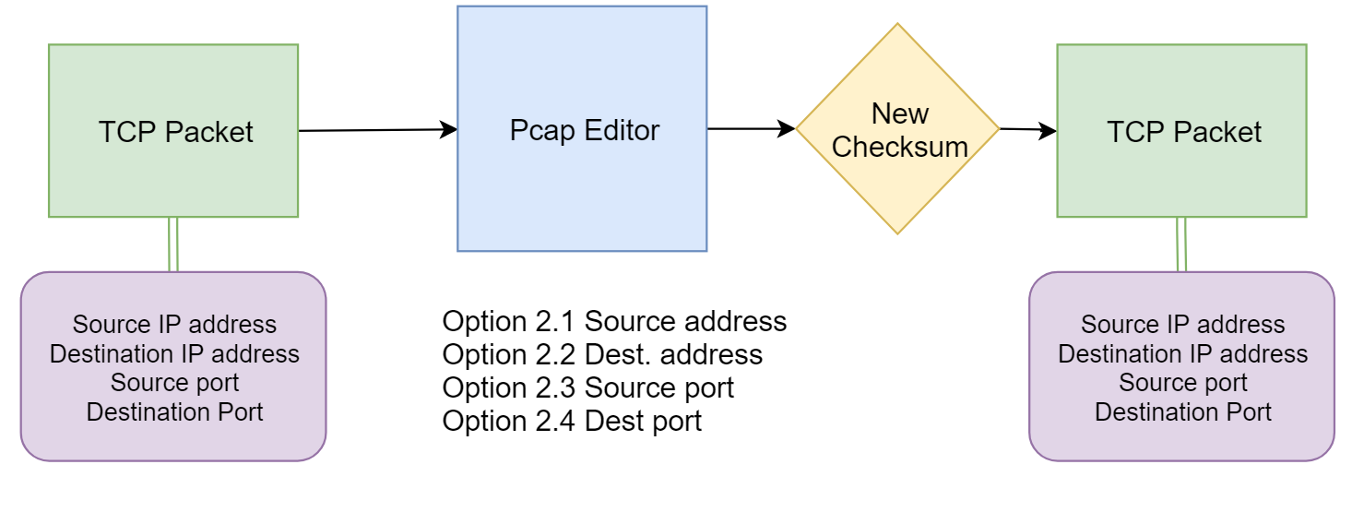

7.2 Replace payload

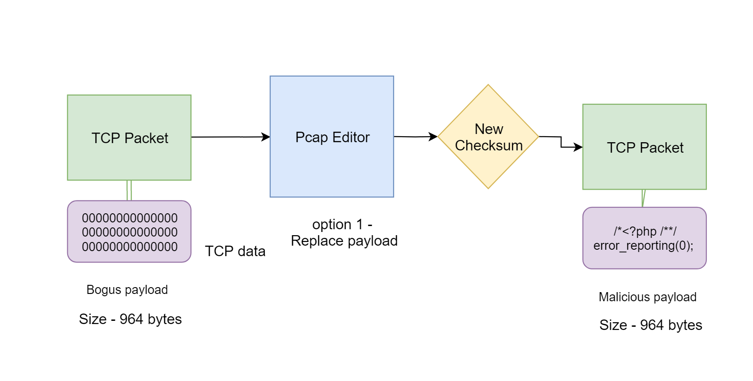

7.3 Pcap replay

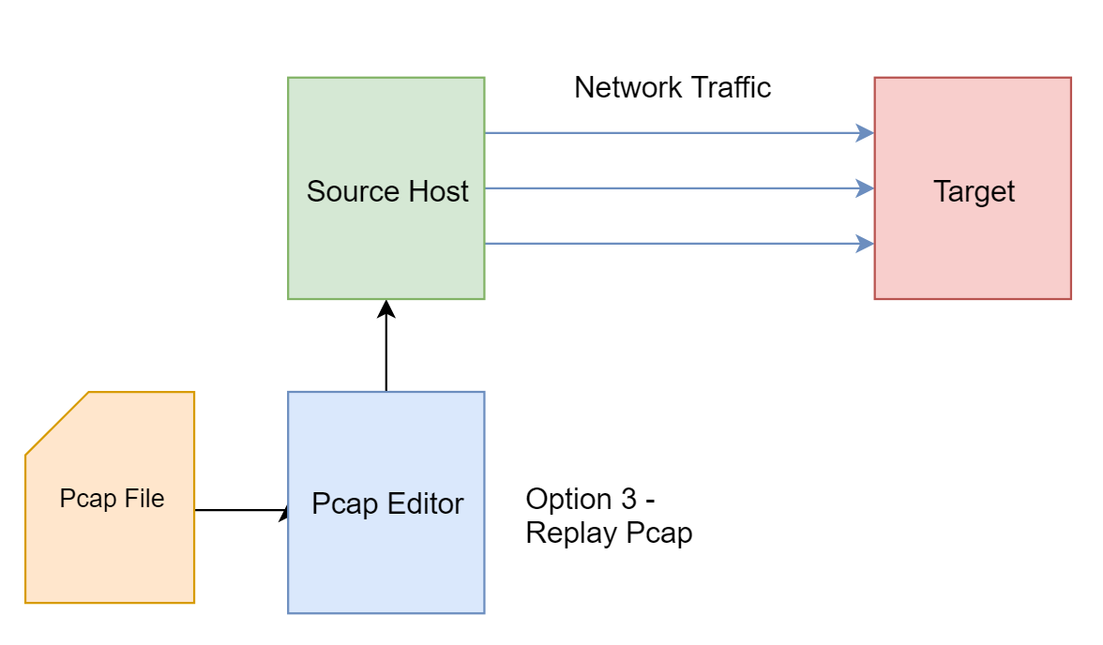

7.4 Read pcap

